**MINISTRY OF RELIGION OF THE REPUBLIC OF INDONESIA**



**STATE ISLAMIC UNIVERSITY OF MAULANA MALIK IBRAHIM MALANG**

**Gajayana Street Numb**[**er 50 Malang 65144 Ph**](http://www.uin-malang.ac.id/)**one (03**[**41) 551354, Fax. (0341)**](mailto:info@uin-malang.ac.id) **572533 Website: http**[**://www.uin-malang.ac.id**](http://www.uin-malang.ac.id/) **Email:** [**info@uin-malang.ac.id**](mailto:info@uin-malang.ac.id)



**THE IMPLEMENTATION FLOW OF**

**INDEPENDENT LEARNING - INDEPENDENT CAMPUS (MBKM)**

**1**



Start

Registration Documents

MBKM

Student

Candidate

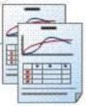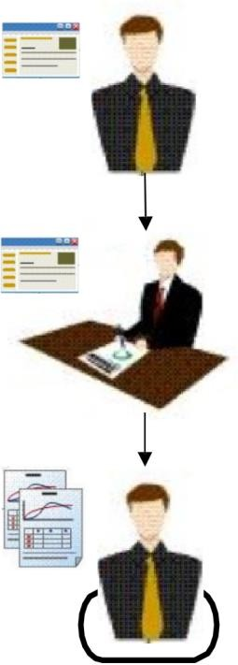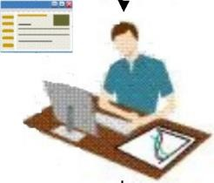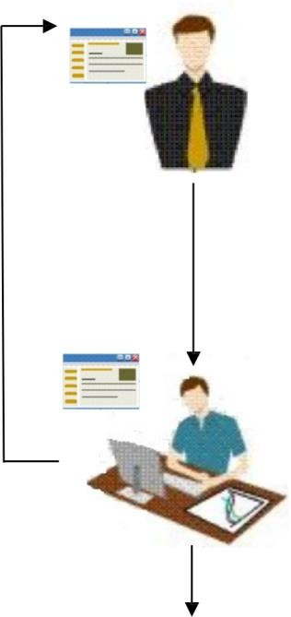

MBKM student candidates are active students at MBKM partner universities.

**2**

MBKM student candidates register for MBKM

on the website <http://mbkm.uin-malang.ac.id> by filling out the registration form (personal data and data from universities), and uploading verification documents (Profile

|  |  |
| --- | --- |
| Rejected | Photos, Cover Letters from Partner Universities, Active Student Letters, and  temporary transcripts). |

MBKM

Service Unit

**3**



Verification Documents

MBKM student candidates print the MBKM Registration Card.

Teaching materials

Study Results Card (KHS)

Study Plan Card (KRS)

**4**

MBKM Service Unit conducts administrative

selection of MBKM applicants.

If rejected, MBKM applicants can re-register in

MBKM

Students

|  |  |  |  |  |  |
| --- | --- | --- | --- | --- | --- |
|  | | |  | the following semester. | |
| Accepted | | | **5** |  | |
|  | | |  | MBKM students do Course Programming | |
|  | | |  | and print the Study Plan Card (KRS) on  <http://siakad.uin-malang.ac.id> | |
| MBKM Students | | |  | |
|  | | | **7**  **6**  **8** | MBKM students do the academic  consultation with their academic advisors. | |
| Finish  Lectures | | | MBKM students carry out the lecture process according to the schedule set in their Study Programs. One of the learning media that can be used by MBKM students is <http://elearning.uin-malang.ac.id>  MBKM students get the Study Results Card (KHS) and return to the Partner Universities. | |
|  |  | |  |
|  |  | |  |
|  |  |