Independent Learning Guide

Maulana Malik Ibrahim State Islamic University (UIN) Malang

**PREFACE**

*Assalamualaikum wr. wb.*

All praise is due to Allah SWT, who has bestowed His grace and blessings, allowing the completion of this Guidebook for Student Exchange Activities in implementing the Independent Learning, Independent Campus (MBKM) program.

May prayers and peace always be upon the Prophet Muhammad SAW, who has guided and directed his people toward a life filled with civilization and divine light.

This guide has been prepared as a follow-up to the MBKM policy initiated by the Indonesian Ministry of Education and Culture in 2020. The MBKM policy provides opportunities for students to take courses outside of their study programs, either at the same university or at different universities, through student exchange programs. Through this program, students can develop themselves according to their talents and interests. The rapid development of science and technology and the increasingly complex demands of the working world require students to have multiple competencies that sometimes cannot be obtained in their original study programs. Therefore, cross-campus courses can be a solution to bridge educational disparities in higher education institutions.

This guidebook is an effort to actualize the big ideas contained in the MBKM regulations so that they are easy to implement from a technical aspect. Hopefully, this guidebook can contribute to improving the quality of education at UIN Maulana Malik Ibrahim Malang, Islamic Religious Higher Education (PTKI), and higher education nationally for the advancement of the Indonesian nation. Thank you to the editorial team and the support from various parties, enabling the completion of this guidebook. May their contributions be considered an act of worship and receive the blessing of Allah SWT. Amen.

The completion of this guidebook involved various parties. Therefore, we would like to express our highest appreciation and deepest gratitude to the Rector of Maulana Malik Ibrahim State Islamic University Malang, the Chairman of the Senate, the Vice Deans I, the heads of study programs, the LPM team, LP2M, the academic section, PTIPD, the Library Unit, and all parties who cannot be mentioned one by one.

We sincerely hope that their good deeds are recorded as righteous acts and receive due reward from Allah SWT. We fully acknowledge that the writing of this MBKM implementation guidebook is far from perfect. Therefore, we kindly request constructive criticism and suggestions from various parties to improve the quality of future guides. We sincerely hope that this guidebook will contribute to scientific development and be of great benefit. We offer prayers that Allah will always protect us and bestow blessings upon us all, Amen.

Malang, December 4, 2021

Vice Rector I,

Umi Sumbulah

**TABLE OF CONTENTS**

Cover Page  
Inner Page  
Editorial Team  
Rector's Decree  
Preface  
Table of Contents  
Glossary

Chapter I: Introduction  
A. Background  
B. Legal Basis  
C. Objectives

Chapter II: General Policy  
A. Higher Education  
B. Participants  
C. Course Lecturers  
D. Academic Advisors  
E. Inter-University Cooperation Agreement

Chapter III: Registration and Implementation of Learning  
A. Registration  
B. Lectures

Chapter IV: Grade Conversion  
A. General Provisions for Conversion  
B. Conversion Procedure

Chapter V: Program Implementation  
A. Program Preparation  
B. Program Implementation  
C. Follow-up

Chapter VI: Financing

Chapter VII: Monitoring and Evaluation  
A. Monitoring  
B. Evaluation

Chapter VIII: Conclusion

# Chapter I

# Introduction

**--------------------------------**

## LEGAL BACKGROUND

In 2021, the Indonesian Ministry of Education and Culture issued the Independent Learning-Independent Campus policy. This policy applies to all higher education institutions, including Maulana Malik Ibrahim State Islamic University (UIN) Malang. Independent Learning at UIN Maulana Malik Ibrahim Malang is a program that allows students to fulfill their right to education and achieve their capabilities by participating in various activities equivalent to course credits outside their study programs. UIN Maulana Malik Ibrahim Malang has adopted a capability-based approach to curriculum development, enabling the implementation of the Independent Learning-Independent Campus programs. The Independent Learning-Independent Campus program is mandated by various policies for higher education, both national policies and those issued by UIN Maulana Malik Ibrahim Malang.

The legal basis related to the implementation of the Independent Learning-Independent Campus program at UIN Maulana Malik Ibrahim Malang includes:

* 1. Law Number 20 of 2003 on the National Education System (State Gazette of the Republic of Indonesia of 2003 Number 78, Supplement to the State Gazette of the Republic of Indonesia Number 4301).
  2. Law Number 13 of 2003 on Manpower (State Gazette of the Republic of Indonesia of 2003 Number 39).
  3. Law Number 12 of 2012 on Higher Education (State Gazette of the Republic of Indonesia of 2012 Number 158, Supplement to the State Gazette of the Republic of Indonesia Number 5336).
  4. Government Regulation Number 04 of 2014 on the Administration of Higher Education and Management of Universities.
  5. Presidential Regulation Number 8 of 2012 on the Indonesian National Qualifications Framework (KKNI).
  6. Regulation of the Minister of Higher Education and Culture of the Republic of Indonesia Number 73 of 2013 on the Implementation of the Indonesian National Qualifications Framework (KKNI) in the Higher Education Sector.
  7. Regulation of the Minister of Research, Technology, and Higher Education of the Republic of Indonesia Number 44 of 2015 on the National Standards for Higher Education.
  8. Regulation of the Minister of Religious Affairs Number 1 of 2016 on Diplomas, Academic Transcripts, and Diploma Supplements for Religious Higher Education Institutions.
  9. Regulation of the Minister of Research, Technology, and Higher Education of the Republic of Indonesia Number 62 of 2016 on the Quality Assurance System for Higher Education.
  10. Regulation of the Minister of Research, Technology, and Higher Education Number 59 of 2018 on Diplomas, Competency Certificates, Professional Certificates, Degrees, and the Procedures for Writing Degrees in Higher Education.
  11. Decree of the Minister of Research, Technology, and Higher Education No. 123 of 2019 on Internships and the Recognition of Industrial Internship Semester Credit Units for Bachelor's and Applied Bachelor's Programs.
  12. Regulation of the Minister of Education and Culture of the Republic of Indonesia Number 3 of 2020 on National Standards for Higher Education.
  13. Regulation of the Minister of Education and Culture No. 5 of 2020 on the Accreditation of Study Programs and Higher Education Institutions.
  14. Regulation of the Minister of Education and Culture No. 7 of 2020 on the Establishment, Amendment, and Dissolution of State Universities and the Establishment, Amendment, and Revocation of Licenses for Private Universities.
  15. Regulation of the Minister of Education and Culture No. 22 of 2020 on the Strategic Plan of the Ministry of Education and Culture.
  16. Decree of the Director General of Islamic Education Number 2500 of 2018 on Graduate Competency Standards and Learning Outcomes for Undergraduate Programs at Islamic Religious Higher Education Institutions and Faculties of Islamic Studies at Universities.
  17. Regulation of the Minister of Villages, Development of Disadvantaged Regions, and Transmigration Number 11 of 2019 on the Priority Use of Village Funds for 2020.
  18. Independent Learning-Independent Campus Guidebook.
  19. PMA Number 40 of 2018 on the Statute of UIN Maulana Malik Ibrahim Malang.
  20. Regulation of the Minister of Religious Affairs of the Republic of Indonesia Number 2 of 2018 on Amendments to the Regulation of the Minister of Religious Affairs Number 8 of 2013 on the Organization and Work Procedures of Maulana Malik Ibrahim State Islamic University Malang.
  21. Rector's Decree of Maulana Malik Ibrahim State Islamic University Malang No. 112 of 2021 on Curriculum Guidelines at Maulana Malik Ibrahim State Islamic University Malang.
  22. Rector's Decree Number 3146 of 2021 on Education Guidelines at UIN Maulana Malik Ibrahim Malang for 2021.

## BACKGROUND

The rapid development of global technology has led to a large and complex transformation in personal life. Technology has changed human life in various aspects. This greatly influences the lifestyle of future generations, leading to a shift in the orientation of education and learning.

Education and learning orientation in the 21st century must shift from expert-centered learning to work-based learning. This orientation will continue to evolve from work-based learning to life-based learning. Thus, efforts to fulfill the need for skilled and proficient workers in various fields can be realized quickly. Concerning this, UIN Maulana Malik Ibrahim Malang is committed to preparing students to face the challenges of social and cultural changes, the world of work, and rapid technological advancements. Student abilities are directed toward developing capabilities that align with the needs of the ever-changing job market and future. Students are viewed as whole persons, which aligns with UIN Maulana Malik Ibrahim Malang's identity as a university with the motto *Ulul Albab* University.

The issuance of the policy by the Minister of Education and Culture in the form of Ministerial Regulation Number 3 of 2020 on the National Standards for Higher Education (SNDikti) requires UIN Maulana Malik Ibrahim Malang to design and implement innovative learning processes so that students can achieve learning outcomes that optimally encompass aspects of attitude, knowledge, and skills. Article 18 of the 2020 SNDikti states that fulfilling the duration and workload of learning for undergraduate or applied undergraduate students can be accomplished by: (1) participating in all learning processes within the study program at the university according to the duration and workload and (2) participating in learning processes within the study program to fulfill part of the duration and workload and the remainder by participating in learning processes outside the study program.

The learning process provided accommodates the fulfillment of students' right to learn, as stated in Article 15 of the National Standards for Higher Education (SNDikti), which requires that the learning process at universities must be facilitated through: (a) the learning process in other study programs at the same university, (b) learning in the same study program at different universities, (c) learning in other study programs at different universities, and (d) learning at non-university institutions. This policy is one of the policies of the Minister of Education and Culture regarding the "Merdeka Belajar-Kampus Merdeka" (Independent Learning - Independent Campus) initiative.

The implementation of the "Independent Learning" program at UIN Maulana Malik Ibrahim Malang is carried out through learning both inside and outside the university. Learning within UIN Maulana Malik Ibrahim Malang is done using a transdisciplinary approach, which is one of the approaches in curriculum development at the university, in addition to the capability approach and life-based learning. Students can take courses outside their study program to fulfill their capabilities, which are facilitated through transdisciplinary courses. Learning outside UIN Maulana Malik Ibrahim Malang is conducted through various forms of learning activities, including internships/practical work in industry or other workplaces, community service projects in villages, teaching in educational units, participating in student exchanges, conducting research, engaging in entrepreneurial activities, undertaking independent studies/projects, and participating in humanitarian programs. These activities are conducted under the guidance of lecturers and provide contextual field experience, which enhances students' overall competencies, making them ready for work or creating new job opportunities.

The implementation of the "Independent Learning" program at UIN Maulana Malik Ibrahim Malang can be carried out optimally because the university has autonomous and flexible authority, creating an innovative learning culture that is non-restrictive and aligns with students' needs. UIN Maulana Malik Ibrahim Malang facilitates students' freedom to exercise their right to learn by conducting a student-centered learning process. This learning approach must provide challenges and opportunities for the development of students' creativity, capacity, personality, and needs while fostering independence in seeking and discovering knowledge through real-world realities and dynamics, such as skill requirements, real problems, social interactions, collaboration, self-management, performance demands, targets, and achievements. Thus, UIN Maulana Malik Ibrahim Malang's efforts to produce graduates who are in tune with the times, technological advancements, business and industry demands, and societal dynamics can be achieved.

## OBJECTIVES

The objectives of the "Independent Learning-Independent Campus" program at UIN Maulana Malik Ibrahim Malang are described as follows:

* 1. Enhance the quality of graduates of UIN Maulana Malik Ibrahim Malang to have the required capabilities in the 21st-century life era and the 4.0 industrial era.
  2. Improve students' learning capabilities by fulfilling their right to learn through a life-based, capability-based, and transdisciplinary learning approach.
  3. Facilitate students' right to learn according to their interests and potential so that they become competitive and well-rounded graduates.
  4. Provide insights and experiences for students to become graduates who align with the graduate profile of UIN Maulana Malik Ibrahim Malang.

# Chapter II

**Implementation of Independent Learning**

**--------------------------------**

## GENERAL REQUIREMENTS

The Independent Learning policy at UIN Maulana Malik Ibrahim Malang requires students to fulfill their credit unit requirements by engaging in activities outside the university (outside UIN Maulana Malik Ibrahim Malang). These requirements include: (1) students must be from accredited programs, meaning that the student's current program at UIN Maulana Malik Ibrahim Malang and the destination program must both be accredited, with the destination program being accredited at least at the same level or higher, and (2) students must be active, registered, and listed in the PDDikti (Higher Education Data System). Only active students who have registered and filled out their study plans in the Academic Information System (SIAKAD) are allowed to participate.

The Independent Learning program at UIN Maulana Malik Ibrahim Malang is guided by the Independent Learning Guide. This program is structured through collaborations with partner institutions, formalized by agreements for various activities. These include internships or work placements in industry or other workplaces, community service projects in villages, teaching at educational institutions, participating in student exchanges, conducting research, engaging in entrepreneurship activities, creating independent studies or projects, and participating in humanitarian programs.

## IMPLEMENTATION

### Role of Related Parties

The relevant parties involved in the implementation of the Independent Learning program include the university as the higher education provider, faculties, study programs, students, and partner institutions. Non-vocational higher education institutions under the Ministry of Religious Affairs of the Republic of Indonesia and the Ministry of Education and Culture of the Republic of Indonesia also play roles. The authority and roles of each party in the administration of Independent Learning at UIN Maulana Malik Ibrahim Malang are described as follows.

## HIGHER EDUCATION INSTITUTION

* + - 1. Create policies for implementing the Independent Learning program in the form of the Rector's Regulations at UIN Maulana Malik Ibrahim Malang, adhering to educational standards.
      2. Set curriculum guidelines and Independent Learning guidelines through rector regulations to facilitate learning activities both within and outside the study programs.
      3. Facilitate student learning rights (optional or mandatory) under the Minister of Education and Culture Regulation No. 3 of 2020 concerning National Standards for Higher Education, allowing:
* Taking credits outside UIN Maulana Malik Ibrahim Malang for a maximum of 2 semesters, up to 40 credits, and
* Taking credits in different study programs within UIN Maulana Malik Ibrahim Malang for 1 semester or equivalent to 20 credits.
  + - 1. Develop cooperation documents (MoU/SPK) with partner institutions.

## FACULTY

* + - 1. Coordinate with study programs to prepare a list of transdisciplinary courses available for cross-program enrollment by students and upload it to the SIAKAD system.
      2. Organize cooperation documents (MoU/SPK) with relevant partners.
      3. Develop Standard Operating Procedures (SOPs) for the process of implementing the Independent Learning program at the faculty level.

## STUDY PROGRAM

* + - 1. Develop curricula focusing on life-based, capability-based, and transdisciplinary learning approaches to fulfill cross-program learning rights at UIN Maulana Malik Ibrahim Malang.
      2. Develop Independent Learning activity packages in line with the curriculum to fulfill student learning rights outside UIN Maulana Malik Ibrahim Malang.
      3. Facilitate students who will take cross-study programs within and outside UIN Maulana Malik Ibrahim Malang.
      4. Offer courses that can be taken by students outside the study program and UIN Maulana Malik Ibrahim Malang along with the requirements.
      5. Conduct equivalency assessments for courses in the curriculum with learning activities outside the program and UIN Maulana Malik Ibrahim Malang.
      6. Prepare and facilitate the implementation of online learning for the fulfillment of independent learning packages.

## STUDENTS

* + - 1. Coordinate with the Academic Advisor to plan the courses to be taken and input them into SIAKAD.
      2. Submit the study plan on SIAKAD after receiving approval from the academic advisor and study program coordinator.
      3. Complete all requirements for external activities, including any selection processes if required.
      4. Engage in the approved external activities according to the academic guidelines.

Generally, taking transdisciplinary courses, both inside and outside UIN Maulana Malik Ibrahim Malang, is carried out by following the following mechanism.

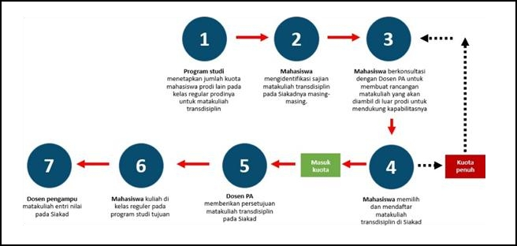

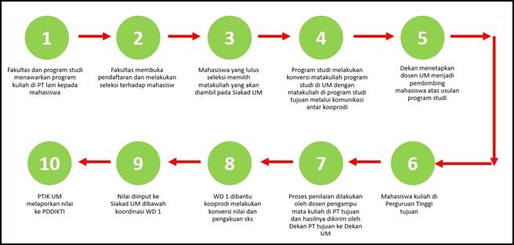**Figure 1. Mechanism for Taking Transdisciplinary Courses- Cross Study Program**

**Figure 2. Mechanism for Taking Transdisciplinary-Cross-University Courses at Other Universities**

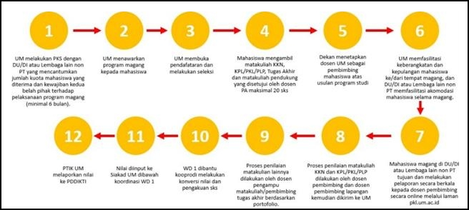

**Figure 3. Mechanism for Taking Transdisciplinary Subjects at DU/DI or other non-higher Education Institutions**

* 1. **Independent Learning Activities**

The Independent Learning activities are adjusted to Permendikbud No.3 of 2020, as illustrated in Figure 4.

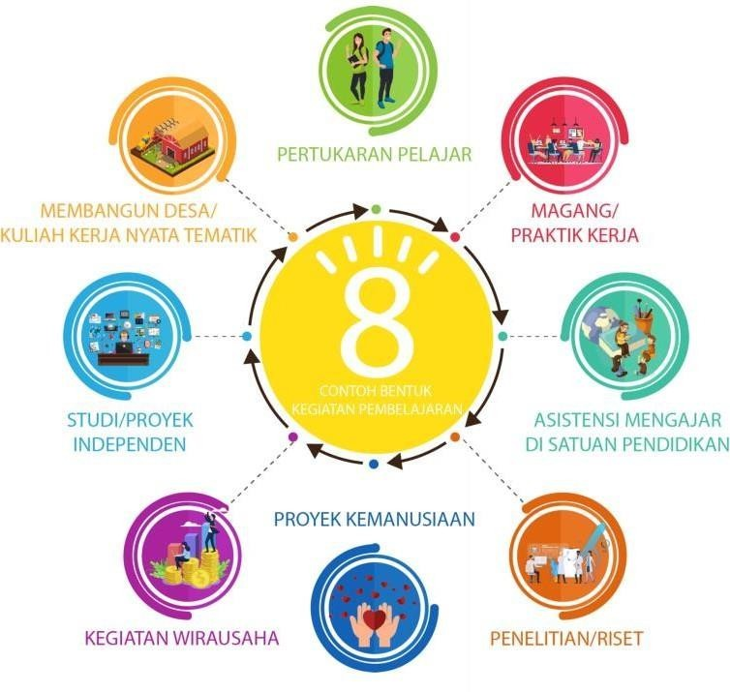

**Figure 4. The Independent Learning Activities**

## STUDENT EXCHANGE

### Definition

The student exchange program allows students to study for one semester either within the same university or at a different university, with a maximum credit transfer of ± 20 credits. Students can choose universities in Indonesia, especially those with exchange agreements with UIN Maulana Malik Ibrahim Malang. This program is characterized by its unique academic administration and atmosphere. The academic environment, learning processes, student activities, and campus culture offer valuable experiences that enhance students' nationalism and support their learning capabilities. Since 2014, the Domestic Student Exchange Program (PERMATA) has been in operation. In PTKIN (Islamic Higher Education Institutions), PERMATA has been carried out through a consortium of academic programs in the Faculty of Science and Technology. However, there is a need to extend this program to other faculties within Islamic Higher Education Institutions. Therefore, creating a guide for student exchanges between universities is crucial to effectively implement the program.

### Objectives

The objectives of the student exchange program are described as follows.

* 1. Enable students to gain educational experiences within their current program and at other institutions through credit transfer and acquisition, as part of the Independent Learning program.
  2. Support learning across campuses (both domestic and international), including living with host families, to enhance students' understanding of Indonesia's diversity (*Bhinneka Tunggal Ika*) and strengthen intercultural and interethnic relationships.
  3. Promote the development of friendships among students from different regions, ethnicities, cultures, and religions, fostering national unity and solidarity.
  4. Address educational disparities by enabling the transfer of knowledge between domestic universities and between domestic and international higher education institutions.

### General Conditions

1. **Higher Education Institution**
2. Non-vocational higher education institutions under the Ministry of Religious Affairs of the Republic of Indonesia (RI) and the Ministry of Education and Culture of the Republic of Indonesia (RI).
3. Higher education institutions and study programs are accredited by BAN-PT or an Independent Accreditation Institution (LAM) according to applicable regulations.
4. The sending higher education institution is required to establish cooperation with the host/receiving higher education institution.
5. Higher education institutions must facilitate the right for students to take credits outside their original study program, whether at the same institution or other institutions.
6. Higher education institutions have adequate facilities to conduct both in-person and online classes.
7. The student exchange program should be based on courses within a study program and is expected to include flagship courses of the institution as well as fundamental courses in specific fields, with the learning outcomes required by students.
8. The number of courses or equivalent activities that can be offered by the study program should be at least five and no more than twenty.
9. The number of inbound student participants (students from other institutions) in each course should not exceed 20% of the class quota.
10. Special classes (classes attended only by exchange students) must have a minimum of 10 students.
11. The number of credits exchanged should be approximately or equivalent to 20 credits per student, with the following options:

a. All 20 credits can be taken at the receiving institution.

b. 10 credits at the receiving institution and 10 credits at the sending institution.

1. Higher education institutions are required to provide recognition and/or conversion of courses taken by students.
2. Any excess credits can be added to the academic transcript up to a maximum of 11 credits and/or transferred to the Diploma Supplement (SKPI).
3. The receiving study program has an equivalent or higher accreditation status.

### Student

* 1. Active students who are registered in the Higher Education Data Base (PD-DIKTI) in the 5th to 7th semester.
  2. Have not been subject to any academic or non-academic sanctions at the sending institution.
  3. Agree to comply with all regulations set by both the sending and receiving institutions.

### Course Lecturer

* 1. Develop a Course Learning Plan (RPS) aligned with established learning outcomes.
  2. Prepare lecture materials that students can access.
  3. Conduct classes both offline and online, using synchronous and/or asynchronous methods.
  4. Follow the Course Learning Plan (RPS) for teaching.
  5. Facilitate active and dynamic student interaction, and act as a facilitator.
  6. Assess learning outcomes according to the regulations.
  7. Report student learning outcomes to the sending institution.

### Academic Advisor

* 1. Students in the exchange program will be assigned an academic advisor from the institution.
  2. The advisor will guide and track the student's academic progress during the program.
  3. The advisor will promote disciplined learning, high ethical standards, and respect for local culture.
  4. The advisor will provide recommendations and other relevant information about the students to relevant parties.

### Student Coordinator (lecturer)

* 1. The student coordinator is a faculty member appointed by the Dean to assist exchange students.
  2. Ensure that exchange students attend classes properly.
  3. Help exchange students adapt to both the academic environment and local culture.
  4. Assist students with any issues they encounter during their studies at the receiving institution.
  5. Issue warnings to students for minor infractions and report serious violations to the academic advisor.
  6. Take prompt action in case of emergencies.
  7. Understand and recommend strategic locations for students to spend their free time or engage in productive activities.

### Inter-Institutional Cooperation Agreement

* 1. The agreement should define the terms of the Student Exchange Program.
  2. Cooperation can be bilateral, in consortia, clusters (based on accreditation), or zonal (based on regions).
  3. The agreement must include:
  4. The identities of the institutions.
  5. The duration of the agreement.
  6. The rights and obligations of each party.
  7. Details of the cooperation program, including:
  8. Scope of cooperation.
  9. Duration.
  10. Financing.
  11. Coordination system for implementing the program.
  12. Termination conditions.
  13. The inter-institutional cooperation agreement should be followed by an inter-faculty agreement that must include at least:

a. The identities of the cooperating institutions.

b. The duration of the cooperation agreement.

c. The rights and obligations of each party.

d. A detailed description of the cooperation program, including:

1. Requirements for students participating in the Student Exchange Program.
2. Curriculum details (learning outcomes, learning process, workload, evaluation, and implementation system).
3. The number of courses offered by each faculty/department/study program.
4. The number of students accepted into the exchange program for each study program.
5. Semester credit recognition and assessment.
6. Coordination system for implementing the cooperation program.
7. Program financing (including practical training).
8. Conditions for terminating the cooperation agreement.
   1. The cooperation agreement should be prepared in multiple copies (exemplars) according to the number of institutions involved in the cooperation.

### Requirements

The requirements for Students Participating in the Exchange Program include:

* 1. Active students who are registered in the Higher Education Data Base (PD-DIKTI) in the 5th to 7th semester.
  2. Minimum GPA of 3.00.
  3. No academic or non-academic sanctions at the sending institution.
  4. Written consent from parents
  5. Physically and mentally healthy.
  6. Health insurance coverage.
  7. Agree to comply with all regulations set by both the sending and receiving institutions.

### Registration

* 1. Applicants fill out the exchange program registration form using the receiving institution’s application system.
  2. Obtain approval from the sending institution’s study program.
  3. Complete the Study Plan Card (KRS) with courses to be taken at both institutions.
  4. The receiving institution selects participants for the semester’s classes.
  5. Institutions will regularly monitor and evaluate the registration process.

### Mechanism

* 1. The receiving study program adjusts its curriculum to enable students to take courses in the same program at other institutions.
  2. The receiving study program establishes agreements with partner programs on learning processes, credit recognition, assessment, financing, and technical aspects of the student exchange program.
  3. The receiving study program defines the courses, credit hours, and participant quotas available for students from the sending program.
  4. The receiving study program shares information on available courses and quotas through the student exchange application system.
  5. Students register for and select courses offered through the student exchange system.
  6. Students participating in the exchange program can take up to 20 credit hours (SKS) under the following options:
     + Students can take all 20 SKS worth of courses at the receiving institution as a package.
     + Students can take 10 SKS at the receiving institution and choose 10 SKS worth of courses from the sending institution.
  7. The academic advisor and the head of the sending study program approve the courses the student takes.
  8. Students download the Study Plan Card (KRS).
  9. The study program coordinates with course lecturers to prepare for the learning process.
  10. Course lecturers conduct the classes, assign final grades, and send the grades to the study program.
  11. Institutions can view data on participants of the Student Exchange Program through the application system and monitor the program’s implementation.
  12. Participants in the Student Exchange Program submit the progress reports to their academic advisor or course lecturer, including documents showing their learning outcomes at the receiving institution. These reports are then sent to the sending institution.
  13. The receiving institution provides feedback on the final reports of the Student Exchange Program participants.
  14. The sending institution coordinates with the receiving institution regarding the study results of exchange participants, including credit transfer, equivalency, and/or issuing a Diploma Supplement (SKPI).
  15. Exchange program participants receive grades for credits recognized by the sending institution.
  16. The sending and receiving institutions evaluate the Student Exchange Program.
  17. Grades for recognized and equivalent learning outcomes must be uploaded to the PD-DIKTI application system, as the regular students at the institution.

### Financing

1. Student exchange programs between institutions are available only to students who have paid their single tuition fee (UKT) up to the current semester at the sending institution.
2. There are no fees for student exchanges between PTKIN institutions.
3. Any expenses beyond the UKT are the student's responsibility.
4. Costs for practical courses at the partner institution are borne by the students from the sending institution.
5. Exchanges with non-PTKIN institutions will be governed by mutual agreements.

### Grade Conversion

1. Course conversion must be fair.
2. Conversions should be based on regulations regarding the adequacy of content and credit values.
3. Grades from courses at the partner institution are converted to equivalent courses at the sending university.
4. Courses that cannot be converted at the sending institution may be listed on the Diploma Supplement (SKPI).
5. Credit conversion should consider the number of credit hours (SKS).
6. The course conversion process follows this order:
7. Courses that are the same.
8. Courses with the same content.
9. Courses from the same field.
10. Course conversions are categorized into three types:
11. Courses with the same name and credit hours (SKS) are directly converted.
12. Courses with the same name but different credit hours are converted based on the sending study program's courses.
13. Courses with different names but similar content are converted to the relevant courses at the sending study program.

### Monitoring

1. Sending universities and receiving universities must monitor the implementation of the Student Exchange program, both offline and online.
2. Monitoring can be conducted by academic advisors, other faculty members, or designated administrative staff.
3. The officer appointed to conduct the monitoring prepares a monitoring report and submits it to the university.
4. The monitoring results are used as the basis for evaluating the student exchange program.

### Evaluation

1. The sending and receiving institutions conduct a joint evaluation based on the monitoring results and activity reports after the completion of the Student Exchange Program.
2. All reports from the receiving institutions are compiled and analyzed to serve as a basis for evaluating and improving the Student Exchange Program for the following year.
3. The evaluation of the Student Exchange Program leads to a joint decision on the continuation of the program and/or recommendations for improvements of future exchanges.

## INTERNSHIP

### Definition and Objectives

### Internship/Work Practice is a learning activity conducted outside the campus facilitated by the university as part of students' personal development in the workforce, and it is a requirement for completing their studies. This learning activity is carried out through collaboration with partners, such as companies, non-profit organizations, multilateral organizations, government institutions, or startups, to apply the knowledge and technology possessed by students according to their competencies in their field of study program. The agreement for the internship/work practice activities between the university and the partner is outlined in an MoU or cooperation agreement between both parties.

### Requirements

* 1. Students are actively registered in the Academic Information System (SIAKAD) and provide proof through a Study Plan Card (KRS) signed by their Academic Advisor.
  2. Students passed the selection process to participate in the internship/work practice according to the specific requirements set by their study program (if applicable).
  3. Students completed at least 100 credit hours (SKS) for non-education undergraduate programs and 110 SKS for education undergraduate programs.
  4. Students attended the internship/work practice orientation provided by the faculty.
  5. Additional requirements for internship/work practice candidates are described as follows.
     + Have a minimum GPA of 3.0.
     + Sign a stamped Integrity Pact, as shown in the following Figure:

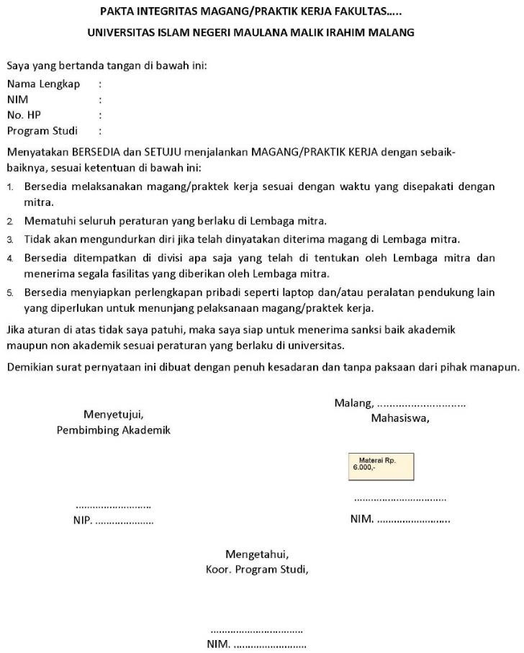

### Figure 5. Stamped Integrity Pact Template

1. **Implementation Process**
   1. Fulfillment of requirements
   2. Online registration
   3. Letter of request to partners
   4. Obtaining a field supervisor
   5. Attending the orientation
   6. Implementation of internship
   7. Submitting the report/essay
   8. Internship evaluation

### Mechanism, Monitoring, Reporting and Assessment

1. **Mechanism**

The internship mechanism is described as follows:

## HIGHER EDUCATION INSTITUTIONS

* + 1. Establish agreements in the form of cooperation documents (MoU/SPK) with partners, covering learning processes, credit recognition, and assessment.
    2. Develop an internship program with partners, including the content of the internship program, competencies that students will gain, and the rights and obligations of both parties during the internship process.
    3. Assign Internship Advisors to guide students during their internships (from the Study Program and Faculty).
    4. Internship Advisors conduct visits to the internship site for monitoring and evaluation.
    5. Internship advisors, along with supervisors/mentors, prepare a logbook/instrument and assess the student's achievements during the internship.
    6. The internship process can be monitored through the Higher Education Database.

## PARTNER INSTITUTIONS

* + 1. Collaborate with the university/faculty to develop and agree on the internship program that will be offered to students.
    2. Ensure that the internship process is of high quality and aligns with the cooperation documents (MoU/SPK).
    3. Provide a supervisor/mentor to guide students during the internship.
    4. The supervisor/mentor accompanies and evaluates the student's performance during the internship and, along with the internship advisor from the faculty, provides an assessment.

## STUDENTS

* + 1. By the approval of the academic advisor and the head of the study program, students apply for and participate in the internship selection process according to the internship site's requirements.
    2. Obtain approval from the academic advisor and program coordinator, and get an internship advisor.
    3. Carry out the internship activities under the guidance of the supervisor/mentor and the internship advisor.
    4. Complete the logbook/instrument according to the activities performed.
    5. Prepare a report on the activities and submit it to the supervisor/mentor and the internship advisor.

## INTERNSHIP ADVISORS AND SUPERVISORS/MENTORS

* + 1. The internship advisor provides guidance and assigns tasks to students throughout the internship process. The supervisor/mentor acts as a guide and supports the students during the internship.
    2. The internship advisor, along with the supervisor/mentor, evaluates and assesses the results of the internship.

### Credits, Equivalency, and Assessment

The Independent Learning program focuses on learning outcomes. The Higher education curricula are not merely a collection of courses but a design of educational/learning processes aimed at achieving specific learning outcomes. Generally, the equivalence of Independent Learning-Independent Campus activities can be categorized into two forms: free form and structured form.

#### Free-Form

The Independent learning activities for 6 months are equivalent to 20 credits without equivalence to courses. These 20 credits are reflected in the competencies gained by students during the program, covering both hard skills and soft skills, according to the desired learning outcomes. For example, in engineering fields, hard skills might include the ability to define complex engineering problems, analyze and solve engineering issues based on scientific and mathematical knowledge, etc. Soft skills might include communication abilities in a professional work environment, teamwork skills, adherence to professional ethics, etc. Learning outcomes and assessments can be expressed through these competencies. For instance, a student might complete a 6-month industrial internship.

|  |  |
| --- | --- |
| **HARD SKILLS** |  |
| * 1. Defining engineering problems | 3 credits |
| * 1. Solving technical problems in the field | 3 credits |
| * 1. Synthesis skills in design | 4 credits |
| **SOFT SKILLS** |  |
| * + - 1. Communication skills | 2 credits |
| * + - 1. Teamwork skills | 2 credits |
| * + - 1. Hard work | 2 credits |
| * + - 1. Leadership | 2 credits |
| * + - 1. Creativity | 2 credits |
| **Total** | **20 credits** |

In addition to the assessment of learning outcomes, the experience/competencies gained during the internship can also be documented in a portfolio as a Diploma Supplement (SKPI).

#### Structured Form

The Independent Learning activities can also be structured according to the curriculum pursued by the students. These 20 credits are equivalent to courses offered that align with the competencies gained during the internship. For example, a Bachelor’s student in Mechanical Engineering who completes a 6-month internship in the automotive industry could be credited with the following courses.

|  |  |
| --- | --- |
| * 1. Machine Maintenance and Condition Monitoring | 3 credits |
| * 1. Coating & Painting Technology | 4 credits |
| * 1. Mechatronics | 1. credits |
| * 1. Occupational Health, Safety, and Environmental Protection | 1. credits |
| * 1. Practical work | 3 credits |
| * + - 1. Thesis | 4 credits |
| **Total** | **20 credits** |

In addition to these two forms, a hybrid form can also be designed, combining both free-form and structured approaches.

* 1. **Monitoring and Evaluation**

The Quality Assurance Unit at the Independent Learning-Independent Campus organizing campus, specifically the “right to study three semesters outside the study program,” must have a formal mechanism to periodically evaluate and monitor students. To ensure the quality of the program, monitoring and evaluation are carried out including the preparation, implementation, and assessment stages.

### Evaluation Principles

The evaluation of the implementation of the "Independent Learning-Independent Campus" policy, particularly the "right to study for three semesters outside the study program," is based on five principles according to National Standards for Higher Education (SNPT), including educational, authentic, objective, accountable, and transparent, conducted in an integrated manner.

1. **Evaluation Aspects**

In line with the evaluation principles, the aspects assessed in the implementation of the "Independent Learning-Independent Campus" policy, specifically the "right to study for three semesters outside the study program," include the following:

1. Attendance during orientation and implementation.
2. Discipline and responsibility in completing tasks.
3. Attitude.
4. Ability to perform tasks.
5. Ability to prepare reports.in an integrated manner.

### Evaluation Procedure

The evaluation of the "Independent Learning-Independent Campus" policy, specifically the "right to study for three semesters outside the study program," is conducted throughout the activity (process evaluation) and at the end of the activity in the form of a learning activity report (outcome evaluation). The process evaluation is carried out through observation (personality and social aspects) as the main technique.

The outcome evaluation is conducted at the end of the program's implementation using the report prepared by the students. The evaluation is performed by a supervisor appointed by the internship partner and an internship advisor from the university.

In addition, the university is required to create a system, such as an online survey, to gather students' experiences and evaluations of the quality of the "Independent Learning" program they participated in for one semester outside the study program. This can be used to obtain feedback from students as a means for the university to evaluate and develop future programs.

### TEACHING ASSISTANCE

1. **Definition**

Teaching Assistance is a field learning activity involving teaching practice in educational units either domestically or abroad. The teaching assistance activity is designed to provide students with teaching practice experience relevant to their field of study. The teaching assistance process is guided by a Field Supervisors (DPL) and a mentor teacher at formal educational units (TK/RA, SD/MI, SMP/MTs, SMA/MA/SMK), non-formal (Islamic Boarding Schools, Qur’an Education Center, Study Groups, Training and Course Institutes, Learning Activity Centers, Community Learning Centers, Tutoring Services, Community Social Organizations, and Youth Groups), and informal education (homeschooling, family education activities, POS PAUD, Integrated Service Posts, and various hobby/interest groups in the community).

### Objectives

* 1. Provide opportunities for students interested in education to teach and deepen their knowledge by working as educators in formal and informal educational settings, both domestically and abroad.
  2. Enhance the competencies of prospective educators to support quality in various educational institutions.
  3. Improve access to equitable education quality and ensure that basic and secondary education remains relevant to higher education and advancements in science and technology.

Teaching assistance activities in educational units can accommodate students' competencies in learning outcomes including:

1. Recognize the environment and culture of the educational unit (2 credits).
2. Analyze the curriculum content according to the field of study (2 credits).
3. Develop lesson plans under the curriculum implemented in the educational unit (2 credits).
4. Develop learning resources and media (3 credits).
5. Practice teaching activities (4 credits).
6. Develop assessment instruments for learning (2 credits).
7. Have the ability to conduct classroom action research (2 credits).
8. Prepare and present a final report (3 credits).

### Requirements

* 1. Active students who have completed at least 100 credits.
  2. Have a minimum GPA of 2.75.
  3. Obtain approval from the Academic Advisor and the Head of the Study Program.
  4. Fill out a statement of willingness to participate in teaching assistance activities.
  5. Not currently participating in any other MBKM activities.
  6. Students participating in overseas teaching assistance must be proficient in an international language as evidenced by a certificate of competence.

### Implementation Process

The mechanism for implementing teaching assistance in educational units is described as follows.

## HIGHER EDUCATION INSTITUTIONS

* 1. Drafting cooperation documents with partner educational units, obtaining permission from the Department of Education, and developing programs with local educational units.
  2. This program can be carried out through collaboration with the Indonesia Teaching Program, the Indonesian Student Teaching Movement Forum (FGMMI), and other programs recommended by the Ministry of Education and Culture.
  3. Providing opportunities for students to participate in teaching programs in formal and non-formal educational units.
  4. Data on educational units can be obtained from the Ministry of Education and Culture or the Ministry of Religious Affairs. The need for the number of teaching assistants and their subjects is based on the requirements of each regional government through the provincial/city education office.
  5. Assigning Field Supervisors (DPL) and Mentor Teachers to provide guidance, training, monitoring, and evaluation of teaching activities conducted by students in educational units.
  6. Equating/recognizing teaching activity hours in educational units to be acknowledged as credit units (SKS).
  7. Reporting learning activity results to the Directorate General of Higher Education through the Higher Education Database.

## STUDY PROGRAM/FACULTY

* 1. Students register online.
  2. The Faculty Operator verifies the list of students participating in the Teaching Assistance Program and reports it to the Study Program.
  3. The Head of the Study Program finalizes the list of students, supervising lecturers, and educational units.
  4. The Study Program provides data on courses that align with the Teaching Assistance activities for one semester.

## EDUCATIONAL UNIT

* 1. The Educational Unit ensures that the teaching activities conducted by students align with the terms outlined in the Cooperation Agreement.
  2. The Educational Unit appoints a mentor teacher to support and guide students engaged in teaching activities within the unit.
  3. The Educational Unit, along with supervising lecturers, conducts monitoring and evaluation of the activities that students participate in.
  4. The mentor teacher provides grades that are converted into student credit units (SKS).

## STUDENTS

* 1. Obtain approval from the Academic Advisor.
  2. Register and participate in the selection process for Teaching Assistant at the educational unit.
  3. Carry out Teaching Assistance activities at the educational unit under the guidance of the supervising lecturer and mentor teacher.
  4. Complete a logbook detailing the teaching assistance activities.
  5. Prepare an activity report and present it.

### Mechanisms, Monitoring, Reporting, and Evaluation

1. **Mechanisms**
   1. Students and supervising lecturers attend the Teaching Assistance orientation.
   2. The supervising lecturer escorts students to the educational unit, carrying a cover letter from the Faculty for the Teaching Assistance program.
   3. The supervising lecturer and mentor teacher develop a work plan to be implemented by the students.
   4. Students carry out Teaching Assistance activities.

### Monitoring and Reporting

* 1. The faculty monitoring team visits the designated educational units with a task letter and a monitoring format to be completed by the unit head/leader, mentor teacher, and teaching assistant students.
  2. The Field Supervisor (DPL) conducts monitoring of the student's teaching practice.
  3. The DPL reports the results of the monitoring to the faculty leaders.
  4. The Faculty and Study Program hold a meeting to discuss the monitoring results.
  5. The monitoring results are used to improve the implementation of future Teaching Assistance programs.

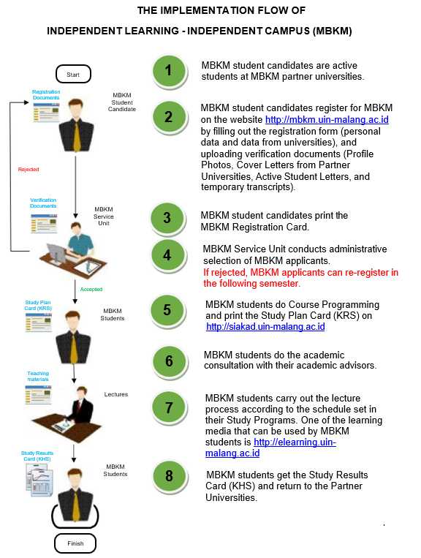

### Figure 6. The Implementation flow of MBKM

1. **Evaluation**

The aspects assessed in the Teaching Assistance activities include all the skills that students demonstrate throughout the program, up to the final examination. The evaluated aspects cover the observation process, guided practice, independent practice, and the final Teaching Assistance examination, using Evaluation and Assessment Instruments which are in line with the Teaching Assistance Learning Outcomes.

**D. RESEARCH PROGRAM**

### Definition and Objectives

The research program in the Independent Learning program applied at Maulana Malik Ibrahim State Islamic University Malang adheres to the principle of allowing students to choose research fields aligned with their academic interests. Students are expected to develop critical thinking skills and produce creative/innovative research. The university facilitates the study programs to collaborate extensively with research partners at both national and international levels. This research program can also serve as a final project required for earning a degree.

The research is conducted under the supervision of faculty members from the study program and mentors from partner institutions. Students have the right to propose research advisors and topics based on their academic interests. The implementation of the research program must adhere to SN-DIKTI regulations.

### The objectives of the research program are:

### To enhance the quality and research skills of students.

### To prepare a new generation of high-quality researchers.

### To provide quality research resources.

### Credits

The credits of the research program at UIN Maliki Malang are 20-22 credits (1-2 semesters) with conversion according to each study program as follows:

* 1. Final project: 6-8 credits
  2. Elective Courses related to the research theme: 8-10 credits
  3. Elective courses in/out of universities (research support): 4 credits

1. **Mechanism**

## HIGHER EDUCATION INSTITUTIONS

* 1. Allow students to conduct research/final projects according to their interests, both within the university and at research institutions/laboratories/centers.
  2. Facilitate the formation and development of research groups and Research Centers of Excellence under the Research Master Plan and Strategic Plan.
  3. Establish an agreement in the form of a cooperation document (MoU/SPK) with partners from research institutions/research laboratories/study centers.
  4. Develop guidelines for final projects (criteria/guidelines/standards that include research) and writing instructions.
  5. Grant students the right to participate in selection and evaluation processes for research programs at institutions/laboratories/study centers outside the campus.
  6. Through the study programs and faculties, appoint field supervisors based on students' research interests to provide guidance and oversight, and collaborate with researchers at institutions/laboratories/study centers to assess the students.
  7. Issue Decree Letters for supervisors.
  8. Faculty members, along with researchers, prepare logbook forms.
  9. Conduct final evaluations and equate research activities at institutions/laboratories to relevant credit courses (SKS) and ensure the continuity of the program.
  10. Develop technical guidelines for learning activities through research.
  11. Report learning outcomes to the Directorate General of Higher Education via the Higher Education Database.

## PARTNER INSTITUTIONS

* 1. Ensure that student research activities at the partner institution are conducted according to the agreement.
  2. Appoint a mentor to assist students in conducting their research.
  3. Collaborate with faculty advisors and supervisors from the higher education institution to evaluate and assess the research projects carried out by students.

## FIELD SUPERVISORS AND MENTOR

* 1. Guide students conducting research.
  2. Complete the research progress report form for students.
  3. Monitor research activities.
  4. Guide students to present their research findings at seminars/conferences.
  5. Determine the eligibility of students to participate in final seminar activities organized by the study program.

## STUDENTS

* 1. By the approval of the Academic Advisor (DPA), students register for the research program based on their field of interest through the MBKM portal at UIN Malang.
  2. If the research is conducted at a partner institution, students must bring a cover letter from the study program/faculty addressed to the partner institution.
  3. Obtain approval from the Research Supervisor, both from the study program and the partner institution.
  4. Conduct research according to scientific ethics and under the guidance of the supervisors from both the study program and the research institution/study center where the research is conducted.
  5. Complete the logbook according to the activities.
  6. Participate in national/international seminars.
  7. Prepare a research report or thesis according to the thesis writing format.
  8. Present the research findings at a seminar organized by the study program as part of the evaluation and assessment of the research activities.
  9. Student publications are collaborative results between students, program advisors, and partner mentors.

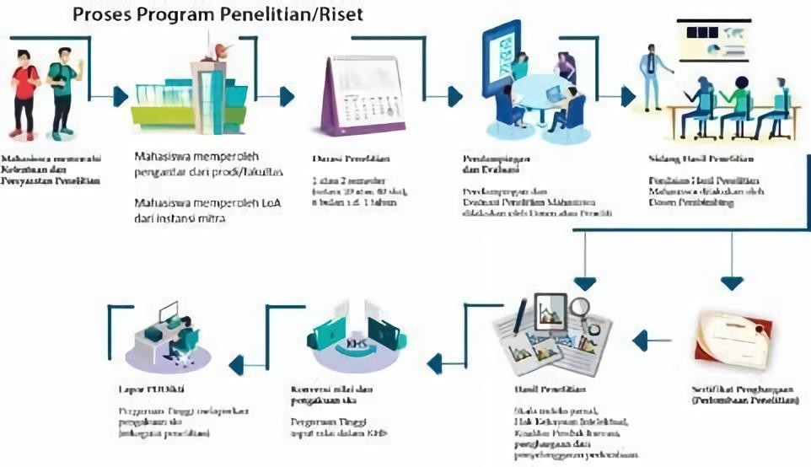

**Figure 7: Research Program Process**

**Figure 7. The Process of Research Program**

## HUMANITARIAN PROJECT

### Definition and Objectives

According to Law Number 1 of 2018, Humanitarian Activities are activities that alleviate the suffering of fellow human beings without distinguishing religion or belief, ethnicity, gender, social position, or other similar criteria.

Humanitarian aid refers to material and non-material assistance provided to people in need. This aid is typically temporary until it is replaced by long-term support from the government and other institutions. The people in need include the homeless, refugees, and victims of humanitarian crises such as natural disasters, war, and famine. The primary goals of humanitarian aid are to save lives, alleviate suffering, and uphold human dignity.

Humanitarian activities are usually conducted under the auspices of or in partnership with organizations that operate in the humanitarian sector, both internationally and nationally. International humanitarian organizations include UNESCO, UNICEF, WHO, UNOCHA, UNHCR, Action Against Hunger, AUMOHD, AmeriCares, CARE, Caritas, DARA, Doctors Without Borders, ECHO, Feed the Children, Humanitarian Accountability Partnership International, International Committee of the Red Cross, International Red Cross and Red Crescent Movement, International Rescue Committee, Islamic Relief, Jugend Eine Welt, LDS Humanitarian Services, Malteser International, Medair, Mercy Corps, Oxfam, Plan International, Salvation Army, Samaritan’s Purse, Save the Children USA, Shelter Centre, Skyrocket Light Project, World Concern, World Food Program, and World Vision International. National humanitarian organizations include PMI, BPBD, BNPB, etc.

Examples of humanitarian activities include:

* 1. Humanitarian projects aimed at combating the spread of infectious diseases (e.g., the COVID-19 pandemic).
  2. Poverty alleviation.
  3. Natural Disaster Mitigation.
  4. Addressing environmental impacts caused by waste.
  5. Conservation of marine environments, forests, rivers, etc.
  6. Assisting victims of war or inter-country conflicts, such as providing asylum to Rohingya refugees.
  7. Volunteering for humanitarian programs at organizations like PMI, BPBD, BNPB, UNESCO, UNICEF, WHO, UNOCHA, UNHCR, etc.
  8. Volunteering at elderly care homes and other institutions that support people with disabilities or those in need of assistance.

The objectives of humanitarian activities are described as follows:

* 1. Prepare outstanding students who uphold humanitarian values in performing their duties based on religion, morals, and ethics.
  2. Train students to develop social sensitivity to explore and address existing issues and contribute solutions according to their interests and expertise.

The requirements for participating in Humanitarian Projects include:

* Active students at UIN Malang from all study programs.
* In good health.
* Have a passion, interest, and ideas for humanitarian projects.
* Involve a supervising lecturer in the implementation.
* Willing to work hard and thoroughly, and adhere to health protocols.
* Willing to collaborate with a team and at the project site.

1. **Stages and Process**

The implementation of humanitarian projects involves all university stakeholders, including the University level, Faculty, Study Program, Faculty Members, and Students, as well as collaboration with Partner Institutions. Humanitarian project activities are carried out through the following stages:

* 1. Students choose and determine a humanitarian project in collaboration with an official humanitarian organization.
  2. Students prepare and submit a project proposal to the university through their study programs.
  3. Students conduct the humanitarian project according to the approved proposal.
  4. Faculty advisors and mentors from the partner institution evaluate the humanitarian project undertaken by the students, using established guidelines.
  5. Recognition, which involves acknowledging and rewarding the humanitarian activities completed by students by granting credits (SKS) or exemption from certain courses with a specified credit value. Recognition and conversion should adhere to the regulations of the university and/or study program.
  6. Inputting grades into the Academic Transcript and reporting to the Higher Education Database (PDDIKTI).

The stages of the humanitarian project activities can be seen in the following figure:

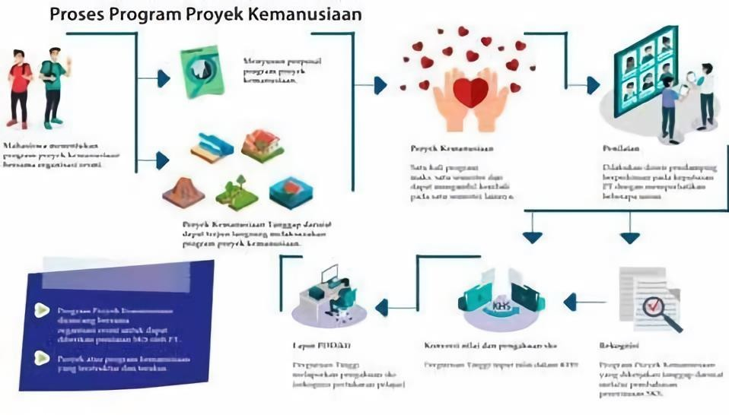

### Figure 8. Humanitarian Project Program stages and processes (Director General of Higher Education, 2020)

1. **Recruitment Requirements for Humanitarian Project Participants**
   1. Registered as an active student of UIN Maulana Malik Ibrahim Malang.
   2. Have a minimum GPA of 3.0.
   3. Passed a minimum of 90 credits in their current study program.
   4. Obtained a recommendation from the Academic Advisor and approval from the head of the study program.
   5. Signed a statement of willingness to participate in the program, which includes parental consent.

### Roles and Responsibilities

## Each unit in the university has specific roles and responsibilities to support the success of humanitarian activities, which include:

## HIGHER EDUCATION INSTITUTIONS

* 1. UIN Malang establishes agreements in the form of cooperation documents (MoU/SPK) with both domestic partners (e.g., local government, PMI, BPBD, BNPB, Ministry of Social Affairs) and international organizations (e.g., UNESCO, UNICEF, WHO, UNOCHA, UNHCR).
  2. Appoint field supervisors from faculty to provide guidance, supervision, assessment, and evaluation of the humanitarian projects conducted by students.
  3. Faculty, along with partner institutions, develop the logbook form.
  4. Conduct a final evaluation and align the student humanitarian project activities with relevant coursework (credits) and ensure the program is sustainable.
  5. Develop technical guidelines for learning activities through humanitarian projects.
  6. Report the outcomes of learning activities to the Directorate General of Higher Education through the Higher Education Data Base.

## STUDY PROGRAMS

* 1. Identify learning outcomes that align with the humanitarian project activities, which can be converted into credits (SKS).
  2. Identify courses that are relevant to the humanitarian project activities and can be converted into credits (SKS).
  3. Recommend field supervisors for the humanitarian projects.
  4. Collaborate with partner institutions and the relevant university departments (Vice Rector 1 and Vice Rector 4) through MoU.

## PARTNER INSTITUTIONS

* 1. Ensure that the humanitarian activities participated in by students adhere to the agreements specified in the cooperation documents (MoU/SPK).
  2. Ensure the rights and safety of students while they are involved in the humanitarian project.
  3. Appoint supervisors/mentors for the humanitarian projects.
  4. Conduct monitoring and evaluation of the activities, in collaboration with field supervisors from faculty.
  5. Assign grades to be recognized as credits (SKS) for the students.

## FIELD SUPERVISORS/LECTURERS

* 1. Provide guidance based on the tasks assigned by the Program Study Coordinator.
  2. Offer preparatory training for students involved in the humanitarian project.
  3. Monitor and evaluate the activities in collaboration with the partner institution.
  4. Assign grades for the activities to be recognized as credits (SKS) for the students.

## STUDENTS

* 1. By approval from the Academic Advisor (DPA), Program Study Coordinator, and parents, students are allowed to register for the humanitarian program.
  2. Conduct humanitarian project activities under the supervision of field supervisors from the faculty and field mentors.
  3. Complete the logbook.
  4. Prepare an activity report.
  5. Present the results of the humanitarian project at a seminar.

### Mechanism, Monitoring, Report, and Evaluation

1. **Mechanism**
   1. Humanitarian projects are carried out over one semester (8 hours/day for 113 days) or according to the agreement between the humanitarian partner and the field supervisor.
   2. The humanitarian project locations are determined based on cooperation agreements with humanitarian partner organizations.
   3. The field Supervisor and humanitarian partner institutions conduct monitoring and evaluation of activities.
   4. Students carry out the humanitarian project activities according to the submitted proposal and adhere to the guidelines set by UIN Malang.

### Monitoring

* 1. During the implementation of the humanitarian project, monitoring is conducted by field supervisors from the faculty and partner institutions at least 3 times.

### Monitoring and evaluation forms are completed by the partner institution, faculty, and students.

### Report

* 1. The report is prepared according to UIN Malang's guidelines and in agreement with the humanitarian partner.
  2. The report is written and requires approval from the field supervisor and the partner organization.
  3. The report is submitted to UIN Malang and the partner organization as accountability for the activity's implementation.
  4. The report is presented by students at a result seminar on the humanitarian project.

1. **Evaluation**

Evaluation is conducted by the field supervisors and the partner organization, based on UIN Malang’s guidelines and the humanitarian project logbook. The evaluation criteria include:

Criteria evaluated by the partner organization:

* 1. Attendance during the humanitarian project, including preparation, implementation, and evaluation (20%).
  2. Attitude, discipline, and responsibility in performing tasks (10%).
  3. Ability to complete the tasks (10%).
  4. Ability to collaborate and adapt to the environment (10%).
  5. Critical, innovative, and analytical thinking to contribute positively (10%).

Criteria evaluated by the field supervisor:

* + - 1. Ability to prepare the humanitarian project report (20%).
      2. Ability to present the results of the humanitarian project report (10%).
      3. Completeness of documentation (posters, images, and videos) (10%).

## ENTREPRENEURIAL ACTIVITIES

### Definition and Objectives

According to the Global Entrepreneurship Index (GEI) for 2018, Indonesia had only a 21% score for entrepreneurs across various sectors, ranking 94th out of 137 surveyed countries. However, research by the IDN Research Institute in 2019 found that 69.1% of millennials in Indonesia have an interest in entrepreneurship. Unfortunately, this entrepreneurial potential among millennials has not been effectively managed. The Independent Learning-Independent Campus policy aims to foster students' entrepreneurial interests by providing appropriate learning programs.

The objectives of the entrepreneurial activity program include:

* + 1. To provide students who have an interest in entrepreneurship the opportunity to develop their businesses early and guided.
    2. To address the issue of unemployment, particularly intellectual unemployment among graduates. The learning activities are in the form of entrepreneurship. The requirements are outlined in the academic guidelines issued by the university.

1. **Requirements**

## STUDENTS

* 1. Have a business idea relevant to their study program.
  2. Provide solutions related to the problems.
  3. Have an interest in learning how to run a business.
  4. Have capital ready or a strong desire to seek funding.

*Note: students must be in groups*

## ACADEMICS

* 1. Approval from the academic advisor (DPA),
  2. Students register for the entrepreneurial activity program.
  3. With the guidance of the incubation center or entrepreneurship supervisor/mentor, students develop an entrepreneurial activity proposal.
  4. Pass the assessment test, which includes a written and interview component.

*Notes:*

#### Procedures

* + 1. Assessment Test by Business Incubator
    2. Assessment Test prepared by:
       - Lecturers from the same study program as the students
       - Lecturer from outside the students' study program
       - Psychology lecturer
       - Practitioners from partner institutions or businessmen in a related sector

### Implementation of entrepreneurial activities

The mechanism for implementing the entrepreneurial activities is described as follows:

## HIGHER EDUCATION INSTITUTIONS

* 1. The student entrepreneurship program is designed at the higher education level, creating an entrepreneurship activity syllabus that can fulfill 20 credits per semester or 40 credits per year, taking into account the needs/uniqueness of each study program.
  2. The program can be a combination of several courses from various study programs offered by faculties within and outside the university, including courses/micro-credentials offered through online or offline learning.
  3. For assessing the entrepreneurship program, a rubric or criteria for measuring the success of learning outcomes can be developed. For example, if students successfully create a startup by the end of the program, they receive an A grade, weighted at 20/40 credits
  4. While participating in the entrepreneurship program, students are guided by a faculty advisor/field supervisor and mentored by successful entrepreneurship experts or businesspeople.
  5. Universities with incubation centers are expected to integrate this program with the center. Those without one can collaborate with business incubation and acceleration centers.
  6. Universities collaborate with partner institutions to provide an integrated entrepreneurship learning system with hands-on practice. This learning system can include facilitating training, mentoring, and guidance from mentors/business practitioners.
  7. Develop technical guidelines for learning activities through entrepreneurship.

## STUDENTS

* 1. With the approval of the academic advisor (DPA), students register for an entrepreneurial activity program.
  2. Under the guidance of the incubation center or entrepreneurship lecturers/mentors, students develop a proposal for entrepreneurial activities.
  3. Students carry out entrepreneurial activities under the guidance of an entrepreneurial supervisor or mentor.
  4. Students present the results of entrepreneurial activities and submit reports in the form of presentations.

## FIELD SUPERVISORS/LECTURERS

* 1. Lecturers from the original study program and lecturers outside the study program
  2. Mentoring students who take up entrepreneurship programs

## SEMESTER CREDIT UNIT RECOGNITION

* 1. One-semester credit unit (SKS) is equivalent to 2,720 (two thousand seven hundred twenty) minutes of student activity in carrying out their entrepreneurship project.
  2. The evaluation is entrusted to the study program. The evaluation can be conducted by the supervising lecturer, considering the outcomes of the entrepreneurship project undertaken by the student (such as profit, social benefits, number of employees, amount of capital, market reach, etc.), or through product exhibitions/displays. Competitions are not mandatory, and the process should align with the written documentation.

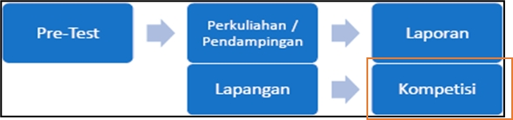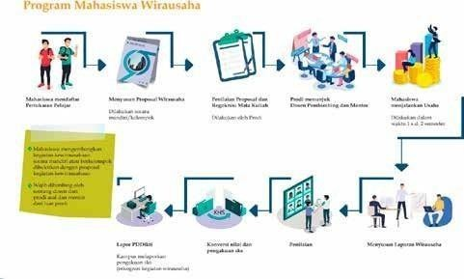

**Figure 9. Example of Communication Science Study Program if participating in Entrepreneurial Activities**

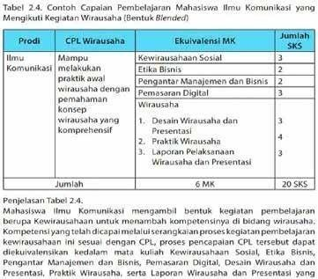

**Figure 10. Example of Communication Science Study Program if participating in Entrepreneurial Activities**

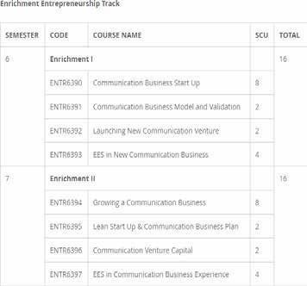

**Figure 11: Example of Entrepreneurial Activity Enrichment Course**

1. **Mechanism, Monitoring, Reporting and Evaluation**

The entrepreneurship curriculum is described as follows.

### Cognitive Entrepreneurship

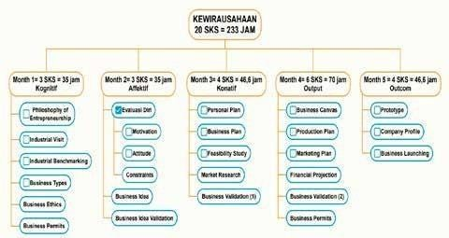

**Figure 12: Credit Chart of Entrepreneurship Curriculum**

### An initial introduction to the field of entrepreneurship, covering foundational cognitive knowledge to serve as the basis of the subject.

### Curriculum

This month, students will engage in the following activities.

* + 1. Philosophy of Entrepreneurship
    2. Industrial Visit
    3. Industrial Benchmarking
    4. Business Varieties
    5. Business Ethics
    6. Business permit knowledge

### Assessment Test

At this stage, the test will be conducted in the following form.

* + 1. Written test
    2. Essay
    3. Report presentation

### Assessment Rubric

Students are expected to master the following aspects.

* + 1. Definition of the theory.
    2. Provide examples related to the theory.

|  |  |  |  |  |
| --- | --- | --- | --- | --- |
| Mastery Level | Grade | | | Grade point |
| 86 - 100 | A | | | 4 |
| 81 - 85 | A- | | | 3,7 |
| 76 - 80 | B+ | | | 3,3 |
| 71 - 75 | B | | | 3,0 |
| 66 - 70 | B- | | | 2,7 |
| 61 - 65 | C+ | | | 2,3 |
| Mastery Level | | Grade | Grade point | |
| 56 - 60 | | C | 2,0 | |
| 51 - 55 | | C- | 1,7 | |
| 46 - 50 | | D | 1 | |
| 0 - 45 | | E | 0 | |

### Affective Entrepreneurship

### This stage focuses on understanding each student's personality in approaching entrepreneurship. Since entrepreneurship requires perseverance and quick thinking in facing challenges, students are expected to evaluate themselves to determine if they are suited for running a business.

### Curriculum

In the second month, students will undertake the following activities.

* + 1. Self-evaluation
       - Motivation
       - Attitude
       - Personal SWOT Analysis
    2. Business Idea
    3. Business Idea Validation

### Assessment Test

At this stage, the tests will be conducted in the following formats:

* + 1. Interview with supervisor.
    2. Business idea presentation.
    3. Essay report.

### Assessment Rubric

Students are expected to master the following aspects.

* + 1. Definition of the theory.
    2. Passed the interview with an expected score.

|  |  |  |
| --- | --- | --- |
| Mastery Level | Grade | Grade point |
| 86 - 100 | A | 4 |
| 81 - 85 | A- | 3,7 |
| 76 - 80 | B+ | 3,3 |
| 71 - 75 | B | 3,0 |
| 66 - 70 | B- | 2,7 |
| 61 - 65 | C+ | 2,3 |
| 56 - 60 | C | 2,0 |
| 51 - 55 | C- | 1,7 |
| 46 - 50 | D | 1 |
| 0 - 45 | E | 0 |
|  |  |  |

1. **Conative entrepreneurship**

### This stage is the third month of the entrepreneurship activities, focusing on behavior in running an initial business.

### Curriculum

At this stage, students will do the following activities:

* 1. Personal Plan
  2. Feasibility Study
  3. Market Research
  4. Business Plan
  5. Business Validation 1

### Assessment Test

At this stage, the tests will be conducted in the following formats:

* 1. Personal Plan Report
  2. Feasibility Study Report
  3. Market Research Report
  4. Business Plan Report
  5. Business Validation 1 Report
  6. Presentation

### Assessment Rubric

Students are expected to have the above reports and presentations to serve as a reference for further business development.

|  |  |  |
| --- | --- | --- |
| Mastery Level | Grade | Grade point |
| 86 - 100 | A | 4 |
| 81 - 85 | A- | 3,7 |
| 76 - 80 | B+ | 3,3 |
| 71 - 75 | B | 3,0 |
| 66 - 70 | B- | 2,7 |
| 61 - 65 | C+ | 2,3 |
| 56 - 60 | C | 2,0 |
| 51 - 55 | C- | 1,7 |
| 46 - 50 | D | 1 |
| 0 - 45 | E | 0 |

### Entrepreneurship Output

This stage will be an intense process as students will create a comprehensive and detailed plan for their business. It will cover planning aspects such as general operations, production, finance, and marketing.

### Curriculum

At this stage, students will carry out the following activities:

* + 1. Business Canvas
    2. Production Plan
    3. Financial Projection
    4. Marketing Plan
    5. Business Permit
    6. Business Validation 2

### Assessment Test

At this stage, the test will be conducted in the following formats:

* + 1. Business Canvas Report
    2. Production Plan Report
    3. Financial Projection report
    4. Marketing Report
    5. Business Permit Report
    6. Business Validation 2 Report
    7. Presentation

### Assessment Rubric

Students are expected to have the above reports and presentations to serve as a reference for further business development.

|  |  |  |
| --- | --- | --- |
| Mastery Level | Grade | Grade point |
| 86 - 100 | A | 4 |
| 81 - 85 | A- | 3,7 |
| 76 - 80 | B+ | 3,3 |
| 71 - 75 | B | 3,0 |
| 66 - 70 | B- | 2,7 |
| 61 - 65 | C+ | 2,3 |
| 56 - 60 | C | 2,0 |
| 51 - 55 | C- | 1,7 |
| 46 - 50 | D | 1 |
| 0 - 45 | E | 0 |

### Entrepreneurship Outcome

### This final stage will be a demonstration of whether students' businesses can attract the market or investors. The public will be able to see their work firsthand and try the prototypes they have developed.

### Curriculum

At this stage, students will carry out the following activities:

* + 1. Product/Service Prototype
    2. Company Profile
    3. Business Launching

### Assessment Test

At this stage, the test will be conducted in the following formats:

* + 1. Prototype Report and Presentation
    2. Company Profile Report and Presentation
    3. Business Launching Report and Presentation

### Assessment Rubric

Students are expected to have the aforementioned reports and presentations to serve as a reference for further business development.

|  |  |  |
| --- | --- | --- |
| Mastery Level | Grade | Grade point |
| 86 - 100 | A | 4 |
| 81 - 85 | A- | 3,7 |
| 76 - 80 | B+ | 3,3 |
| 71 - 75 | B | 3,0 |
| 66 - 70 | B- | 2,7 |
| 61 - 65 | C+ | 2,3 |
| 56 - 60 | C | 2,0 |
| 51 - 55 | C- | 1,7 |
| 46 - 50 | D | 1 |
| 0 - 45 | E | 0 |

### Independent Study/Project

1. **Definition**

Independent Study/Project in the Independent Learning by the Ministry of Education and Culture is student collaboration to develop a project based on a special social topic. This project is conducted together with other students within or across study programs, guided by a lecturer or instructor. The Independent Study/Project activities are carried out in the form of interdisciplinary group work to solve specific social problems.

Independent Study/Project can be a complement or substitute for courses that need to be taken. The equivalence of independent study activities into courses is calculated based on the contribution and role of students as evidenced in activities under the coordination of the field supervisor.

Project-Based Learning (PBL) is an educational approach where learning begins with planning, implementation, evaluation of results, and presentation of learning outcomes. This learning model provides students the opportunity to engage in project work.

Project-Based Learning is a method that uses problems as the starting point for gathering and integrating new knowledge based on students' real-world experiences. It is designed to address complex problems that require students to conduct investigations and gain understanding. Course subjects (materials) will be taught to students.

Project-Based Learning is a teaching method that uses projects as a medium. Students engage in exploration, assessment, interpretation, synthesis, and information analysis to produce various project outcomes to address specific social issues/topics. The main steps of Project-Based Learning are described as follows.

* 1. Determining essential questions.
  2. Designing project plan.
  3. Creating a schedule.
  4. Monitoring
  5. Assessing the outcome
  6. Evaluating the experience

Independent Study/Project-Based Learning integrates knowledge from science, technology, society, history, mathematics, and politics, along with productive discussion opportunities for students. It encourages student-directed investigations to solve real-world problems, fostering enthusiasm and a passion for learning, making education more effective.

The advantages obtained from choosing the "Independent Learning” curriculum in Independent Study/Project-Based Learning activities include improved learning outcomes, increased student activity and engagement, enhanced creativity and student work, and making learning more enjoyable, useful, and meaningful. The implementation of project-based learning is effective in enhancing independence, teamwork, and technical skills (psychomotor/practical activities).

### Objectives

The objectives of the Independent Study/Project program include:

* 1. Realizing students' ideas in developing innovative products based on their concepts.
  2. Implementing research and development (R&D)-based education, projects, boot camps, and MOOCs.
  3. Enhancing student achievements in national and international competitions.

### Requirements

The criteria for Independent Study/Project that can be equated into courses and receive credit recognition are described as follows:

* 1. The Independent Study/Project starts at the university level with the selection and appointment of a field supervisor or partner institution, following procedures established by the university committee.
  2. The team consists of at least two different study programs with a minimum of five students.
  3. Activities like competitions, exhibitions, performances, and other events are organized by credible institutions relevant to those activities.
  4. Students participating in the Independent Study/Project must attend training programs or similar activities for a specified duration to prepare for the study/project. The proof of attendance can be provided by a certificate from the organizer; Thus, the students must leave regular classes during this time.
  5. If no specific training program is provided, students preparing independently must obtain a certificate from the supervisor of the Independent Study/Project, authorized by the study program and faculty.
  6. Students must acquire a certificate from the activity organizing committee confirming their participation, which requires them to leave regular classes for a specified period (1-2 semesters).
  7. The competencies involved in competitions must be relevant to the competencies of the study program.
  8. The scale of activity and its benefits to social issues in the community should be considered.
  9. The duration of the activity is based on the time needed for the preparation and implementation process, which may prevent students from meeting minimum class attendance requirements in the ongoing semester.
  10. The study program and faculty must verify that the activities are eligible to be equated to credits in courses within the curriculum structure, whether as compulsory or elective courses.

### Implementation Flow

The implementation flow of Independent Study/Project activities is described as follows:

* 1. The university assembles a team of supervising lecturers or partner institutions with relevant expertise to guide the student teams' independent projects.
  2. Students are encouraged to form project teams that include members from various academic disciplines.
  3. The university evaluates the feasibility and criteria of the proposed projects to ensure they meet the necessary standards.
  4. Students receive ongoing guidance, mentoring, and training throughout their independent project process.
  5. The completed projects are evaluated and may be converted into academic credits, equating them to relevant courses.
  6. Students obtain approval from the Academic Advisor (DPA).
  7. Students prepare a proposal for their cross-disciplinary Independent Study.
  8. Students carry out the Independent Study activities.
  9. The projects may result in tangible products, participation in national or international competitions, or contributions to intellectual property, publications, conferences, or books.
  10. Students prepare a report of their activities and present their findings through a formal presentation.

The implementation process of Independent Study/Project activities can be seen in the following figure:

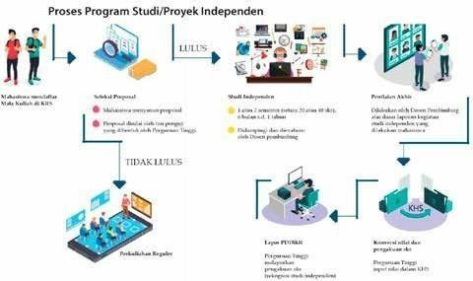

**Figure 13: Independent Study/Project Process**

1. **Implementation, Monitoring, Reporting and Evaluation**

The Independent Study/Project activities that can be converted into academic credits (SKS) in the study program should align with the following provisions:

* 1. All Independent Study/Project activities carried out by students, regardless of their direct relation to the student's study program field, are eligible for credit as long as they produce demonstrable outputs.
  2. The credit equivalence is based on the scale and duration of the activities that students are required to participate in. The specific details are provided in Table 1.
  3. A team, established by the study program and approved by the faculty, conducts the equivalence process to ensure that activities meet the necessary academic standards.
  4. The criteria and guidelines for converting these activities into credits (SKS) are detailed in Table 1.

Table 1. Credit Equivalence for Independent Study/Project Activities Related to the Study Program

|  |  |  |  |  |  |  |  |
| --- | --- | --- | --- | --- | --- | --- | --- |
| **No** | **Field of Activities** | **The activity (Allied/No)** | **Scale** | **Stage** | **Minimum duration (activity hours)** | **Course Equalization** | **Credits** |
| 1 | Interests and talents | Allied | National | Preparation |  |  |  |
| 2 | Interests and talents | No | National | Competition |  |  |  |
| 3 | Special Interests |  | International | Preparation |  |  |  |
| 4 | Interests and talents |  | International | Competition |  |  |  |
| 5 | Sports |  |  |  |  |  |  |
|  | Etc. |  |  |  |  |  |  |

The credit equalization process can be calculated by referring to the following calculation:

V1 = Credibility of the organizer

V2 = Achievement scale

v3 = Achievement Level

v4 = Relevance

v5 = Duration (activity hours)

The score guidelines of each variable are described as follows.

Table 2. Credibility and Legitimacy of the Activity Organizer (v1)

|  |  |  |
| --- | --- | --- |
| **No** | **Description** | **Score** |
| 1 | Relevant ministry | 5 |
| 2 | Internationally reputed field association (for international competitions) | 4 |
| 3 | Nationally reputed field association (for national competitions) | 4 |
| 4 | Local organization (university or local association) with approval from the ministry or reputed field association (evidenced by an official stamp on the certificate) | 3 |
| 5 | Local organization (university or local association) without approval from the ministry or reputed field association (evidenced by an official stamp on the certificate) | 2 |
| 6 | Student organization | 1 |

Table 3. Achievement Scale (v2)

|  |  |
| --- | --- |
| **No Description** | **Score** |
| 1 International tiered | 5 |
| 2 Non-tiered international | 4 |
| 3 National Tiered | 3 |
| 4 National not tiered | 2 |

Table 4. Achievement Level (v3)

|  |  |  |  |
| --- | --- | --- | --- |
| **No** | **Description** |  | **Score** |
| 1 | 1st place |  | 5 |
| 2 | 2nd place |  | 4 |
| 3 | 3rd place |  | 3 |

Table 5. Relevance of achievements to the scientific field of the intended study program referring to *Permendikbud* 124/2014 (v4)

|  |  |  |
| --- | --- | --- |
| **No** | **Description** | **Score** |
| 1 | Align with the field of study | 5 |
| 2 | Align with the branch of study | 4 |
| 3 | Align with the area of study | 3 |
| 4 | Align with the group of study | 2 |
| 5 | Not Aligned | 1 |

### Village Development/Thematic Community Service Program

1. **Definition**

Village Development/Thematic Community Service Program (KKNT) is a form of education that provides students with learning experiences to live in a community outside the campus. By working with the community, students identify potential and address issues, which is expected to develop the potential of the village/area and offer solutions to existing problems. KKNT activities are also expected to hone students' soft skills in partnership, interdisciplinary teamwork (cross-competence), and leadership in managing development programs in rural areas.

Universities have been running the KKNT program, but it has not yet been formally recognized in terms of Semester Credit Units (SKS) under the independent campus program. Ideally, this recognition would allow the KKNT to equate to 6-12 months or 20-40 SKS, depending on the specific implementation models used. After students complete the KKNT, they are expected to document their experiences and the results of their activities in a final project.

The implementation of KKNT is conducted to support collaboration with the Ministry of Villages, Development of Disadvantaged Regions, and Transmigration (PDTT) and other ministries/stakeholders. The government, through the Ministry of Villages PDTT, distributes village funds amounting to 1 billion rupiah per village to 74,957 villages in Indonesia. According to the Village Development Index (IDM) data from 2019, there are 6,549 highly underdeveloped villages and 20,128 underdeveloped villages.

The KKNT can be conducted in highly disadvantaged, disadvantaged, and developing villages where human resources lack planning capabilities for development with these funds. Therefore, the effectiveness of using village funds to drive economic growth still needs to be improved, one way through students who can serve as human resources to help empower village funds.

The theme of Village Development programs includes the following partners:

* + 1. Supported Villages

KKNT in Supported Villages is a program/activity where students work with the community/partners to develop the village according to their field of study. Students can explore the potential of the supported village to develop it further, benefiting the community/partners and assisting the government in creating self-sufficient villages.

* + 1. Village Cooperatives

KKNT in Village Cooperatives involves students working with the community/partners to establish cooperatives in the village to meet community needs. These cooperatives serve as a platform for developing various economic activities, including the distribution of production tools and marketing of goods produced by and for the community.

* + 1. Early Childhood Education (PAUD)

KKNT in Early Childhood Education (PAUD) is a program/activity where students collaborate with the community/partners to establish PAUD institutions aimed at supporting the growth and development of young children, preparing them for further education.

* + 1. Village Granaries

KKNT in Village Granaries is a program/activity where students work with the community/partners to create storage spaces for staple foods. These granaries are intended for use during emergencies, food shortages, or periods of low agricultural output to ensure the community's survival.

* + 1. Community Product Marketing

KKNT in Community Product Marketing involves students working with the community to support, develop, or enhance marketing strategies for products produced by the community/partners.

1. **Objectives**
   1. The presence of students for 6-12 months allows them to apply their knowledge, technology, and skills while collaborating with various stakeholders in the field.
   2. To help accelerate development in rural areas in collaboration with the Ministry of Villages PDTT.
2. **Significance**
   * 1. **STUDENTS**
        1. Enable students to recognize the potential of villages, identify problems, and find solutions to enhance potential and achieve self-sufficiency.
        2. Equip students to collaborate in drafting and creating the Village Medium-Term Development Plan (RPJMDes), Village Development Activity Plan (RKPDes), and other strategic village programs with Supervising Lecturers, Village Government, Community Self-Reliance Activists (PSM), Village Empowerment Cadres (KPMD), local village facilitators, and community members.
        3. Allow students to apply their knowledge collaboratively with the Village Government and community members to build the village.
        4. Enable students to utilize their knowledge, technology, and skills in their preferred field of practice.
     2. **UNIVERSITIES**
   1. Provide feedback to universities on the knowledge and technology that are needed by the community.
   2. Serve as a means for universities to establish networks or strategic partnerships to assist in village development.
   3. Support the development of the university's tri dharma (education, research, and community service).
   4. Offer a platform for faculty members to advance their knowledge and expertise.

## VILLAGES

* + - 1. Receive intellectual and manpower support from educated individuals to develop the Village Medium-Term Development Plan (RPJMDes) and Village Development Activity Plan (RKPDes).
      2. Assist in improving village governance.
      3. Encourage the development of young professionals needed for community empowerment.
      4. Enhance community awareness regarding village development.
      5. Accelerate development in rural areas.

### Requirements

In addition to the general requirements for participating in the Independent Learning- Independent Campus policy, students should meet the following additional requirements to participate in the KKNT program:

* 1. Students have completed the learning process after semester 4 (Four).
  2. Conducted in groups, with ± 10 members per group and or according to the needs of the village, and multidisciplinary (from different study programs/faculties/cluster).
  3. Participants must live in the community or must "live in" at the designated location.
  4. Physically and mentally healthy and not pregnant for women.
  5. Minimum GPA of 3.00up to semester 4 (four).
  6. Other provisions can be regulated by the implementing universities.
  7. Relevant activities include Community Service Program (KKN), Management of Village-Owned Enterprises (BUMDes), and Eco-village Development.

### Implementation Flow

## UNIVERSITIES

The flow for implementing the village development/Community Service Program (KKNT) activities is as follows:

* 1. Establish partnerships with the Ministry of Villages PDTT and the Ministry of Education and Culture, or directly with local government for program implementation in villages.
  2. Manage student registration and placement in target villages.
  3. Assign supervising lecturers to guide students on the KKNT program.
  4. If possible, the supervising lecturer visits the KKNT site for monitoring and evaluation.
  5. Departing and returning students from campus to the program sites.
  6. Provide debriefing and health checks, and ensure health and safety coverage for KKNT participants.
  7. Develop Standard Operating Procedures (SOPs) for KKNT implementation, ensuring student safety and security in KKNT sites.
  8. Provide training on local community wisdom and ethical behavior during KKNT activities.
  9. Report the outcomes of KKNT activities to the Directorate General of Higher Education.

## STUDENTS

* 1. Students are required to live in the designated location.
  2. If, during the implementation process, students do not meet the 20 SKS equivalency, they may be allowed to take additional measures.
  3. The process and results of the activities must be documented and reported to the university.
  4. The results of the activities can be equated to a thesis or final project according to university regulations.

1. **SUPERVISING LECTURERS AND LOCAL SUPERVISORS**
   1. Supervising lecturers from universities are responsible for student activities throughout the program.
   2. Local supervisors are from the village government at the project site.
   3. Involve relevant partners, such as Village Development Facilitators (PSM) and other stakeholders.
   4. The supervising lecturer, along with the local supervisors, will guide and evaluate the student’s program.
   5. Other provisions are regulated by the implementing university (UIN Maulana Malik Ibrahim Malang).

## LOCATION

* 1. The locations are based on recommendations from the Rector.
  2. The sites include very underdeveloped, underdeveloped, and developing villages.
  3. The villages are part of the university's development program.
  4. The KKNT location should be within a 200 km radius of the university.
  5. Other villages proposed by partners (local government, industry, and others).

## PARTNERS

* 1. Government agencies (Ministry of Villages, university-supported villages, Ministry of Health, Ministry of Public Works and Housing, Ministry of Agriculture, Ministry of Social Affairs, Ministry of Environment and Forestry, Ministry of Home Affairs, Ministry of Foreign Affairs, military, police, and other institutions).
  2. Local government.
  3. State-owned enterprises and industry.
  4. Social investment organizations.
  5. Community groups (migrants and diaspora).

## SAFETY AND SECURITY OF STUDENTS (SPECIAL CONDITIONS)

* 1. Students with illnesses or special needs that prevent them from participating in activities should report their condition to the KKNT program administrators at the implementing university, supported by a certificate from an authorized party. This will allow for adjustments in placement location based on distance and accessibility.
  2. The universities develop Standard Operating Procedures (SOP) for KKNT implementation, ensuring the safety and security of students.
  3. The universities provide training on local community wisdom and ethical behavior during KKNT activities.

## FUNDING

1. Funding Source
   1. The university
   2. Partners.
   3. Other non-binding sources.
   4. Student.
2. Fund Usage Component
   1. Transportation.
   2. Living expenses.
   3. Accident and health insurance.
   4. Program costs.
   5. Other incidental expenses related to program implementation.
   6. Further details on funding components will be outlined according to the regulations of the implementing university.

**Figure 14. KKNT flow**

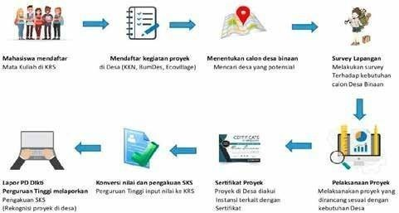

1. **Implementation, Monitoring, Reporting, and Evaluation**
2. **KKNT Implementation Model**

There are several models in the implementation of the KKNT, as follows:

* 1. Extended KKNT Model

In this model, the university develops a competency package for students participating in regular KKNT activities. Students can apply for an extension of up to 1 semester or 20 SKS credits. For the extended KKNT program, students can use the Holistic Village Development and Empowerment Program (PHP2D) by following the Directorate of Belmawa’s procedures. Extended KKNT activities might include community empowerment projects and research for students' final projects.

Figure 15. Example of an Extended KKNT Model

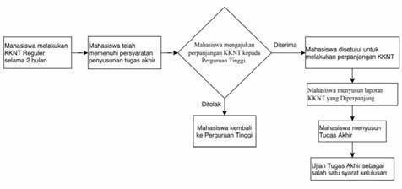

(Source: Independent Learning-Independent Campus Guidebook (2020)

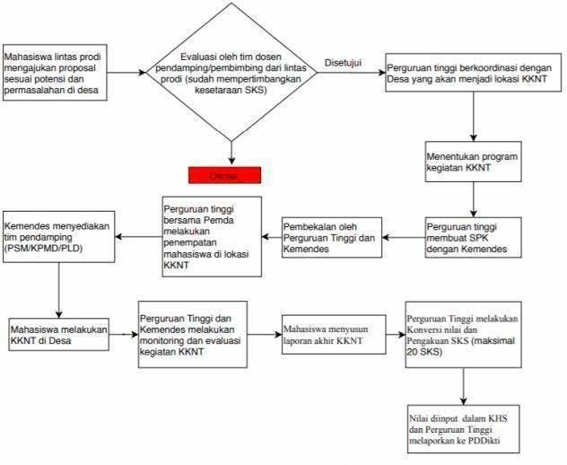

Figure 16. Example of KKNT Model of Development and Empowerment with Partners (Source: Independent Learning-Independent Campus Guidebook (2020))

* 1. KKNT Model of Village Development and Empowerment

In this model, universities collaborate with partners to conduct KKNT programs focused on Village Development and Empowerment based on the opportunities and conditions of the village. They create competency packages or develop the RPJMDes that students will work on during the KKNT. The number of students and their fields of study are adjusted to meet the program's needs in the village. The KKNT program lasts between 6 to 12 months at the location or is equivalent to a maximum of 20 SKS. Achievements equivalent to 20 SKS can be credited to various relevant courses aligned with the learning outcomes. Evaluation of learning achievements is done through reports and portfolio exams/rubric activities related to the KKNT. To ensure alignment with the learning outcomes, a proposal or activity plan representing the field of expertise must be prepared. Field supervisors should represent the study programs of final-semester courses from each program. Students can also utilize the Holistic Village Development and Empowerment Program (PHP2D) by following the procedures from the Directorate of Belmawa.

* 1. KKNT Teaching in Villages Model

This model primarily targets students from education programs. Students from other programs can also engage in teaching activities relevant to their fields of expertise, such as the application of appropriate technology, for community empowerment. All KKNT teaching activities aim to support both formal and non-formal education. If the outcomes of these activities are intended to be used as final projects, they must be planned from the beginning in the form of a proposal that adheres to the program's regulations.

Figure 17. Example of KKNT Model Teaching in the Village

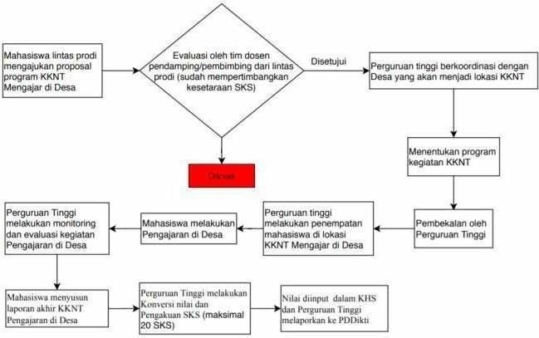

(Source: Independent Learning-Independent Campus Guidebook (2020))

* 1. KKNT Free Form Model

Students are allowed to determine and carry out the form of the KKNT program that will be implemented with partners. When developing this model, students must consider the relevant curriculum and consult with their Academic Advisors.

Figure 18. Example of KKNT Free FormModel

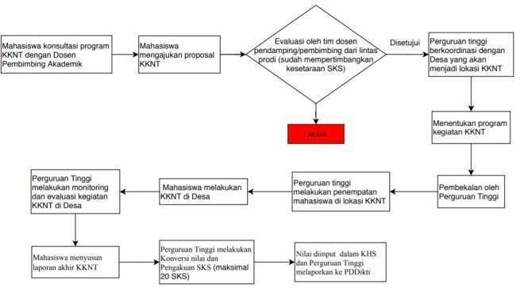

(Source: Independent Learning-Independent Campus Guidebook (2020))

### Implementation

The KKNT program is carried out over 6 to 12 months and is equivalent to 20 SKS. During this period, students live at the KKNT location. They apply their knowledge and dedicate themselves according to their fields of study. All student activities during KKNT should align with the goal of village development.

The implementation steps include:

* 1. After forming a group and obtaining a field supervisor, the students conduct a preliminary field survey to identify possible programs for the village. They can coordinate with the village head or other stakeholders involved in village development.
  2. The results of the field survey are discussed with the field supervisor to determine feasible programs for the KKNT.
  3. The programs are tailored to the abilities and expertise of the student groups from various study programs.
  4. The developed programs should be consulted with or informed to the village head where the KKNT will be conducted to ensure synchronization.
  5. Once the programs are well-prepared, the student groups wait for the departure time to start the KKNT.
  6. During the KKNT, the students should uphold their personal and institutional reputation by avoiding activities that disrupt local customs, engage in unethical behavior, or cause similar issues.

### Monitoring

Monitoring is crucial to track the progress of the KKNT implementation in the village. Over the 6 to 12-month period, monitoring should be conducted periodically, approximately every 3 months. There could be up to 4 monitoring sessions including at the beginning, at the end, and two additional sessions in the ongoing program.

### Report

The report on village development/KKNT activities should follow general reporting guidelines and be prepared in a manuscript format that includes the following elements:

* 1. Background/Situation Analysis.
  2. Problems Identified.
  3. Alternative Programs to Address Issues.
  4. Results of the Village Development/KKNT Activities.
  5. Discussion of the Results of the Village Development/KKNT Activities.
  6. Conclusions, Suggestions, and Recommendations.
  7. For students using the report as a final project, it should be adjusted to the thesis writing format.

### Evaluation

Evaluation is essential to determine the success of students participating in village development/KKNT activities. The evaluation can only be given by the supervisor if:

* 1. The activity report is prepared in manuscript form.
  2. A certificate from the activity location or village is included, verifying that the student has carried out the village development/KKNT activities. This certificate should be signed by the village head and include an official stamp. If possible, research findings should be published or used as part of the final project.
  3. The student presents their work within their study program.
  4. The assessment is given by the supervisor following a predetermined format.
  5. The activities are shared on social media.

## RELIGIOUS MODERATION

### Concept

Religious Moderation is an approach, attitude, and practice of religion in communal life that embodies the core principles of religious teachings—upholding human dignity and promoting public welfare—while adhering to justice, balance, and constitutional agreements. It includes several indicators, such as commitment to nationality, tolerance, anti-violence, and respect for tradition. Key terms to focus on in religious moderation are humanity, public welfare, justice, balance, adherence to the constitution, national commitment, tolerance, anti-violence, and respect for tradition.

Religious moderation aims to strengthen national commitment while promoting a balanced understanding and practice of religion in community life. It serves as a bridge between religious enthusiasm and national allegiance, striving for a harmonious, peaceful, and tolerant society. This concept extends beyond mere national commitment and defense.

To implement religious moderation, various strategies can be employed, including education and teaching, research, and community service. Programs can be designed in different formats such as educational modules, training for moderation agents, research initiatives, mentoring, etc.

### Requirements

* + 1. **General Requirements**
       1. Active student and registered in PD-Dikti;
       2. Obtain approval from the Academic Advisor (DPA) and/or Head/Coordinator of the Study Program;
       3. Have taken at least four semesters;

### Mechanism

The religious moderation program can be conducted individually or in groups, through structured activities such as training, social work, and other relevant activities. Religious higher education institutions collaborate with both government and private organizations. For this program, study programs define both hard skills and soft skills to represent the learning outcomes, with a maximum credit of 20 credits. In addition to course credits, participants may also receive a competency certificate.

The general procedure for implementing the religious moderation program is described as follows:

* 1. The students consult with their study program and academic advisors.
  2. The students register for the religious moderation program.
  3. The study program verifies and selects participants who meet the requirements.
  4. The students participate in the religious moderation program.
  5. The students prepare and present a report on their activities.
  6. The study program converts or credits the learning outcomes achieved by the students as semester credits.
  7. The study program reports the results of the student's participation in the religious moderation program on the Higher Education Database (PD-DIKTI).

**4. Roles and Responsibilities**

The religious moderation program involves several institutions both on and off campus. This explanation outlines the roles and responsibilities of the higher education institution and the organizations where students participate in the program.

**a. Higher Education Institutions**

1) Collaborate with training centers, correctional institutions, the National Counterterrorism Agency (BNPT), police, Interfaith Harmony Forums (FKUB), community organizations, Islamic boarding schools, educational institutions, ministry/agency work units, local governments, and other institutions relevant to the implementation of the religious moderation program.

2) Provide opportunities for students to participate in the religious moderation program through registration and selection.

3) Assign field supervisors to provide guidance, monitoring, and evaluation of the religious moderation activities conducted by students.

4) Facilitate students' administrative needs, such as permission letters, assignment letters, and others.

5) Standardize/recognize religious moderation activity hours to be acknowledged as credits.

6) Report the results of the religious moderation activities to the Higher Education Database (PD-DIKTI) under the provisions.

**b. Partner Institutions**

1) Ensure that the religious moderation activities participated in by students comply with the agreement outlined in the cooperation contract.

2) Appoint a team to assist students in conducting religious moderation activities within their institution.

3) Collaborate with field supervisors to monitor and evaluate the activities participated in by students.

4) Provide grades that can be recognized as academic credits for students.

**6. Output and Credit Recognition**

The main output of this religious moderation program is a converted score from a comprehensive student performance assessment. the output can also include a competency or professional certificate and recognition on the Diploma Supplement (SKPI). Students who have completed the religious moderation program have their semester credits recognized as a form of credit transfer to fulfill the semester credit requirements for their undergraduate program as outlined in the curriculum of the study program. The recognition of semester credits is based on the relevance and equivalence of learning outcomes and the credit value achieved by students during the religious moderation program.

The assessment can be conducted by the faculty advisor based on the evaluation provided by the accompanying team or trainer. Credit recognition is based on hard skills and soft skills as a representation of learning outcomes established for a maximum of 20 credits from religious moderation activities. Credit recognition can also be granted to students participating in activities that include religious moderation content and are converted according to the fulfillment of religious moderation indicators.

The authority for determining grade conversion and credit recognition lies with the head or coordinator of the study program. For setting guidelines on conversion and credit recognition, the institution may form a conversion team involving the Vice Dean I, the Head and Secretary of the Department, the Head/Coordinator of the program, relevant partner units/institutions, and faculty members.

The example of religious moderation credit recognition is presented as follows:

**Table 19**. Example 1 of Religious Moderation Credit Recognition

|  |  |  |
| --- | --- | --- |
| **CLO of Religious Moderation** | **Course Equivalency** | **Credits** |
| Students have awareness, understanding, and the ability to implement religious moderation through national commitment, tolerance, anti-violence, and respect for tradition. | Humanity | 3 |
| Equality | 2 |
| Justice | 2 |
| Balance | 2 |
| Legal Obedience | 2 |
| Love of the Motherland | 3 |
| Tolerance | 2 |
| Openness (Inclusive) | 2 |
| Respect for Local Traditions | 2 |
| **Total** | | **20** |

**Table 20**. Example 2 of Religious Moderation Credit Recognition

|  |  |  |
| --- | --- | --- |
| **CLO of Religious Moderation** | **Course Equivalency** | **Credits** |
| Students have awareness, understanding, and the ability to implement religious moderation through national commitment, tolerance, anti-violence, and respect for tradition. | **Hard skills:** |  |
| Formulate a program | 4 |
| Resolve technical field problems | 10 |
| Prepare a report, presentation, or program publication | 6 |
| **Total** | **20** |
|  |  |
| **Soft skills:** |  |
| Humanity | 3 |
| Equality | 2 |
| Justice | 2 |
| Balance | 2 |
| Legal Obedience | 2 |
| Love of the Motherland | 3 |
| Tolerance | 2 |
| Openness (Inclusive) | 2 |
| Respect for Local Traditions | 2 |
| **Total** | | **20** |

**Chapter III**

**Quality Assurance**

­­­­­­­­­­­­­­­­

* 1. **Developing Policies and Quality Manuals**
  2. UIN Maulana Malik Ibrahim Malang has developed policies and quality manuals for the Independent Campus Program which is integrated with university quality assurance.
  3. In developing policies and quality manuals for the Independent Campus Program, it is advisable to refer to the existing quality assurance policies and manuals that have been implemented at the university.
  4. The policies of UIN Maulana Malik Ibrahim Malang outline how the university understands, designs, and implements the Internal Quality Assurance System (SPMI) in higher education, aiming to foster a quality culture at the university.
  5. The Quality Manual of UIN Maulana Malik Ibrahim Malang guides the methods, steps, or procedures for setting, implementing, evaluating, controlling, and improving each university standard.
  6. The established policies and quality manuals for the Independent Campus Program must be disseminated and socialized.
  7. This dissemination should specifically target academic advisors, final project supervisors, industry mentors, and internship participants.

### Establishing Quality

To ensure that the implementation of the Independent Learning-Independent Campus policy, particularly the program allowing “three semesters of learning outside the study program,” maintains guaranteed quality, several quality aspects need to be established, including:

1. Quality of participants' competencies.
2. Quality of lecturer competence.
3. Quality of the implementation (which includes content, process, management, and financing)
4. Quality of internal and external mentoring processes.
5. Quality of facilities for the implementation.
6. Quality of reporting and presentation of the results.
7. Quality of evaluation/assessment.

Some criteria are recommended for off-campus activities to maintain quality and earn full credits.

### Table 6: Criteria for Off-Campus Activities

|  |  |  |
| --- | --- | --- |
| No | Activities | Criteria for full credits (20 credits) |
| 1 | Students Exchange | The courses taken must be equivalent to the original ones, confirmed by passing an exam based on the learning outcomes of the original courses.Additionally, the courses must meet the requirements set by the originating study program, such as fulfilling the core curriculum, general education, or elective requirements. |
| 2 | Internship | The partnership between the two institutions should offer reciprocal benefits: UIN Malang gains from improved curriculum relevance and shorter job search times, while companies benefit from reduced recruitment and initial training costs.The internship should provide skills at the undergraduate level (not high school level). For a 1-semester internship equivalent to 20 SKS, it should include both hard and soft skills and meet various course requirements. Additionally, the skills gained could contribute to the SKPI (Diploma Supplement).Students should actively participate in team activities and receive performance feedback every 2 months.At At the end of the internship, students must give a presentation to a company executive.The internship should demonstrate positive outcomes, such as being funded or supporting student activities and scientific articles. |
| 3 | Teaching Assistance in Educational Units | Define the targets to be achieved during the program (e.g., improving students' numerical skills), and evaluate these achievements at the end of the activity.For a 1-semester program equivalent to 20 SKS, the focus should be on both hard and soft skills and align with several course requirements. It should also have the potential to contribute to the SKPI (Diploma Supplement) due to the skills acquired.The program should demonstrate positive outcomes, such as being funded or supporting student activities and scientific articles. |
| 4 | Research Program | The type of research (difficulty level) should be appropriate for the undergraduate level.Involvement in preparing the final report and presenting research results is required.The research must be presented at a national seminar or published in a national journal, at least Sinta 4, or obtain intellectual property rights (IPR) or similar recognitions. |
| 5 | Humanitarian Projects | Dedicate to 1 or 2 main projects (acting as "foot soldiers"), with a focus on:- Solving social problems (e.g., lack of counselors in areas, inadequate sanitation)- Providing manpower to alleviate the burden on disaster victimsAchieve tangible impact by the end of the project (e.g., serving as a counselor during an outbreak). |
| 6 | Entrepreneurial Activities | Develop a business plan with short-term and long-term goals.Achieve sales targets as outlined in the initial business plan, resulting in a startup by the end of the program.Ensure growth in human resources within the company according to the business plan.The competencies gained should be equivalent to 20 credits and can be credited toward relevant courses. |
| 7 | Independent Studies/Projects | The type of independent study (level of difficulty) must be at the undergraduate level.The topic of the independent study should not be offered within the current curriculum of the university/study program.Students should develop independent objectives along with curriculum design, learning plans, types of final projects, etc., to be achieved by the end of the study.The results must be presented at a national seminar or published in a national journal with at least a Sinta 4 ranking, or intellectual property rights (IPR) or similar recognition. |
| 8 | Village Development/Community Service Program | Students must document their activities and outcomes in a final project.The program should be conducted in extremely underdeveloped, developing, or disadvantaged villages where there is a lack of planning skills and significant government funding. The project should result in a Village Medium-Term Development Plan (RPJMDes), a Village Development Activity Plan (RKPDes), and other strategic programs, developed in collaboration with the supervising lecturer, village government, Community Self-Reliance Activists (PSM), Village Community Empowerment Cadres (KPMD), local facilitators, and community members.Students must compile a list of Competency Learning Outcomes (CPL) equivalent to 20 SKS to be applied in the village development program.Must be able to create a list of competencies used as feedback for the university regarding the knowledge and technology needed by the community.Should facilitate lecturers in actualizing their knowledge development.Must be able to produce young professionals needed for empowering rural communities.Dedicate efforts to one or two main projects focusing on:- Enhancing the entrepreneurial capacity of communities, micro, small, and medium enterprises (MSMEs), or village-owned enterprises (BUMDes).- Solving social problems (e.g., shortage of healthcare workers in villages, inadequate sanitation development).- Creating tangible impacts by the end of the activity (e.g., improved village irrigation, and increased profitability of village cooperatives). |

* 1. **Conducting Monitoring and Evaluation**

The quality assurance unit at UIN Maulana Malik Ibrahim Malang, responsible for ensuring the Independent Learning-Independent Campus program, which includes the "right to study three semesters outside the study program," has established a formal mechanism for periodically evaluating and monitoring students. To ensure the quality of this program, monitoring and evaluation are conducted starting from the preparation stage, through implementation, and including assessment.

Assessment and evaluation are key activities aimed at improving the quality, performance, and productivity of this program. The evaluation focuses on individual students and the achievements they have made during the program. Through this process, insights can be gained about what students have accomplished and what they have not during the activities.

Evaluation provides information about the skills students have developed during the program. Additionally, it allows for judgment regarding the value or implications of the program's outcomes. Ultimately, this program is used to enhance student competencies.

* 1. **Principles of Assessment**

The assessment for implementing the Independent Learning-Independent Campus policy, specifically the "right to study three semesters outside the study program," adheres to five principles according to SNPT: educational, authentic, objective, accountable, and transparent, conducted in an integrated manner.

* 1. **Aspects of Assessment**

In line with the principles of assessment, the aspects evaluated in implementing the Independent Learning-Independent Campus policy, for the "right to study three semesters outside the study program," include:

a. attendance during preparation and implementation,

b. discipline and responsibility in carrying out tasks,

c. attitude,

d. ability to complete the tasks, and

e. ability to create reports.

* 1. **Procedures of Assessment**

Under the principle of continuity, the assessment in the implementation of the Independent Learning-Independent Campus policy, particularly the "right to study three semesters outside the study program," is conducted throughout the program (process assessment) and at the end of the program in the form of a learning activity report (result assessment). The process assessment is carried out through observation (personal and social) as the main technique. Meanwhile, the resulting assessment is conducted at the end of the program using the report prepared by the students. The assessment is carried out by mentors from Third Parties related to the activities undertaken by the students and the supervising lecturers at UIN Maulana Malik Ibrahim Malang.

In addition to the previous components, UIN Maulana Malik Ibrahim Malang has developed a system in the form of an online survey about students' experiences and their assessment of the quality of the Independent Learning program they have undertaken for one semester outside the study program. This feedback can be used to obtain input from students as an evaluation tool for UIN Maulana Malik Ibrahim Malang in developing future programs.

**CHAPTER IV**

**CONCLUSION**

This guide is developed as a reference for implementing the Independent Learning- Independent Campus (MBKM) program at UIN Maulana Malik Ibrahim Malang and can also be used by Islamic Higher Education institutions collaborating with UIN Maulana Malik Ibrahim Malang. It aims to guide and support students in developing their potential in line with their talents. This guide is intended for university administrators, faculty members, students, industry partners, and other related parties, to produce educated, professional, and competitive individuals who contribute to the nation's well-being.

The academic community needs to understand this guide to help students develop their creativity, capacity, competencies, and individual needs. It is also a step towards providing graduates who are distinguished and internationally reputable, in alignment with the vision and mission of UIN Maulana Malik Ibrahim Malang.