APPENDIX

DECREE OF THE DIRECTOR GENERAL OF ISLAMIC EDUCATION

NUMBER YEAR 2022

CONCERNING

TECHNICAL GUIDELINES FOR THE IMPLEMENTATION OF INDEPENDENT LEARNING - INDEPENDENT CAMPUS AT ISLAMIC HIGHER EDUCATION INSTITUTIONS

# TECHNICAL GUIDELINES

# FOR THE IMPLEMENTATION OF INDEPENDENT LEARNING -INDEPENDENT CAMPUS (MBKM)

# AT ISLAMIC HIGHER EDUCATION INSTITUTIONS

# PART I

# INTRODUCTION

1. **BACKGROUND**

Independent Learning - Independent Campus (MBKM) is philosophically one of the goals of the Unitary State of the Republic of Indonesia (NKRI) to educate the nation's life. This is enshrined in the *Staatfundamental Norm* and elaborated in Article 31 Paragraph 1 of the 1945 Constitution as a *Staatground Gezet* which can be interpreted as a manifestation of the right to education which is guaranteed its fulfillment by the state so that every citizen is obliged to carry out this education. This is done by the state to realize social justice in the field of education which is formally regulated further in several laws and regulations, including Law Number 12 of 2012 concerning Higher Education as *Formal Gezet*.

Law Number 12 of 2012 mandates that higher education should be able to develop innovative, responsive, creative, skilled, competitive, and cooperative academicians through the implementation of the *Tridharma*. This mandate makes it necessary for Islamic Higher Education Institutions (PTKI) to formulate several policies and activities that support the achievement of learning competencies. The readiness of students to face social, cultural, scientific, and technological changes as well as the progress of the industrial world or the dynamic world of work, is an important part that must be considered in formulating PTKI activities which can ultimately support the achievement of excellent and dynamic graduate competencies. The formulation of the policies and activities in question can be seen in the nine types of activities within the Independent Learning-Independent Campus (MBKM) policy.

Sociologically, educated unemployment is one of the problems faced by Islamic Higher Education Institutions (PTKI); therefore, MBKM can be a solution to produce graduates who meet the needs of the job market. Through MBKM, PTKI is also able to create an autonomous and flexible learning culture and be able to improve links and matcheswith the business and industrial world, thus preparing students for the workforce from the outset. Juridically, MBKM at PTKI is a manifestation of the Directorate of Islamic Higher Education's duty to facilitate quality assurance of higher education services as stated in Minister of Religious Affairs Regulation Number 42 of 2016 which functionally must ensure that the educational services provided by Islamic higher education institutions to students and society in general are truly oriented and based on quality standards. Based on this premise, the MBKM Policy at PTKI, formulated in 2020, is highly relevant to the demands for justice, usefulness, and certainty of MBKM.

The Decree of the Director General of Islamic Education Number 7290 of 2020 concerning Guidelines for Implementing Independent Learning – Independent Campus in the Study Program Curriculum at Islamic Higher Education Institutions still contains eight MBKM activities. In terms of implementation, the guidelines still need several more technical operational instructions and need to include one more activity as a specialty of the Ministry of Religion, namely religious moderation. Thus, the Ministry of Religion completes it by drafting the Technical Guidelines for the Implementation of Independent Learning – Independent Campus in *Tridharma* at Islamic Higher Education Institutions. The implementation of the MBKM policy in the *Tridharma* of Higher Education is an effort by the Ministry of Religion to create, control, and supervise the implementation of education and teaching, research, and community service that are autonomous, innovative, productive, adaptive, and relevant to social dynamics, advances in science and technology, and the business and industrial world.

One of the MBKM policies is realized through a three (3) semester study rights program for students outside the study program thus creating a flexible and autonomous learning pattern. This learning culture is developed creatively and innovatively according to the interests, needs, and orientation of students in the learning process. The learning activities for two (2) semesters outside the study program and outside the home university can take place either on campus or off campus. MBKM in *Tridharma* of Higher Education includes; student exchange, internships, teaching assistance, research, independent studies/projects, humanitarian activities, village development/integrated thematic community service (KKNT) entrepreneurship, and religious moderation.

The implementation of MBKM at PTKI is the authority of the campus by referring to the guidelines and technical guidelines set by the Ministry of Religious Affairs. This is important because each campus has different characteristics and uniqueness based on its potential. The MBKM learning approach provides challenges and opportunities for developing students' creativity, capacity, personality, independence, and the need for skill development (both hard skills and soft skills).

In skills development (hard skills and soft skills) as part of the implementation of MBKM, the academic community is expected to be actively involved in forums initiated and developed by the Ministry of Religious Affairs. Among these forums are the Biannual Conference on Research Results (BCRR), the International Conference on University Community Engagement (ICON-UCE), ADIKTIS, AICIS, and others.

# LEGAL BASIS

* 1. Law No. 20 of 2003, on the National Education System;
  2. Law No. 12 of 2012, on Higher Education;
  3. Government Regulation Number 04 of 2014, concerning the Implementation of Higher Education and Management of Higher Education;
  4. Presidential Regulation number 8 of 2012, concerning the Indonesian National Qualifications Framework (KKNI);
  5. Regulation of the Minister of Education and Culture of the Republic of Indonesia Number 3 of 2020, concerning National Higher Education Standards (SN- Dikti);
  6. Government Regulation No. 46/2019 on Religious Higher Education;
  7. Decree of the Director General of Islamic Education Number 706 of 2018 concerning Guidelines for PTKI Curriculum Development Referring to KKNI and SN-Dikti;
  8. Decree of the Director General of Islamic Education Number 3879 of 2019 concerning Guidelines for Learning and Assessment at Islamic Higher Education Institutions;
  9. Decree of the Director General of Islamic Education Number 7290 of 2020 concerning Guidelines for Implementing Independent Learning-Independent Campus in the Study Program Curriculum at Islamic Higher Education Institutions.

# OBJECTIVES

The preparation of this technical guideline aims to:

* 1. Guidelines for the Implementation of MBKM at PTKI, both public and private;
  2. Enrich and improve students' insights and competencies by their talents, interests, and abilities;
  3. Encourage students to master various fields of knowledge that are useful for the business and industrial world;
  4. Become a benchmark in planning, implementing, controlling, supervising, and quality assurance of the MBKM policies at each PTKI;

1. **TARGETS**

The target of this technical guideline is addressed to:

* 1. The head of PTKI as the person in charge of implementing the MBKM policy;
  2. Faculty leaders as MBKM implementers;
  3. Head/Coordinator of Study Program as the technical implementer of MBKM implementation;
  4. Lecturers as the course lecturers in student exchange programs;
  5. Lecturers as field supervisors in MBKM activities both on and off campus;
  6. Students as participants in MBKM activities.

# SCOPE

The scope of these technical guidelines includes curriculum design, concepts, requirements, mechanisms, roles, tasks, outputs, and recognition of credits (SKS), as well as quality assurance of MBKM activities at PTKI.

# PART II

**DEVELOPMENT OF STUDY PROGRAM CURRICULUM**

**REFERRING TO MBKM**

1. **RELEVANCE OF MBKM IN CURRICULUM DEVELOPMENT**

The Independent Learning – Independent Campus (MBKM) policy established by The Ministry of Education and Culture includes four main policies, including; ease of establishing new study programs, changes in the university accreditation system, ease of transforming universities into legal entities, and the right to study for three semesters outside the study program. The MBKM policy aims to address the challenges faced by higher education institutions in providing graduates who meet the advancements in science and technology and the demands of the business and industrial worlds.

The objectives of the MBKM policy are; a. To encourage a more autonomous and flexible learning process in higher education; b. To create an innovative, non-restrictive learning culture that meets student needs; c. To improve the quality of graduates so they have the capabilities required in 21st-century life and the 4.0 industrial era; d. To enhance student learning capabilities by fulfilling their right to education through life-based, capability-focused, and transdisciplinary learning approaches; e. To facilitate students' right to learn according to their interests and potential, making them competitive and well-rounded graduates; f. To provide insights and experiences to students so they graduate in line with the desired graduate profile.

To meet demands, dynamics, and disruptive changes resulting from advancements in digital technology, as well as the need for alignment between education, business, and industry, a study program curriculum is required that prioritizes relevance to prepare students for the workforce. Therefore, higher education institutions, particularly at the study program level, are expected to design and implement their curriculum through creative and innovative learning processes so that students can achieve learning outcomes that encompass attitudes, knowledge, and skills optimally

The MBKM policy is expected to address these demands. The study program curriculum based on MBKM represents autonomy and flexibility in higher education, creating a learning culture that is creative, innovative, liberating, meaningful, functional, and aligned with student needs. Through the right to study for three semesters outside the study program, students are given the freedom to take credits outside the study program. These three semesters can be used for learning outside the study program within the university and/or learning outside the university. Learning programs outside of higher education include internships/practical work, village projects, teaching assistance in educational institutions, student exchanges, research, entrepreneurship activities, independent studies/projects, and humanitarian projects. All of these learning activities must be supervised by lecturers and relevant parties. A curriculum that adheres to the Independent Learning - Independent Campus principles is expected to provide contextual and empirical field experiences that will enhance students' competencies in a holistic, comprehensive, and job-ready manner.

Higher education institutions are required to design and implement innovative learning processes so that students can achieve learning outcomes that encompass attitudes, knowledge, and skills optimally. The MBKM policy is expected to address these demands. MBKM represents autonomous and flexible learning in higher education, fostering an innovative, non-restrictive learning culture that meets student needs.

The right to study for three semesters outside their study program is part of the MBKM policy. This must be an integral part of the curriculum development process. The curriculum development process that adheres to MBKM policy is closely linked with the Indonesian National Qualifications Framework (KKNI) and Outcome-Based Education (OBE). Therefore, the framework for curriculum development in the MBKM policy is shown in the following figure.

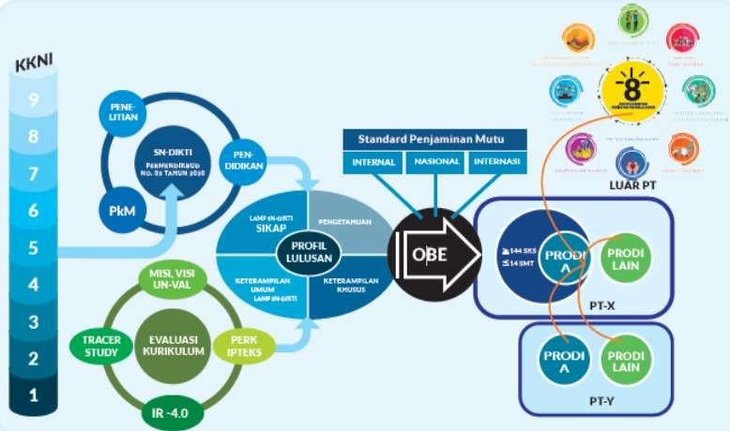

Figure 1: Independent Learning Curriculum Paradigm

In the context of curriculum design at PTKI, learning outcomes related to attitudes and noble moral values, as well as basic religious knowledge and skills, are essential as distinguishing characteristics of graduates. Thus, PTKI graduates should be able to demonstrate a profile that reflects both piety and intellectuality, grounded in professionalism aligned with their field of study. The implementation of the MBKM policy, through the three-semester learning outside the study program, is expected to foster an out-of-the-box mindset for PTKI students in responding to and entering life by the demands of the 4.0 industrial revolution, Society 5.0, and 21st-century skills.

# STAGES OF STUDY PROGRAM CURRICULUM DEVELOPMENT REFERRING TO MBKM

The stages in developing the study program curriculum that refers to the Independent Learning - Independent Campus policy follow the patterns and stages of developing the study program curriculum by referring to several regulations related to curriculum development such as Law Number 12 of 2012 concerning Higher Education, the implementation of KKNI (Indonesian National Qualifications Framework), and the OBE (Outcome-Based Education) approach. It also considers various regulations, social dynamics, and advancements in science and technology (IPTEKS). Generally, curriculum development consists of three work stages: curriculum design, learning implementation, and learning evaluation.

The preparation and development of the undergraduate curriculum at PTKI should be based on a strong foundation, whether philosophically, sociologically, psychologically, historically, or juridically. The following figure shows a series of legal foundations, and national and institutional policies for higher education curriculum development.

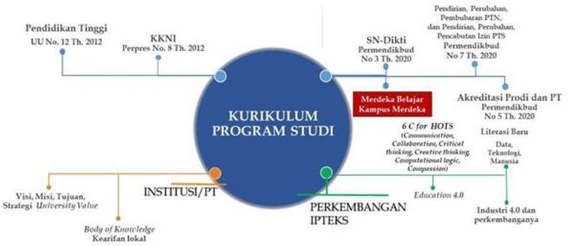

Figure 2: Foundation for Curriculum Development

The stages of developing the study program curriculum are described as follows:

1. Formulating Graduate Profiles

The study program curriculum allows students to take courses outside their main program by formulating a Major Graduate Profile and a Minor Graduate Profile. The Major Graduate Profile includes the core competencies of the study program, while the Minor Graduate Profile contains additional skills that support or are relevant to the core competencies.

1. Determining Graduate Learning Outcomes (GLOs)

Each graduate profile is formulated into Graduate Learning Outcomes (GLO). To develop additional graduate profiles and their corresponding GLOs, information can be gathered through alumni tracking, input from stakeholders, professional associations or academic colloquiums, and emerging fields or skills required by the business and employment sectors. The GLO formulation includes attitudes, knowledge, general skills, and specific skills, about the National Standards for Higher Education (SN-Dikti).

1. Course Establishment

Course establishment begins with the selection of study materials and learning materials used in developing courses for the main profile and its learning outcomes. The knowledge components from additional GLOs should outline the boundaries and scope of the field of study/skills, representing the minimum study materials that each program graduate must master. These study materials may consist of one or more branches of knowledge along with their subfields, or a set of integrated knowledge that has been agreed upon by similar program forums as characteristic of that field of study. From these minimal study materials, the program can further detail them in terms of depth, breadth, and level of mastery. The study materials become the content standards for learning, with levels of depth and breadth referring to the GLOs and National Standards for Higher Education (SN-Dikti).

The establishment of courses, as part of the operational steps in implementing the MBKM policy, can be achieved by integrating courses with credit units set by other programs that are part of those courses. For example, a program wishing to provide additional GLOs in the field of technology may include courses from the Informatics program, according to the desired credit units.

1. Course Structure

The curriculum structure of the study program which refers to independent learning - independent campus consists of four groups:1. University Mandatory Personality Development Courses (MKWU); 2. Core Knowledge and Skills Courses (MKKU); 3. Specialization Knowledge and Skills Courses (MKKP); and 4. Inter-Program Knowledge and Skills Courses (MKKP). The MKKP and MKLP course groups are designed to fulfill students' rights to study outside their program for three semesters. Meanwhile, the MKWU and MKKU groups are mandatory courses within the program. Therefore, every student in a specific program must complete these course groups. The distribution of courses in the semester program under the MBKM curriculum can be illustrated in the following curriculum structure:

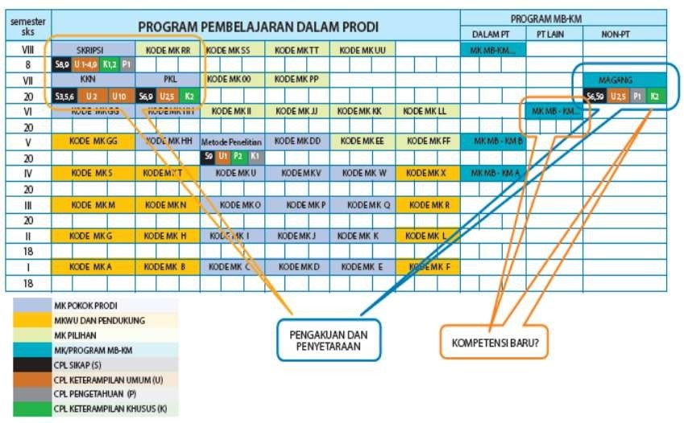

Figure 3: Example of Study Program Curriculum Structure

From the curriculum structure, the distribution of courses for each semester can be outlined using the following matrix:

**Table 1**. Distribution of Study Program Courses

|  |  |  |  |  |  |  |  |  |  |
| --- | --- | --- | --- | --- | --- | --- | --- | --- | --- |
| Semester | Course | Course Locations | | | | | | | |
| Within the University | | | Outside the University | | | | |
| Home Study Program | Different Study Program, Same Faculty | Different Study Program, Different Faculty | College | | Business/Industry | | |
| Same Study Program | Different Study Program | Government | Private sector | Independent |
| I | A |  |  |  |  |  |  |  |  |
|  | B |  |  |  |  |  |  |  |  |
|  | C |  |  |  |  |  |  |  |  |
|  | D |  |  |  |  |  |  |  |  |
|  | ... |  |  |  |  |  |  |  |  |
| II | A |  |  |  |  |  |  |  |  |
|  | B |  |  |  |  |  |  |  |  |
|  | C |  |  |  |  |  |  |  |  |
|  | D |  |  |  |  |  |  |  |  |
|  | ... |  |  |  |  |  |  |  |  |
| etc... | etc... |  |  |  |  |  |  |  |  |

1. Learning Mechanism

According to the Ministerial Regulation No. 3 of 2020, which forms the basis for implementing the "Independent Learning-Independent Campus" curriculum, it is stated that “Higher Education Institutions must grant students the right to voluntarily (optional) take several courses or learning programs with semester credit units outside their study program at the same university for 1 semester (equivalent to 20 credits) and outside their study program at different universities for 2 semesters (equivalent to 40 credits).” The implementation of learning outside the study program can be carried out using several models:

* 1. Block Model

The Block Model of Learning Outside Higher Education is a model where a student participates in a learning program in their chosen study program during the first, second, and third semesters as a student. In the fourth semester, the student takes a program in a different study program within the same campus. Then, in the fifth and sixth semesters, the student engages in learning outside the campus. This off-campus learning can include lectures at another university or participating in internships at companies, government institutions, or other private organizations.

An overview of the implementation of the Block Model for MBKM can be described as follows:

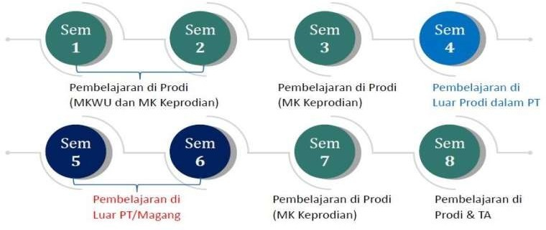

Figure 4: Block Model MBKM Learning

* 1. Non-Block Model

The Non-Block Model for MBKM involves a varied (non-monotone) learning experience outside the university, particularly during the fifth, sixth, and seventh semesters. In this model, students follow their study program from the first to the fourth semester, covering courses in the MKWU and MKPS clusters. Then, in the fifth semester, they study outside the university, followed by the sixth semester at a different study program within the same campus. The seventh semester involves studying outside the campus again, and the eighth semester is spent returning to their original study program. An example of the flow of this model is illustrated in the following figure:

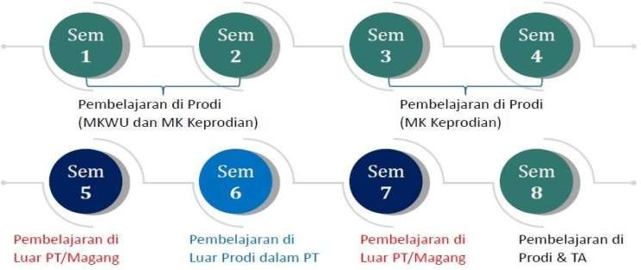

Figure 5: Non-Block Model MBKM Learning

* 1. Accelerated Model

The accelerated model is regulated by the Regulation of the Minister of Education and Culture No. 3 of 2020, allowing for an inter-semester period that can be held between the even and odd semesters, or vice versa. In this model, the maximum number of credits (SKS) allowed is 9 credits. This opportunity can be used to conduct MBKM activities during the inter-semester period, with a maximum of 9 credits. Many universities have already implemented activities during this break, such as internships or community service programs. This model allows for the development of MBKM-based internship or community service programs, with a maximum conversion of 9 credits. To meet the total of 20 credits, this can be combined with regular semester courses.

An example of the accelerated model scheme can be described as follows:

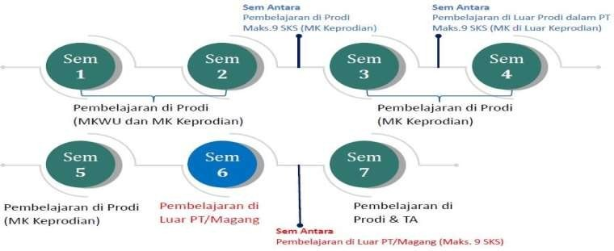

Figure 6: Example 1 of Accelerated MBKM Learning

Another example of an accelerated MBKM learning implementation scheme can be described in the following figure:

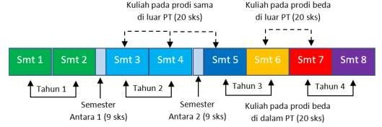

Figure 7: Example 2 of Accelerated MBKM Learning

# PART III

**MBKM LEARNING ACTIVITIES**

This MBKM implementation guideline discusses the implementation of nine forms of learning activities (BKP) which are realized in lectures outside the study program and outside the campus by involving various other institutions. In these technical guidelines, the implementation of nine activities is emphasized in the *Tridharma* of Higher Education. The strengthening of this *Tridharma* is to put more emphasis on which parties are involved in its implementation. Among the parties involved are faculties, research and community service institutions, study programs, and various collaborating partner institutions. As a specialty of the Ministry of Religion, the implementation of the MBKM program needs to strengthen religious moderation, either as an insertion in each program or as a separate program as the ninth learning activity.

# STUDENT EXCHANGE

* 1. **Concept**

Student exchange is a learning activity undertaken by students within the same study program or across different study programs, both on and off campus, by considering graduate learning outcomes (CPL).

# Requirements

* + 1. **General Requirements**
       1. Active student and registered in PD-DIKTI
       2. Obtain approval from the Academic Advisor (DPA) and/or head/coordinator of the study program
       3. At least in the third (3rd) semester.

# Special Requirements

Special requirements are determined by each PTKI.

# Mechanism

* + 1. **Inter-Study Program Student Exchange Within the Same University.**

This student exchange program lasts for one semester or a maximum of 20 credits. The student exchange mechanism across study programs at the same university can be conducted either offline, online, or blended. The general mechanisms to support this program include:

* + - 1. Each study program creates and determines a list of MBKM courses that students can choose from other study programs, considering the relevance of these courses. This relevance is based on an analysis of Graduate Learning Outcomes (CPL) and Course Learning Outcomes (CPMK).
      2. The students are allowed to take courses from other study programs that support their program's CPL, with guidance and approval from their academic advisor and/or the program coordinator.
      3. The study program determines the recognition of credits and the grade conversion system for courses taken in other study programs.

In addition to these general mechanisms, higher education institutions can regulate more specific operational procedures.

* + 1. **Student Exchange for the Same Study Program Across Universities**

Student exchanges within the same program across universities can last up to one semester or a maximum of 20 credits. The learning activities in this mechanism can be conducted either offline or online. Online learning must adhere to the standards set by the institution with the higher regulations. The general mechanisms to support this program include:

* + - 1. The study program creates and establishes a list of equivalent courses that students can choose from other institutions. Ideally, this should be done through a joint curriculum outlined in a cooperation agreement.
      2. The students are allowed to take courses from the same study program at another university, with guidance and approval from their academic advisor and/or program coordinator.
      3. The study program determines the credit recognition and grade conversion system for courses taken at other institutions.

In addition to these general mechanisms, institutions may develop more specific operational procedures.

* + 1. **Inter-Study Program Student Exchange Across Universities**

Inter-study program student exchanges across universities can last for a maximum of one semester or the equivalent of 20 credits. The learning activities in this program can be conducted either offline, online, or blended. Online learning must adhere to the online learning standards set by the institution with the higher regulations. The general mechanisms to support this program include:

1. The study program creates and establishes a list of courses that are relevant to those in other study programs. The relevance of these courses is based on an analysis of the Graduate Learning Outcomes (CPL) and Course Learning Outcomes (CPMK).
2. The students are allowed to select relevant courses from other study programs at different universities, with guidance and approval from their academic advisor and/or program coordinator.
3. The study program determines the credit recognition and grade conversion system for courses taken at other institutions.

In addition to these general mechanisms, institutions may develop more specific operational procedures. The overall process for student exchange is illustrated in the following Figure:

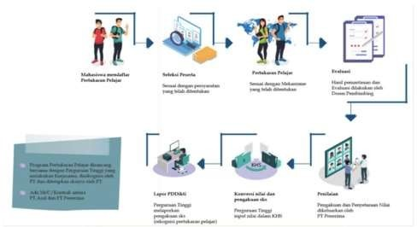

Figure 8: Student Exchange Process

*Source: MBKM Guidebook Directorate General of Higher Education,*

*Ministry of Education and Culture (2020)*

# Roles and Responsibilities

# Student exchanges involve the sending university and/or study program with the host university and/or study program as partners. At each university, the exchange program involves the head/coordinator of the study program and the academic advisor (DPA). The general responsibilities of each university are outlined as follows:

# Sending University

The sending university must carry out the following tasks:

1. Establish cooperation with domestic and international universities or with academic consortia for credit transfer programs.
2. Determine the courses that can be taken or pursued in the student exchange program;
3. Allocate quotas for inbound students and outboundstudents (reciprocal);
4. If necessary, organize student exchanges by considering the principle of fairness for students;
5. Monitor the organization of student exchanges.
6. Assess and evaluate the outcomes of the student exchange for the recognition of student credits.
7. Report the results of learning activities to the Directorate General of Higher Education through the Higher Education Database (PD-DIKTI).

# Partner Universities

The host university (Partner University) must carry out the following tasks:

1. Establish cooperation with domestic and international universities or with academic consortia for credit transfer programs that students can participate in;
2. Ensure the implementation of student learning programs and off-campus activities in accordance with the cooperation agreement.
3. Determine the courses that can be taken or pursued in the student exchange program;
4. Allocate quotas for inbound students and outbound students (reciprocal);
5. If necessary, conduct a selection process for student exchanges that adhere to the principles of fairness and equality for students.
6. Organize regular supervision of the student exchange process;
7. Ensure quality assurance and manage the implementation of student exchanges.
8. Provide grades and final evaluation results for students to be recognized at their home university;
9. Reporting the results of learning activities to the Directorate General of Higher Education through the Higher Education Database (PD-DIKTI).

To determine the courses in the target study program that are relevant to the original study program, the decision is based on the consideration of the relevance of the Graduate Learning Outcomes (CPL) of the original study program with the CPL of the target study program, which is translated into the Course Learning Outcomes (CPMK) for each program. This course mapping is carried out by the target study program. Here are some examples of schemes for determining target study programs and relevant courses for student exchanges.

# Example of Graduate Learning Outcomes (GLOs) formulation for different Study Programs within the same University.

# Table 2. Example of GLO Formulation Model 1

|  |  |  |  |
| --- | --- | --- | --- |
| **Home Study Program** | **Graduate Learning Outcomes (GLOs)** | **Target Study Program** | **Graduate Learning Outcomes (GLOs)** |
| Islamic Education | **Skill Aspect:** | Informatics Engineering | **Skill Aspect:** |
|  | Able to utilize information and communication technology effectively for learning Islamic Religious Education in schools/madrasahs. |  | Able to design, implement, and evaluate computing-based solutions that meet the computing needs of a specific discipline. |

**Table 3.** Example of GLO Formulation Model 2

|  |  |  |  |
| --- | --- | --- | --- |
| **Home Study Program** | **Graduate Learning Outcomes (GLOs)** | **Target Study Program** | **Graduate Learning Outcomes (GLOs)** |
| Islamic Education | **Knowledge Aspect:** | Tafseer and Quranic Studies | **Knowledge Aspect:** |
| **Graduate Profile:** Educator (Qur'an Hadith Teacher) | Mastering the concepts, scientific methods, material substance, structure, and scientific mindset of Al-Qur'an- Hadith as a sub-science of PAI (Islamic Religious Education) | **Graduate profile:** Academics in the field of Quran and Tafseer | Mastering knowledge of the sciences of the Qur'an and tafseer to read and understand the interpretation of the Qur'an properly and precisely |

1. **Example of GLO formulation for the same study program in different universities**

**Table 4**. Example of GLO Formulation Model 1

|  |  |  |  |
| --- | --- | --- | --- |
| **Study Program** | **Graduate Learning Outcomes (GLOs)** | **Study Program Courses of University A** | **Study Program Courses of University B** |
| Arabic Language Education  **Graduate Profile:** Instructional Material Developer | Able to utilize information and communication technology effectively for Arabic language learning in schools/madrasahs. | * Design of an Arabic Language Teaching Application System * Development of Arabic Teaching Materials for Elementary Schools Levels * Development of Arabic Teaching Materials for   Junior High Schools | * Teaching Material Development * Development of learning resources and media |

**Table 5**. Example of GLOs Formulation Model 2

|  |  |  |  |
| --- | --- | --- | --- |
| **Study Program** | **Graduate Learning Outcomes (GLOs)** | **Study Program Courses of University A** | **Study Program Courses of University B** |
| Tafseer and Quranic Studies (IAT) | Produce thematic exegesis works that are useful for society according to the needs and developments of the era. | * Qur'an, Hadith, and Gender * Living Qur'an (Qur'an and Socio-Culture) * Interpretation of Narrative Verses. | * Thematic Interpretation of Social and Political * Living Qur'an * Thematic Interpretation of Worship and *Muamalah* |

# Example of GLO Formulation for Different Study Programs Across Universities

**Table 6.** Example of GLO Formulation Model 1

|  |  |  |  |
| --- | --- | --- | --- |
| **Home Study Program** | **Graduate Learning Outcomes (GLOs)** | **Graduate Learning Outcomes (GLOs)** | **Different Target University and Study Programs (Courses)** |
| Islamic Education | **Key Competencies:**  Able to communicate effectively, both orally and in writing, using Arabic and English in academic and professional settings." | **Additional Competencies:**  Able to develop media, tools, and teaching materials for Islamic Religious Education learning | Informatics Engineering (Multimedia Design) |
|  | Able to read the Qur'an based on the knowledge of *qira'at* (recitation) and *tajwid* (rules of pronunciation) | Apply knowledge and skills in information technology in the context of scientific development and effective implementation of expertise areas for Islamic Religious Education learning in schools/madrasahs | Informatics Engineering (Application Engineering) |

**Table 7.** Example of GLO Formulation Model 2

|  |  |  |  |
| --- | --- | --- | --- |
| **Home Study Program** | **Graduate Learning Outcomes (GLOs)** | **Graduate Learning Outcomes (GLOs)** | **Different Target University and Study Programs (Courses)** |
| Da'wah Management  **Graduate Profile:** Da'wah Management Practitioner | **Key Competencies:**  Demonstrate the ability to use information literacy, media literacy, and information and communication technology for scientific development and professional skills enhancement. | **Additional Competencies:**  Able to design digital-based multimedia | Informatics Engineering (Multimedia Design) |
| **Graduate Profile:** Da’wah Institute Developer | Able to develop planning and strategies for the growth of religious institutions (such as Hajj and Umrah institutions, *Zakat, Infak*, and *Shadaqah* (ZIS) institutions, Islamic boarding schools, orphanages, religious tourism agencies, and other religious institutions), based on data and information analysis. | Able to design multimedia-based  da'wah management in informatics engineering | Informatics Engineering (Application Engineering) |

# Output and Recognition of Credits

The student exchange program has several potential outputs, including grades corresponding to converted credits, certificates, or a Diploma Supplement (SKPI). The study program has the authority to determine grade conversion and credit recognition based on established conversion guidelines. The establishment of these guidelines can be carried out by a team formed by the university, involving the Vice Dean of Academic Affairs, the Head and Secretary of the Department, the Head/Coordinator of the Study Program, and the course lecturers.

# a. Grades

The assessment of courses taken in this student exchange program is carried out by the lecturer in charge of the course at the target study program with assessment standards under their academic guidelines. The results of the assessment are then received by the sending study program and reported to PD-DIKTI. In this case, the sending study program has the authority to acknowledge the grades and number of credits by the established grade conversion guidelines.

# Certificate

Certificates can serve as an alternative output for the student exchange program if there are differences in credit value between the receiving and sending study programs. For example, if a student takes courses at the receiving study program that exceed the credit conversion recognized by their home program, the receiving program will convert the courses based on the established credit amount, and any excess will be recognized through a certificate of expertise accompanied by a transcript, similar to training. Certificates can also be issued when the courses taken at the receiving program involve more practical approaches, while the courses at the home program are more theoretical. In such cases, the certificate of expertise is awarded as recognition for the practical program attended or other forms of recognition.

# Diploma Supplement (SKPI)

In addition to grades and certificates, recognition of student exchange results can also be included in the Diploma Supplement (SKPI). This will strengthen the student's competency profile. SKPI as an output serves as a solution when the number of credits converted into the transcript cannot be fully recognized. Thus, besides the recognition in the form of expertise certificates mentioned above, it can also be included in the SKPI.

# INTERNSHIP OR WORK PRACTICE

* 1. **Concept**

An internship is an effort to develop knowledge, build skills, and reinforce attitudes through learning by doing. Internships can be carried out in collaboration with companies, businesses, and industries (DUDI), non-profit organizations, multilateral organizations, government institutions, Professional Certification Bodies (LSP), startups, and others. Internships can be oriented toward certified competency programs in the student’s field of study, in cooperation with LSPs that have been accredited by the National Professional Certification Agency (BNSP).

The MBKM internship is a systematic effort by educational providers to ensure the quality and relevance of graduates concerning the job market and industry through partnerships with institutions/companies. In this context, the study program collaborates with partners and identifies the learning outcomes of graduates.

# Requirements

* + 1. **General Requirements**
       1. Active student and registered in PD-Dikti;
       2. Obtain approval from the Academic Advisor (DPA) and/or the Head/Coordinator of the Study Program;

23

* + - 1. Be at least in the 5th semester;
      2. Obtain approval from the internship partner institution/company;

# Special Requirements

Special requirements are determined by each PTKI.

# Mechanism

To participate in an internship or work practice program, the general mechanism is:

* + 1. Universities (study programs) collaborate with partner institutions by agreeing on competencies (CPL) or competency certificates that will be given to students.
    2. The study program conducts registration of prospective internship or work practice participants;
    3. Students prepare the design of the internship program that will be carried out;
    4. Students undergo a selection process conducted by their home study program;
    5. Students carry out the internship program activities at the intended partner institution/company;
    6. Students take part in evaluation/assessment activities carried out by the study program and partner institutions/companies where the internship takes place;
    7. Student learning outcomes are converted or transferred semester as credits by the student's home study program as recognition of the earned credits;
    8. The study program at the student's home university reports the study results of students who take part in the internship or work practice program on the Higher Education Database (PD-DIKTI).

The mechanism for implementing the internship or work practice program can be presented in the following flowchart:

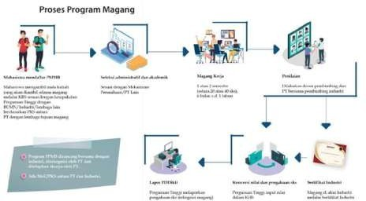

Figure 9: The Process of the Internship Program

*Source: MBKM Guidebook Directorate General of Higher Education,*

*Ministry of Education and Culture (2020)*

# Roles and Responsibilities

# The internship or work practice activities involve the university and the partner institution/company. The university manages the curriculum and sends students. Meanwhile, the institution/company serves as the host for the interns or practical workers. In general, the roles and responsibilities of each party are explained as follows:

# Higher Education Institutions

1. Establish partnerships with institutions/companies that can serve as internship sites.
2. Provide opportunities for students to participate in internship or work practice programs by accepting registration and selection.
3. Assign field supervisors to provide mentoring, training, monitoring, and evaluation of internship or work practice activities.
4. Facilitate student’s administrative needs such as permission letters, assignment letters, and others.
5. Equalize/recognize hours of internship or work practice activities to be recognized as credits.
6. Report the results of internship activities to PD-DIKTI.

# Partner Institution/Company

1. Ensure that high-quality internship activities are carried out at the institution/partner according to the cooperation agreement.
2. Provide supervisors/mentors/coaches who accompany students/student groups during the internship.
3. Provide rights and guarantees under laws and regulations (health insurance, work safety, internship rights).
4. The supervisor accompanies and assesses the student's performance during the internship, and along with the academic advisor, provides evaluation.

# Output and Credit Recognition

The main output of the internship/work practice program is the grade converted from the comprehensive assessment of student performance. If possible, the output may also include a professional competency certificate and recognition on the SKPI (Diploma Supplement). Credit equivalency can be done in three forms: a) Free-form equivalency; b) Structured-form equivalency; and c) Combined-form equivalency.

The authority for determining grade conversion and credit recognition rests with the head/ coordinator of the study program. Competency certificates can be issued by Professional Certification Institutions (LSPs), whether created by the university itself or in collaboration with other institutions recognized by the National Professional Certification Agency (BNSP). In setting the guidelines for conversion and credit recognition, universities can form a conversion team involving the Vice Dean I, the Head and Secretary of the Department, the Head/Coordinator of the study program, related partner units/institutions, and lecturers.

# Free-form Equivalency

MBKM internship activities for 6 months are equal to a maximum of 20 credits without equalization with courses. The assessment and equivalency are divided into two forms: hard skills and soft skills.

**Table 8**. Free Form Internship Equivalency Example

|  |  |
| --- | --- |
| **Hard skills**   1. Formulate technical field problems 2. Create a report, presentation, or publication 3. Resolve technical field issues | **Credits**   1. credits 2. credits   3 credits |
| **Soft skills** | **Credits** |
| 1) Integrity | 2 credits |
| 2) Responsibility | 2 credits |
| 3) Hard Work | 2 credits |
| 4) Creativity | 2 credits |
| 5) Communication skills | 2 credits |

* + 1. **Structured-form Equivalency**

Internship activities with a maximum recognition of 20 credits are expressed as equivalency to the courses offered and aligned with the competencies of the internship performed.

**Table 9**: Example of Structured Internship Equivalency

|  |  |
| --- | --- |
| **Courses** | **Credits** |
| 1) Practical Work Report | 4 credits |
| 2) Management in Islamic Perspective | 3 credits |
| 3) Entrepreneurship | 3 credits |
| 4) Digital Marketing | 3 credits |
| 5) Leadership | 2 credits |
| 6) Financial Technology | 3 credits |
| 7) Consumer Behavior | 2 credits |

* + 1. **Combined-form equivalency**

This type of equivalency combines free form and structured form. Internship activities can be carried out by integrating both courses and hard skills as well as soft skills.

**Table 10:** Example of Combined Form Internship Equivalency

|  |  |  |  |
| --- | --- | --- | --- |
| **Study Program** | **Entrepreneurial Course Learning Outcome (CLO)** | **Course Equivalency** | **Credits** |
| Communicati on Studies | Able to perform initial entrepreneurial practices with a comprehensive understanding of entrepreneurial concepts | Social entrepreneurship | 3 credits |
| Business ethics | 2 credits |
| Introduction to management  and business | 2 credits |
| Digital Marketing | 3 credits |
| Entrepreneurship:   1. Entrepreneurial design and   presentation   1. Entrepreneurial practice 2. Entrepreneurship implementation report and presentation | 1. credits 2. credits 3. credits |
| **Total** | | | 1. **credits** |

# TEACHING ASSISTANCE IN EDUCATIONAL INSTITUTIONS

* 1. **Concept**

Teaching assistance programs involve students teaching in educational institutions such as early childhood education centers (PAUD/TK/RA), elementary schools (SD/MI), junior high schools (SMP/MTs), senior high schools (SMA/MA), and vocational schools (SMK/MAK). These institutions may be located in urban areas or remote, frontier, and border regions. Students from various programs at the higher education institution can participate, under the guidance of qualified lecturers and supervising teachers at the educational institution. This activity offers students interested in education the opportunity to teach and deepen their knowledge by becoming teachers, helping to improve educational quality, and ensuring the relevance of basic and secondary education with higher education and modern developments.

# Requirements

* + 1. **General Requirements**
       1. Active student and registered in PD-Dikti;
       2. Obtain approval from the Academic Advisor (DPA) and/or Head/Coordinator of the Study Program;
       3. Have passed the courses required by the study program;

# Special Requirements

Special requirements are determined by each PTKI.

# Mechanism

Universities establish partnerships with the Education Office and/or the Provincial and Regional Ministry of Religious Affairs, as well as with partner schools/madrasahs. For implementing teaching assistance, study programs define hard skills and soft skills as part of the learning outcomes, which are set for a credit weight of 20 credits for the teaching assistance activities, and create guidelines for the implementation of these activities to ensure quality assurance.

To carry out the teaching assistance program, the general mechanism is described as follows:

1. Students consult with their study programs and academic advisors (DPA)
2. Students register for the teaching assistance program;
3. The study program conducts verification and selection to determine eligible participants;
4. Students attend the debriefing of the teaching assistance program;
5. The study program collaborates with the educational institutions where the practice will take place;
6. Students carry out the teaching assistance practices;
7. Students prepare and present an activity report;
8. Participate in evaluations/assessments conducted by the study program, academic advisor, and supervising teacher at the practice location.
9. The student's learning outcomes are converted or credited by their home study program as recognition of earned credits;
10. The study program reports the results of students participating in the teaching assistance program to the Higher Education Database (PD-DIKTI).

The process of the teaching assistance activity can be described as follows:

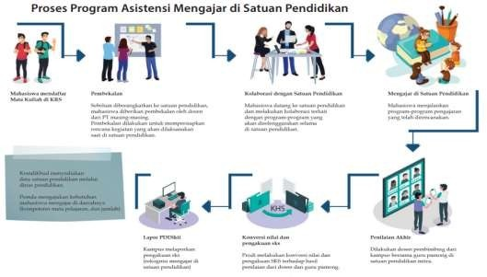

Figure 10: The Process of the Teaching Assistance Program in Educational Institutions

*Source: MBKM Guidebook Directorate General of Higher Education,*

*Ministry of Education and Culture (2020)*

# Roles and Responsibilities

The teaching assistance program involves several institutions both within and outside the campus. This explanation only outlines the roles and responsibilities of the higher education institution and the institution where students perform their teaching assistance. Practically, the higher education institution involves the study program and field supervisors, while the institution where the practice takes place also involves a supervising teacher.

**a. Higher Education Institutions**

1. Collaborate with educational partners, obtain permissions from the education office or Ministry of Religion, and develop a program in cooperation with local educational institutions.
2. Universities can collaborate with the *Indonesia Mengajar* program, the Indonesian Student Teaching Movement Forum (FGMMI), MGMP, and other programs recommended by the Ministry of Education and Culture or the Ministry of Religious Affairs.
3. Provide opportunities for students to participate in teaching programs at both formal and non-formal educational institutions through registration and selection.
4. Data on educational institutions can be obtained from the Education Office or the local Ministry of Religion Office. The need for teaching assistants and the subjects taught are based on the needs of each educational institution.
5. Assign field supervisors to provide assistance, training, monitoring, and evaluation of teaching activities in educational institutions carried out by students.
6. Facilitate students' administrative needs such as permission letters, assignment letters, and other requirements.
7. Recognize and convert the hours of teaching assistance at educational institutions into credits.
8. Report the results of teaching assistance activities to the Higher Education Database (PD-DIKTI).

# Partner Educational Institutions (Schools/Madrasahs)

1. Ensure the implementation of teaching assistance activities under the cooperation agreement;
2. Appoint a supervising teacher/mentor teacher to supervise students conducting teaching activities at the educational institution.
3. Collaborate with the field supervisor from the faculty to monitor and evaluate the students’ activities.
4. Provide grades for recognition as academic credits for the students.

# Output and Credit Recognition

The main output of the teaching assistance program is the grade converted from a comprehensive assessment of the student's performance. If needed, the output can also include a certificate and recognition in the SKPI (Diploma Supplement). Students who have completed the teaching assistance program will have their semester credits recognized as a form of credit transfer to meet the credit requirements for their undergraduate program, as specified in the curriculum. This credit recognition is based on the alignment and equivalence of learning outcomes and the semester credits achieved by the student during the teaching assistance program.

Assessment can be conducted by the field supervisor based on evaluations from the mentor teacher at the school where the student teaches, as well as the improvement in students' knowledge, attitudes, and behaviors according to the program proposal designed by the student. Credit recognition is based on both hard skills and soft skills, reflecting the learning outcomes set for a 20-credit weight from the teaching assistance activities.

The authority responsible for determining grade conversion and credit recognition lies with the head/coordinator of the study program. In setting the guidelines for conversion and credit recognition, the higher education institution may form a conversion team involving the Vice Dean I, the Head and Secretary of the Department, the Head/Coordinator of the study program, relevant partner units/institutions, and lecturers.

The example of credit recognition for the teaching assistance program is presented as follows:

**Table 11**: Example of Credit Recognition for Teaching Assistance Program

|  |  |  |
| --- | --- | --- |
| **Teaching CLO** | **Course Equivalency** | **Credits** |
| Students conduct online/virtual teaching practice effectively and accurately | Lesson Planning (Online/Offline) | 5 |
| Implementation of Learning Practices | 6 |
| Material and media development learning | 2 |
| Evaluation of Learning Outcomes | 2 |
| Implementation of Non-Curricular Program | 2 |
| Teaching Practice Report and Presentation | 3 |
| **Total** | | **20** |

The study program conducts synchronization with the current curriculum to recognize the student teaching assistance activities. The following skills may be considered for credit recognition. The study program will determine the credit values, with a maximum of 20 credits.:

1. Islamic values
2. Moral education
3. Religious moderation
4. Leadership
5. Collaboration
6. Critical thinking
7. Problem-solving
8. Creativity and Innovation
9. And so on

The study program can also recognize credits through a combination of structured and flexible programs.

# RESEARCH

* 1. **Concept**

For students with an interest in and aptitude for research, MBKM can be realized through research activities at research institutions, study centers, or laboratories, both within and outside their university. Research helps students develop critical thinking skills, which are essential for various fields of study at higher education levels. With these skills, students can better delve into, understand, and apply research methods. For those aspiring to a career in research, internships at research labs are highly desirable. Additionally, research labs or institutions sometimes face a shortage of research assistants for short-term projects (1 semester).

The objectives of the Research Program include:

* + 1. Students can improve the quality of their research.
    2. Students strengthen their abilities and talents in the field of research.
    3. Students gain research competencies through direct mentoring by researchers or faculty members at research institutions, study centers, or laboratories.
    4. Students gain hands-on experience in the field of research at research institutes, study centers, or laboratories.
    5. Research institutions, study centers, or laboratories benefit from additional research resources and early career researcher development.
    6. Islamic Higher Education Institutions (PTKI) can enhance the quality of their faculty/researchers and expand their research networks collaboratively with research institutions, study centers, or other partner organizations.

# Requirements

* + 1. **General Requirements**
       1. Active student and registered in PD-DIKTI;
       2. Obtain approval from the Academic Advisor (DPA) and/or Head/Coordinator of the Study Program;
       3. At least have completed four (4) semesters;

# Special Requirements

Special requirements are determined by each PTKI.

# Mechanism

In carrying out MBKM research activities, universities collaborate with relevant partner institutions. These partner institutions can include universities, laboratories, study centers, and others with research programs or those suitable for internships/research assistance. The general mechanism for conducting research is described as follows:

* + 1. The university collaborates with partner institutions and then proceeds with formulating the competencies (CPL) to be provided to students. This formulation involves the faculty, study programs, and LP2M/P3M.
    2. By the approval of the Academic Advisor (DPA) and acknowledgment of the study program, students submit their research plans, which are relevant to their field of study, to the research institution/study center/laboratory through LP2M/P3M.
    3. LP2M/P3M, along with the study program, appoints the research supervisor and communicates with the partner research institution/study center/laboratory for the research assistance program.
    4. Students carry out research activities under the directions of the research institute/study center/laboratory where the research is conducted.
    5. Students maintain a logbook of their activities.
    6. Students prepare a report on their activities and submit it to LP2M/P3M or the study program in the form of research reports/theses, scientific journal articles, and/or other outputs.
    7. Students present their research findings to their supervisors/examiners.
    8. LP2M/P3M and the research supervisors evaluate the work and report the results to the study program.
    9. The study program reports the results of students participating in the research program in the Higher Education Database (PD-DIKTI).

The flow of research program implementation is described as follows:

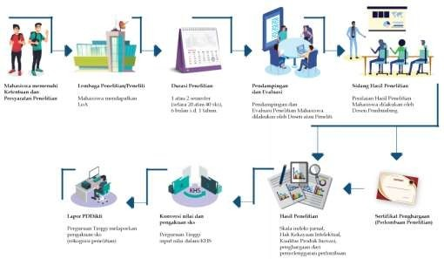

Figure 11: Flow of Research Program Implementation

*Source: MBKM Guidebook Directorate General of Higher Education,*

*Ministry of Education and Culture (2020)*

# Roles and Responsibilities

This research program involves the roles and functions of universities and partner institutions where research is conducted. Generally, the roles and functions of each party are described as follows:

# Higher Education Institutions

* + - 1. Establish collaboration agreements with partners from research institutions/laboratories/centers initiated by LP2M/P3M or faculties/programs.
      2. Develop technical guidelines for learning activities through research.
      3. Give students the right to participate in the selection and evaluation of research programs at research institutes/labs/study centers.
      4. Appoint field supervisors to provide guidance, supervision, and collaborate with researchers at research institutions/laboratories/study centers to assess performance.
      5. Facilitate students' administrative needs, such as permission letters, assignment letters, and other requirements.
      6. Develop a logbook form to record the progress of activities.
      7. Conduct final evaluations and convert research activities at the research institution/laboratory/center into relevant courses (credits) and ensure the program's continuity.
      8. Report research activities to PD-DIKTI.

# Partner Institutions

* + - 1. Ensure the implementation of student research activities at partner research institutions/study centers/laboratories under the cooperation agreement.
      2. Appoint a mentor/supervisor from the research institution/study center/laboratory partner for students in conducting their research.
      3. Collaborate with the field supervisor from the faculty to evaluate and assess the research projects carried out by students.

# Output and Credit Recognition

The main output of this research program is a converted score from a comprehensive student performance assessment. If necessary, the output can also include certificates and recognition in the Diploma Supplement (SKPI). This activity may also produce various outcomes, such as articles published in journals, books, or Intellectual Property Rights (IPR). Students who complete the research program are credited with semester credits as a form of transfer credit to fulfill their credit requirements in their undergraduate program, up to a maximum of 20 credits. The recognition of semester credits is based on the alignment and equivalence of the output with learning outcomes and the credit weight achieved by the students during the research program.

The authority for determining grade conversion and credit recognition lies with the head/coordinator of the study program. For establishing guidelines on credit conversion and recognition, the higher education institution may form a conversion team involving the Vice Dean I, the Head and Secretary of the Department, the Head/Coordinator of the program, LP2M/P3M/related units or institutions, and lecturers.

The example of calculating the credit recognition of the research program is described as follows:

**Table 12:** Example of Credit Recognition for Research Program

|  |  |  |
| --- | --- | --- |
| **Research CLO** | **Course Equivalency** | **Credits** |
| Students produce research work that is relevant to the competencies of the study program. | Research Methodology | 4 |
| Statistics | 4 |
| Utilization of Technology in Research | 2 |
| Writing books and scientific journal articles | 4 |
| Thesis/Final Report | 6 |
| **Total** | | **20** |

# INDEPENDENT STUDY/PROJECT

* 1. **Concept**

Independent study/project is a program that provides students with the opportunity to express their academic abilities by producing work derived from learning outcomes, research, or community service. This work can be nationally or internationally competitive and registered for Intellectual Property Rights (IPR). Ideally, independent study/project serves as a complement to the curriculum that students have already completed. Higher education institutions (Universities/Institutes/Colleges, Faculties, and Study Programs) can also use independent study/project activities conducted by students to cover topics not included in the regular course schedule but still available in the Course Learning Plan (RPS) of the study program or faculty.

Independent study/project activities can be carried out and facilitated by faculties/study programs along with LP2M/P3M, which is responsible for research and community service activities. These activities can be conducted either individually or as group work, based on a single discipline or interdisciplinary fields of study within the institution.

In group-based independent study/projects, each student must demonstrate academic distinction in their respective study programs. For example, the outcomes of independent study/projects in a specific academic discipline include:

a) Students in the *Akhwalussyakhsiyah* program can produce an innovative project such as the "Child-Friendly Village" as a form of innovation in Family Law.

b) Students in the Sharia Economics program can develop technopreneurship projects to advance local tourism in various regions.

c) Students in the Islamic Broadcasting Communication program can develop appropriate technology programs to develop a Digital Village through digital literacy or to foster political awareness in the community through political literacy projects.

For example, an independent study or project that spans multiple disciplines might involve several programs collaborating on empowerment research, such as helping communities establish cooperatives based on their needs. This type of independent study or project could combine programs like Sharia Economics and Banking for the economic aspects, Islamic Community Development for community empowerment, and the Islamic Education program to integrate Islamic values such as honesty, openness, and consultation, in line with ethical principles in Islam.

The objectives of an independent study/project include:

a. Students are able to realize their ideas by developing innovative products that align with the institution's vision and mission and the goals of the Islamic higher education institution (PTKI).

b. Develop learning, research, and community service works into synergistic products.

c. Organize dissemination of educational, research, and community service works within the framework of religious moderation.

d. Enhance student achievements on regional, national, and international scales.

e. Strengthen Islamic and Indonesian studies in independent study/projects.

# Requirements

* + 1. **General Requirements**
       1. Active student and registered in PD-DIKTI;
       2. Obtain approval from the Academic Advisor (DPA) and/or Head/Coordinator of the Study Program;
       3. At least have completed four (4) semesters;

# Special Requirements

Special requirements are determined by each PTKI.

# Mechanism

Independent studies/projects can be conducted by students either individually or in groups. Independent studies/projects offer an alternative for producing technology, cultural arts, or scientific works that benefit society. To carry out independent studies/projects, Islamic higher education institutions (PTKI) must establish the necessary criteria and requirements and create guidelines for implementation to ensure quality.

The independent study/project generally follows these steps:

* + 1. Students consult with their Academic Advisor (DPA) or the head/coordinator of their study program regarding their plan to participate in an independent study/project.
    2. Students register to their study program or LP2M/P3M or the designated unit.
    3. Students participate in the program selection process by submitting a proposal. If the proposal is approved, students proceed with the independent study/project. If not approved, students continue with regular coursework.
    4. The study program coordinates with LP2M/P3M to assign a supervising lecturer.
    5. Students carry out the independent study/project with guidance from their supervising lecturer.
    6. Students prepare a report on their activities and submit it to LP2M/LP3 or their study program, in the form of a report, scholarly journal article, and/or other outputs.
    7. Students present the results of their study/project and are evaluated by the supervising lecturer or the board of examiners.
    8. The study program converts the grades or credits as recognition of the earned credits.
    9. The study program reports the results of the student’s independent study/project activities on the Higher Education Data Base (PD-DIKTI).

The flow of independent study/project implementation is described as follows:

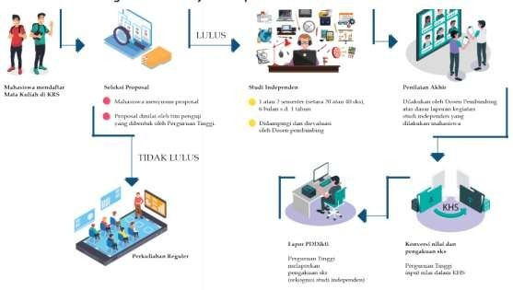

Figure 12: Flow of Independent Study/Project Implementation Mechanism

*Source: MBKM Guidebook Directorate General of Higher Education,*

*Ministry of Education and Culture (2020)*

# Roles and Responsibilities

# The independent study/project involves the roles and functions of both the higher education institution and the partner organizations where the independent study/project is carried out. Generally, the roles and functions of each party are described as follows:

# Higher Education Institutions

* + - 1. Communicate and collaborate with institutions/organizations/ communities that will become independent study/project partners through LP2M/P3M.
      2. Develop technical guidelines for independent study/project activities.
      3. Socialize independent study/project programs to lecturers, students, and partner institutions/communities.
      4. Conduct registration and selection of independent study/project proposals.
      5. Appoint field supervisors to provide guidance, supervision, and along with the examination team, to assign grades.
      6. Facilitate students' administrative needs, such as permission letters, assignment letters, and other documentation.
      7. Develop a logbook form to record the activity process.
      8. Establish policies for recognizing achievements in independent study/projects.
      9. Conduct final evaluation and equate independent study/project activities with grade conversion and credit recognition.
      10. Report the results of independent study/project activities to PD-DIKTI.

# Partner Institution/Community

* + - 1. Ensure the smooth implementation of independent study/project activities, adhering to the established quality standards.
      2. If necessary, appoint a mentor from the institution/community to guide students in carrying out the independent study/project.
      3. Collaborate with the field supervisor from the faculty to evaluate and assess the independent study/project conducted by the students.

# Output and Credit Recognition

The primary output of the independent study/project program is the grade, which is converted from the comprehensive assessment of the student's performance. If necessary, outputs can also include certificates and recognition on the Diploma Supplement (SKPI). This activity can also produce various outcomes, such as articles published in journals, books, or Intellectual Property Rights (HKI). In terms of credit recognition for the implementation of the independent study/project, the study program formulates hard and soft skills as an outline of the learning outcomes established for a maximum credit weight of 20 credits. The equivalence of these 20 credits can be recognized with several courses in either the odd or even semester, under the curriculum guidebook of each study program.

The authority for determining grade conversion and credit recognition lies with the head/coordinator of the study program. Meanwhile, for setting the guidelines for conversion and credit recognition, the university can form a conversion team involving the Vice Dean I, the Head and Secretary of the Department, the Head/Coordinator of the study program, LP2M/P3M/related units or institutions, and lecturers.

The example of credit recognition and its conversion into courses equivalent to 20 credits is presented as follows:

**Table 13:** Example of Credit Recognition for Independent Study/Project Program

|  |  |  |
| --- | --- | --- |
| **Independent Project CLO** | **Course Equivalency** | **Credits** |
| Students produce research works or projects that are  relevant to the competencies of their  study program. | Research Methodology | 4 |
| Internship | 2 |
| Community Service Program | 4 |
| Study Program Courses (relevant to the type of student project) | 4 |
|  |  |
|  | Thesis/Final Report | 6 |
| **Total** | | **20** |

In addition to credit recognition through conversion into courses, credits can also be recognized based on the outcomes of student innovation projects.

**Table 14:** Example of Credit Recognition of Innovation Output-Oriented

|  |  |  |
| --- | --- | --- |
| **Independent Project CLO** | **Course Equivalency** | **Credits** |
| Producing work derived from learning, research, or community service that can be competed nationally and internationally and registered as Intellectual Property Rights (HKI) within the framework of religious moderation. | Novelty of Independent Study/Project | 3 |
| Actualization of Institutional Vision and Mission and Religious Moderation in Independent Programs | 2 |
| Independent product/work development strategy | 2 |
| Sources of Ideas for Independent Project Products | 2 |
| Project Results and Dissemination Reports | 3 |
|  | Independent Project Outputs that are registered in Intellectual Property Rights IPR (Copyright, Patent Rights, Brand Rights, etc.) | 4 |
| Output of Independent Project Results published in an accredited journal (Sinta 5-1) | 4 |
| **Total** | | **20** |

# HUMANITARIAN PROJECT

* 1. **Concept**

Indonesia's geographical position along the equator results in dynamic movements and, in some cases, anomalies. This situation means that Indonesia's physical and biological aspects have a great potential for continuous long-term changes, which, if not properly addressed, can lead to natural disasters. This is evidenced by Indonesia's history of experiencing all types of natural disasters, which can be classified into four groups: (1) marine and aquatic, (2) mountains and hills, (3) land, and (4) climate-related. Examples of marine and aquatic disasters include tsunamis, high waves, abrasion, and floods. Mountain and hill disasters include volcanic eruptions, landslides, and forest fires. Land disasters include ground movement (liquefaction), drought, and mud floods. Climate-related disasters include windstorms and prolonged droughts. Given this geographical physical situation, Indonesia is a region with a high potential for various disasters occurring continuously.

Socially, Indonesia is a country with a high level of diversity. The variety of ethnicities, languages, religions, and cultures poses a potential source of significant conflict. Several horizontal conflicts have occurred, creating systemic effects on national life. Democracy then becomes the most representative choice for a nation with such high heterogeneity. All groups have relatively equal and proportional space, which automatically generates social dynamics at a high intensity. Competition becomes an unavoidable social process that politically produces two differing groups in binary opposition, such as rich-poor, advanced-backward, modern-traditional, and so on. Further implications of this binary opposition lead to the emergence of marginalized and vulnerable groups that need attention to ensure they have adequate resources to achieve or at least maintain the most fundamental aspects of humanity.

The transformation scheme for marginalized and vulnerable groups needs to be implemented in various forms, involving as many stakeholders as possible, including Islamic Higher Education Institutions. Students become a valuable resource for driving humanitarian transformation projects through systematic, innovative, and structured learning schemes.

Humanitarian Project Objectives:

* + 1. Facilitate students in carrying out learning within the MBKM scheme through the implementation of humanitarian projects focused on community transformation and empowerment.
    2. Enhance stakeholder participation in humanitarian transformation projects creatively and innovatively through integrative and structured learning schemes.
    3. Increase the responsibility of students and stakeholders towards humanitarian issues and the empowerment of marginalized and vulnerable groups through collaborative educational initiatives.

# Requirements

* + 1. **General Requirements**
       1. Active student and registered in PD-DIKTI;
       2. Obtain approval from the Academic Advisor (DPA) and/or Head/Coordinator of the Study Program;
       3. At least have completed four (4) semesters;

# Special Requirements

Special requirements are determined by each PTKI.

# Mechanism and Procedure

The implementation mechanism for MBKM humanitarian projects is conducted through collaboration between universities and external parties involved in humanitarian programs, based on the following principles:

* + 1. Humanitarian projects are not only focused on achieving the quality of targeted issues as per program objectives but also on providing adequate space for the learning process of students. Therefore, from the beginning, humanitarian projects carried out through this collaborative mechanism are designed to offer dual benefits for students: achieving program targets and providing transformative learning experiences.
    2. The series of humanitarian project activities can be converted into learning outcomes to accommodate the implementation of MBKM. Each activity has a substance that can be converted into learning outcomes agreed upon by the parties, especially universities and partner institutions.
    3. Each party involved in the collaboration prepares the entire process, outlining the stages and technical procedures for implementing the humanitarian project within the MBKM framework.

Several institutions that can be partnered in this activity include:

1. Government, local government, and village government institutions and agencies such as the Indonesian Red Cross (PMI), National Disaster Management Agency (BNPB national/regional), National/Regional Search and Rescue Agency (BASARNAS), National Narcotics Agency (BNN), and others.
2. Domestic non-governmental organizations include social organizations, religious social organizations, and non-governmental organizations.
3. International donor and humanitarian organizations such as WHO, UNDP, UNHCR, UNICEF, UNESCO, and others.

The mechanism and procedures for implementing the MBKM humanitarian project program are described as follows:

1. The university collaborates with partner institutions by agreeing on the competencies (CPL) that will be provided to students: This collaboration can be initiated by the faculty or LP2M/P3M;
2. By the approval of the Academic Advisor (DPA) and acknowledgment of the study program, students submit their humanitarian project plans, aligned with their academic field, to the partner institution through the study program or LP2M/P3M;
3. The study program, along with LP2M/P3M, determines the field supervisor and communicates to partner institutions for humanitarian project programs;
4. Students carry out humanitarian project activities under the directions of the partner institution where the project is conducted;
5. Students fill out a logbook according to the activities undertaken.
6. Students prepare a report of the activities and submit it to LP2M/P3M or the study program as a program project report, research/thesis report, scientific journal article, or other outputs;
7. Students present their project program report to the board of examiners;
8. The study program, along with LP2M/P3M, the partner institution, and the faculty advisor, provides recognition in the form of evaluations converted according to the learning outcomes or courses established;
9. The study program reports the results of the students' humanitarian project program participation on the Higher Education Data Base (PD-DIKTI).

In general, the flow of implementation of the humanitarian project program is described as follows:

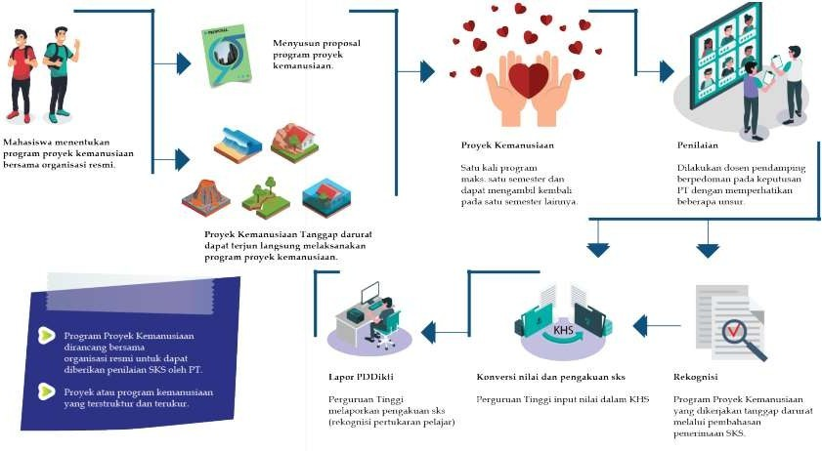

Figure 13: Flow of implementation of the Humanitarian Project Program

*Source: MBKM Guidebook Directorate General of Higher Education,*

*Ministry of Education and Culture (2020))*

# Roles and Responsibilities

This humanitarian project activity involves the roles and functions of universities and partner institutions for the place to carry out activities. In general, the roles and functions of each party are described as follows:

# Higher Education Institutions

* + - 1. Communicate and collaborate with institutions/communities that will become partners in humanitarian project activities initiated by faculty or lp2m/p3m.
      2. Develop technical guidelines for learning activities through humanitarian projects.
      3. Grant students the right to participate in humanitarian projects starting from socialization, registration, selection, and debriefing.
      4. Appoint field supervisors to provide guidance, supervision, and assessment.
      5. Facilitate students' administrative needs, such as permission letters, assignment letters, and other documentation.
      6. Develop a logbook form to record the activity implementation process.
      7. Conduct final evaluation and recognition of humanitarian projects in partner institutions into relevant courses (maximum 20 credits).
      8. Report the results of humanitarian project activities to PD-DIKTI under the provisions.

# Partner Institution

* + - 1. Ensure the achievement of quality standards for student humanitarian project activities at partner institutions in accordance with the agreement.
      2. Provide orientation, introduction, and reinforcement to students in carrying out the humanitarian project plan.
      3. Provide mentoring and assistance to the implementation of humanitarian projects.
      4. Assign a supervisor or mentor to implement the humanitarian project program.
      5. Conduct monitoring, evaluation, and recognition in the form of assessment as agreed upon related to learning outcomes or course conversion.

# Output and Credit Conversion

The main output of this humanitarian project program is a converted score from a comprehensive student performance assessment. If necessary, the output may also include certificates and recognition in the SKPI (Diploma Supplement). This activity can also produce several outcomes, such as articles published in journals, books, or Intellectual Property Rights (IPR). For credit recognition in the implementation of the humanitarian project, the study program formulates hard skills and soft skills as a representation of the learning outcomes established for a maximum credit weight of 20 credits. The equivalence of these 20 credits can be recognized with several courses in one semester, either odd or even, according to the curriculum guidelines of each study program.

The authority to determine grade conversion and credit recognition lies with the head/coordinator of the study program. For establishing the guidelines for conversion and credit recognition, the university can form a conversion team involving the Vice Dean I, the Head and Secretary of the Department, the Head/Coordinator of the study program, LP2M/P3M/related units/institutions, and lecturers.

Here is an example of credit recognition and its conversion into courses equivalent to 20 credits:

**Table 15:** Example of Humanitarian Project Program Course Recognition

|  |  |  |
| --- | --- | --- |
| **Humanitarian Project CLO** | **Course Equivalency** | **Credits** |
| Students produce  humanitarian projects that are relevant to the  competencies of their  study program. | Service/Empowerment Methodology | 4 |
| Internship | 4 |
| Leadership and Social Welfare | 4 |
| Study Program Courses (relevant to the type of student project) | 4 |
|  |  |  |
|  | Community Service Program | 4 |
| **Total** | | **20** |

In addition to recognition in the form of full course credits, the humanitarian project can also be recognized by combining courses with soft skills and program outcomes.

**Table 16.** Example of Soft Skill Oriented Credit Recognition and Innovation Outputs

|  |  |  |
| --- | --- | --- |
| **Humanitarian Project CLO** | **Course Equivalency** | **Credits** |
| Students produce humanitarian projects that are relevant to the competencies of their study program. | Development of logic and critical reasoning | 2 |
| Accuracy, depth, and breadth of problem assessment | 4 |
|  |  |
|  | Initiative, innovation, cooperation, and responsibility | 4 |
|  |  |  |
|  | Leadership, control, and network | 2 |
|  | development |  |
|  | Analysis, Reporting, and Publication of Results | 4 |
|  | Community Service Program | 4 |
| **Total** | | **20** |

# ENTREPRENEURIAL ACTIVITIES

* 1. **Concept**

Entrepreneurship in MBKM refers to student activities that provide opportunities to create business ventures through the analysis of market needs and opportunities. The form of entrepreneurship learning involves direct, planned, and structured entrepreneurial practice. Entrepreneurial activities can take the form of goods or services. This program aims to be the starting point for cultivating entrepreneurs from the campus community (students) who can significantly contribute to job opportunities. The entrepreneurship program initiated by the government and introduced to higher education institutions as a pilot project leverages the entrepreneurial potential inherent in students and faculty as two key components of these institutions.

Entrepreneurship, in terms of developing student potential, can take the form of skills and business activities through the analysis of assets, potential, needs, and market opportunities. The objectives of such entrepreneurial activities are:

* + 1. Provide opportunities for students to develop their entrepreneurial potential;
    2. Facilitate students to apply their entrepreneurial plans;
    3. Provide entrepreneurial experience and develop a business;
    4. Provide opportunities to students to assist the community;
    5. Reduce unemployment among intellectuals/educated people.

Schemes of entrepreneurial activities may include:

1. Independent entrepreneurship scheme, which is a form of entrepreneurship initiated by students (bottom-up);
2. Student activities scheme, which is a form of entrepreneurship where the concept is provided by the Ministry of Religion/higher education institutions for students to implement (top-down);
3. Students provide entrepreneurship assistance to the community.

# Requirements

* + 1. **General Requirements**
       1. Active student and registered in PD-DIKTI;
       2. Obtain approval from the Academic Advisor (DPA) and/or Head/Coordinator of the Study Program;
       3. At least four semesters have been completed;

# Special Requirements

Special requirements are determined by each PTKI.

# Mechanism and Procedure

This entrepreneurship program is institutionally implemented by the faculty/study program in collaboration with LP2M/P3M because it is included in the category of community service. The general mechanisms and procedures are described as follows:

1. The higher education institution develops the guidelines for the entrepreneurship program involving the study program and related units (LP2M/P3M, Career Development Unit, or Entrepreneurship Unit).
2. Students, either individually or in groups, conduct a preliminary study and present it in an entrepreneurship proposal.
3. By the approval of the Academic Advisor (DPA) and acknowledgment of the study program, students register their entrepreneurship program plan with LP2M/P3M or the Career Development Center or the entrepreneurship unit designated by the institution.
4. Assign field supervisors and external mentors as supervisors.
5. Students carry out business activities or entrepreneurial mentoring.
6. Students complete the logbook according to the activities they have conducted.
7. Students prepare a report on entrepreneurial activities.
8. Students present the activity report to the board of examiners, supervisors, and mentors to get an assessment.
9. The study program provides recognition in the form of an assessment that is converted according to the learning outcomes or courses that have been determined.
10. The study program reports the results of students participating in the entrepreneurship program on the Higher Education Database (PD-DIKTI).

The flow of this entrepreneurial activity is generally described as follows:

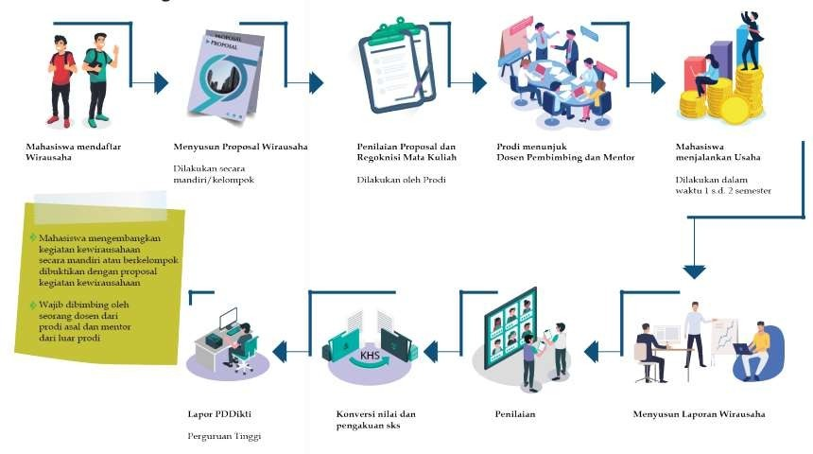

Figure 14: Flow of Entrepreneurship Activities

*Source: MBKM Guidebook Directorate General of Higher Education,*

*Ministry of Education and Culture (2020)*

# Roles and Responsibilities

The implementation of this entrepreneurship program institutionally involves the study program along with LP2M/P3M or the Career Development Center or the Entrepreneurship unit as the program manager, as well as partner institutions as assistants. The duties and roles of each party in general are described as follows:

# Higher Education Institutions

* + - 1. Collaborate with partner institutions for entrepreneurial activity support.
      2. Develop technical guidelines for learning activities through the entrepreneurship program.
      3. Grant students the right to participate in entrepreneurial projects, including socialization, registration, selection, and training.
      4. Appoint field supervisors to provide guidance, supervision, and assessment.
      5. Facilitate administrative needs for students, such as permission letters, task letters, and others.
      6. Develop a logbook form to record the activity process;
      7. Conducting final evaluation and recognition of entrepreneurial programs into relevant courses (maximum 20 credits); and
      8. Report the results of entrepreneurial activities to PD-DIKTI under the provisions.

# Partner Institution

* + - 1. Provide orientation, introduction, and reinforcement to students in carrying out their entrepreneurial plans;
      2. Provide mentoring and assistance to entrepreneurial programs;
      3. Assign a supervisor or mentor to implement the entrepreneurship program;
      4. Conduct monitoring, evaluation, and recognition in the form of assessment under the agreement related to CPL (Course Learning Outcomes) or course conversion.

# Ouput and Credit Conversion

The main output of this entrepreneurship program is the converted score from the comprehensive student performance assessment. If needed, the output can also be a certificate and recognition on SKPI. This activity can also produce several outcomes, including articles published in journals, books, or IPR. To provide credit recognition in the context of implementing the entrepreneurship program, the study program formulates hard skills and soft skills as a description of the learning outcomes that have been determined for a maximum credit weight of 20 credits. The 20 credits can be recognized with several courses in one semester either odd or even according to the curriculum guidebook in each study program.

The authority for determining grade conversion and credit recognition lies with the head/coordinator of the study program. In terms of establishing guidelines for conversion and credit recognition, the university can form a conversion team involving the Vice Dean I, the Head and Secretary of the Department, the Head/Coordinator of the study program, LP2M/P3M/related units/institutions, and lecturers.

The example of credit recognition and its conversion into courses equivalent to 20 credits is described as follows:

**Table 17:** Example of Entrepreneurial Program Course Recognition

|  |  |  |
| --- | --- | --- |
| **Entrepreneurial Project CLO** | **Course Equivalency** | **Credits** |
| Students are able to carry out initial entrepreneurial practices with a comprehensive understanding of entrepreneurial concepts | Introduction to business | 2 |
| Entrepreneurship | 2 |
| Entrepreneurship practice | 4 |
| Business feasibility study | 2 |
| Marketing management | 2 |
| Service/empowerment methodology | 4 |
| Community Service Program | 4 |
| **Total** | | **20** |

# VILLAGE DEVELOPMENT/THEMATIC COMMUNITY SERVICE PROGRAM (KKN-T)

* 1. **Concept**

Village projects are social projects to help communities in rural or remote areas in developing the local economy, infrastructure, and more. The Thematic Community Service Program (KKN-T) is a form of education that provides students with the experience of living among communities outside the campus. Students work directly with the community to identify potentials and address issues, with the hope of being able to develop the village/area's potential and devise solutions for the problems in the village.

The KKN-T activities are expected to hone students' soft skills in partnership, cross-disciplinary/team collaboration (cross-competency), and leadership in managing development programs in rural areas.

The implementation of the village development/thematic community service program is carried out based on the following basic concepts:

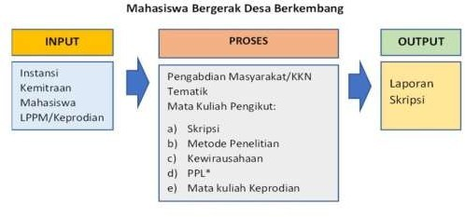

Figure 15: Thematic KKN community service program Concept

The objectives of the village development program/KKN-T are presented as follows:

1. The presence of students for 6-12 months can assist program planning, starting from assessing village potential, problems, and development challenges in the village, setting development priorities, designing programs, designing infrastructure, empowering the community, managing village-owned enterprises (BUMDes), supervising the development, to monitoring and evaluation.
2. Providing professional experience in the field of village development and empowerment to prepare students as an optimal generation, providing opportunities to develop students' fields of study and interests with final outputs in the form of written works, audio-visual projects, or other forms of final student reports.
3. Develop mutually beneficial cooperative networks between higher education institutions and village governments and communities in the form of introducing scientific and technological innovations acquired by students from their universities.

# Requirements

* + 1. **General Requirements**
       1. Active student and registered in PD-DIKTI;
       2. Obtain approval from the Academic Advisor (DPA) and/or Head/Coordinator of the Study Program;
       3. At least have completed six semesters.
       4. Be ready to live in the designated location.

# Special Requirements

Special requirements are determined by each PTKI.

# Mechanism

The village development/thematic community service program (KKN-T) is institutionally implemented by LP2M/P3M in collaboration with study programs, as it falls under the category of community service.

There are at least 3 (three) models of KKN-T that can be implemented:

* + 1. Model of KKN-T for Village Development and Empowerment

In this model, higher education institutions collaborate with partners to conduct KKN-T focused on village development and empowerment, based on the opportunities and conditions of the village that students will encounter during the program. The number and field of students participating in this program will be adjusted according to the village's needs. KKN-T activities will be carried out over 6–12 months at the location or up to a maximum of 20 credits.

* + 1. Model of KKN-T Teaching in Villages

This model is primarily for students from education programs. Students from other programs may also engage in teaching activities according to their areas of expertise, such as applying appropriate technology for community empowerment. All KKN-T teaching activities are intended to support both formal and non-formal education.

* + 1. Model of KKN-T Free-Form

Students are allowed to design and implement their own KKN-T program in collaboration with partners. When creating this KKN-T model, students must consider the relevant curriculum and consult with their Academic Advisor.

The general mechanisms and procedures are described as follows:

* 1. The higher education institution (LP2M/P3M) prepares thematic KKN guidelines as part of the MBKM curriculum.
  2. By the approval of the Academic Advisor (DPA) and acknowledgment by the study program, students register to participate in the village development/KKN-T program to LP2M/P3M;
  3. LP2M/P3M maps out potential participants, selects potential locations, and conducts a needs assessment survey;
  4. Students, in groups, prepare a program proposal, which is then reviewed by LP2M/P3M;
  5. Appoint field supervisors, a training team, and village mentors as guides;
  6. Students carry out the village development/KKN-T activities;
  7. Students complete a logbook detailing their activities;
  8. Students prepare an entrepreneurship activity report;
  9. Students present their reports to the board of examiners, including advisors and village supervisors, for assessment;
  10. The study program provides recognition through grades converted according to the learning outcomes or established courses;
  11. The study program reports the results of students participating in the village development/KKN-T program on the Higher Education Data Portal (PD-DIKTI).

The mechanism of the village development program/KKN- T is generally described as follows:

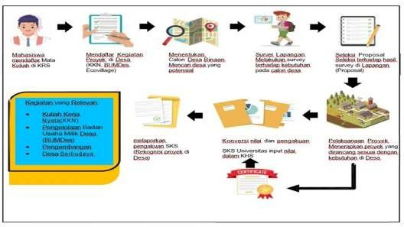

Figure 16: Mechanism of Village Development Activities

*Source: MBKM Guidebook Directorate General of Higher Education,*

*Ministry of Education and Culture (2020)*

# Roles and Responsibilities

The village development program/KKN-T institutionally involves LP2M/P3M as the person in charge of community service programs and partner institutions (villages). The duties and roles of each party in general are described as follows:

# Higher Education Institution

# Collaborate with the Ministry of Villages, Ministry of Education and Culture, development partners, local governments, the private sector, and other partners in the implementation of project programs in villages;

* + - 1. Manage the registration and placement of students to destination villages.
      2. Assign a coordinator, an advisor who will coordinate the implementation of KKN-T and guide students during the program;
      3. If possible, the coordinator and field supervisor visit the site for an initial survey, monitoring, and evaluation;
      4. Depart and return students from campus to the location to the KKN-T location;
      5. Provide debriefing, health checks, and provide health and safety insurance to prospective KKN-T participants;
      6. Developing guidelines and technical instructions as well as SOPs for the implementation of KKN- T by considering the guarantee of safety, security, and smooth implementation of student programs while in the field;
      7. Provide briefings on social culture, local wisdom, etiquette, customs, and manners specific to the community where KKN-T activities are conducted.
      8. Report the results of students participating in the village development program/KKN-T on the Higher Education Database (PD-DIKTI).

# Partner Institutions

The partners are the government (such as the Ministry of Village Affairs, Village Development by Universities, Ministry of Health, Ministry of Public Works and Housing, Ministry of Agriculture, Ministry of Social Affairs, Ministry of Environment and Forestry, Ministry of Home Affairs, Ministry of Foreign Affairs, Indonesian National Army, Indonesian National Police, and other institutions), local governments, State-Owned Enterprises (BUMN), industries, social investments, and community groups (migrants and diaspora).

The roles of these partners are:

* + - 1. The Ministry of Village Affairs provides village funds, relevant data and information, and field facilitators or village fund assistants.
      2. Provide Corporate Social Responsibility (CSR) funds and other funding sources to help student mobilization, logistics, and accommodation.
      3. Ensure the successful implementation of the village development/KKN-T project as agreed upon by the students.
      4. Provide supervisors, mentors, or coaches to support students or student groups during their village development/KKN-T activities.
      5. Supervisors assist and evaluate students' performance during the village project and, along with the field supervisors from the faculty, provide assessments.

# 6. Output and Credit Recognition

The main output of the village development program/KKN-T is a converted grade from a comprehensive student performance assessment. If needed, the output can also include a certificate and recognition on the Diploma Supplement (SKPI). This activity can also produce several outcomes, including articles published in journals, books, or Intellectual Property Rights (IPR).

The authority for determining grade conversion and credit recognition lies with the head or coordinator of the study program. For setting guidelines on conversion and credit recognition, the institution may form a conversion team involving the Vice Dean I, the Head and Secretary of the Department, the Head/Coordinator of the study program, LP2M/P3M, and faculty members.

KKN-T activities are carried out by students under the guidance of field supervisors assigned by the university. Through KKN-T, students can continue their tasks by documenting their activities and results in the form of a thesis or scientific writing as a final assignment. Therefore, the study program must create guidelines for the implementation of activities to ensure quality.

Here is an example of grade conversion into courses and credit recognition.

**Table 18:** Example of Course Recognition for the Village Development Program/KKN-T

|  |  |  |
| --- | --- | --- |
| **CLO of Village Development Program/KKN-T** | **Course Equivalency** | **Credit s** |
| Students can develop their hard skills and soft skills, including partnership, teamwork, social sensitivity, and leadership in interdisciplinary teams (across competencies). They will also enhance their managerial abilities in managing development programs in rural areas. | Service/Empowerment Methodology | 4 |
| Entrepreneurship | 2 |
| Internship | 4 |
| Community Service Program | 4 |
| Thesis/Final Report | 6 |
| **TOTAL** | | **20** |

# RELIGIOUS MODERATION

* 1. **Concept**

Religious moderation is a perspective, attitude, and practice of religion in common life by embodying the essence of religious teachings - which protects human dignity and builds public benefits - based on the principles of fairness, balance, and obeying the constitution as a national agreement. Religious moderation has several indicators, including national commitment, tolerance, anti-violence, and respect for tradition. According to this definition and these indicators, there are at least nine key terms that should be emphasized in religious moderation: humanity, the common good, justice, balance, constitutional adherence, national commitment, tolerance, anti-violence, and respect for tradition.

Religious moderation is a collective effort to foster a strong national commitment, alongside promoting a moderate understanding, knowledge, and practice of religion in communal life. Religious moderation acts as a bridge between religious zeal and national commitment, aiming to achieve a harmonious, peaceful, and tolerant religious and national life. Thus, religious moderation encompasses a broader scope compared to just national commitment and defense.

Religious moderation can be pursued through education and teaching, research, and community service. Programs based on religious moderation can be developed in various forms, such as learning modules, training of trainers (TOT) for religious moderation agents, research, mentoring, and more.

# Requirements

* + 1. **General Requirements**
       1. Active student and registered in PD-DIKTI;
       2. Obtain approval from the Academic Advisor (DPA) and/or Head/Coordinator of the Study Program;
       3. At least have completed four semesters.

# Special Requirements

Special requirements are determined by each PTKI.

# Mechanism

The religious moderation program can be carried out individually or in groups, in a structured format including training, social work, and other relevant activities. Islamic higher education institutions collaborate with both government and private organizations. For implementing this program, the study program defines the hard skills and soft skills as learning outcomes, with a maximum credit weight of 20 credits. In addition to course credit conversion, this program may also offer competency certificates.

To implement the religious moderation program, the general process is described as follows:

1. Students consult with study programs and academic advisors (DPA)
2. Students register for the religious moderation program;
3. The study program conducts verification and selection to determine eligible participants;
4. Students participate in the religious moderation program;
5. Students prepare and present a report on their activities;
6. The study program converts or transfers the semester credits as recognition for the student's achievements.
7. The study program reports the results of students participating in the religious moderation program on the Higher Education Database (PD-DIKTI).

# Roles and Responsibilities

The religious moderation program involves several institutions both on and off campus. This explanation outlines the roles and responsibilities of the higher education institution and the organizations where students participate in the program.

# Higher Education Institutions

1. Collaborate with training centers, correctional institutions, the National Counterterrorism Agency (BNPT), police, Interfaith Harmony Forums (FKUB), community organizations, Islamic boarding schools, educational institutions, ministry/agency work units, local governments, and other institutions relevant to the implementation of the religious moderation program.
2. Provide opportunities for students to participate in the religious moderation program through registration and selection.
3. Assign field supervisors to provide guidance, monitoring, and evaluation of the religious moderation activities conducted by students.
4. Facilitate students' administrative needs, such as permission letters, assignment letters, and others.
5. Standardize/recognize religious moderation activity hours to be acknowledged as credits.
6. Report the results of the religious moderation activities to the Higher Education Database (PD-DIKTI).

# Partner Institutions

# Ensure that the religious moderation activities participated in by students comply with the agreement outlined in the cooperation contract.

# Appoint a team to assist students in conducting religious moderation activities within their institution.

# Collaborate with field supervisors to monitor and evaluate the activities participated in by students.

# Provide grades that can be recognized as academic credits for students.

# 6. Output and Credit Recognition

The main output of this religious moderation program is a converted score from a comprehensive student performance assessment. the output can also include a competency or professional certificate and recognition on the Diploma Supplement (SKPI). Students who have completed the religious moderation program have their semester credits recognized as a form of credit transfer to fulfill the semester credit requirements for their undergraduate program as outlined in the curriculum of the study program. The recognition of semester credits is based on the relevance and equivalence of learning outcomes and the credit value achieved by students during the religious moderation program.

Assessment can be conducted by the faculty advisor based on the evaluation provided by the accompanying team or trainer. Credit recognition is based on hard skills and soft skills as a representation of learning outcomes established for a maximum of 20 credits from religious moderation activities. Credit recognition can also be granted to students participating in activities that include religious moderation content and are converted according to the fulfillment of religious moderation indicators.

The authority for determining grade conversion and credit recognition lies with the head or coordinator of the study program. For setting guidelines on conversion and credit recognition, the institution may form a conversion team involving the Vice Dean I, the Head and Secretary of the Department, the Head/Coordinator of the program, relevant partner units/institutions, and faculty members.

The example of religious moderation credit recognition is presented as follows:

**Table 19**. Example 1 of Religious Moderation Credit Recognition

|  |  |  |
| --- | --- | --- |
| **CLO of Religious Moderation** | **Course Equivalency** | **Credits** |
| Students have awareness, understanding, and the ability to implement religious moderation through national commitment, tolerance, anti-violence, and respect for tradition. | Humanity | 3 |
| Equality | 2 |
| Justice | 2 |
| Balance | 2 |
| Legal Obedience | 2 |
| Love of the Motherland | 3 |
| Tolerance | 2 |
| Openness (Inclusive) | 2 |
| Respect for Local Traditions | 2 |
| **Total** | | **20** |

**Table 20**. Example 2 of Religious Moderation Credit Recognition

|  |  |  |
| --- | --- | --- |
| **CLO of Religious Moderation** | **Course Equivalency** | **Credits** |
| Students have awareness, understanding, and the ability to implement religious moderation through national commitment, tolerance, anti-violence, and respect for tradition. | **Hard skills:** |  |
| Formulate a program | 4 |
| Resolve technical field problems | 10 |
| Prepare a report, presentation, or program publication | 6 |
| **Total** | **20** |
|  |  |
| **Soft skills:** |  |
| Humanity | 3 |
| Equality | 2 |
| Justice | 2 |
| Balance | 2 |
| Legal Obedience | 2 |
| Love of the Motherland | 3 |
| Tolerance | 2 |
| Openness (Inclusive) | 2 |
| Respect for Local Traditions | 2 |
| **Total** | | **20** |

# PART IV

# QUALITY ASSURANCE

1. **Quality policy**
   1. Objectives
      1. Ensure that every implementation of the Independent Learning – Independent Campus (MBKM) program in the *Tridharma* of Higher Education complies with all established standards;
      2. Achieve transparency and accountability to the public and stakeholders regarding the implementation of the MBKM program in the *Tridharma* of Higher Education according to the established standards;
      3. Involve all institutions, centers, units, and departments in the Higher Education institution to collaborate in achieving objectives by adhering to standards and continuously striving to improve quality; and
      4. Strengthen the MBKM implementation system with a focus on producing competent and experienced graduates.
   2. Strategies
      1. Mobilize internal and external resources from the stage of establishment to the stage of quality improvement in the implementation of the Independent Learning – Independent Campus (MBKM) program in the fields of the *Tridharma* of Higher Education.
      2. Conduct structured and planned training for MBKM lecturers/field supervisors;
      3. Promote the program to all stakeholders so they understand the policy documents created and can implement them effectively.
      4. Implement the Internal Quality Assurance System (SPMI) cycle using the PPEPP method.
   3. Principles
      1. Oriented towards enhancing students' competencies, interests, and talents;
      2. Process- and output-oriented;
      3. Prioritizes the satisfaction of graduates' users;
      4. Flexible to diverse methods;
      5. Measurable, systematic, and sustainable.
   4. Management

The implementation of the Independent Learning – Independent Campus (MBKM) program in the *Tridharma* of Higher Education follows the PPEPP cycle (Establishment, Implementation, Evaluation, Control, and Improvement), which can enhance sustainable quality (kaizen/continuous quality improvement) at Higher Education institutions. Each MBKM activity in the *Tridharma* of Higher Education has accountable documents that reflect the PPEPP cycle and can be audited internally (internal quality audit) and externally (BAN-PT, LAM, International Accreditation, ISO, etc.). The quality assurance management of MBKM at Higher Education institutions is handled by the Quality Assurance Institution (LPM), involving the Quality Control Team, Curriculum and Learning Development Center, and/or other units with similar functions.

The management structure for the implementation of the Independent Learning – Independent Campus (MBKM) program in the *Tridharma* of Higher Education is described as follows:

* + 1. Education and Teaching
       - Vice Rector/Chairman I
       - Dean/Head of Department
       - Vice Dean I/Department Secretary
       - Head/Coordinator of Study Program
       - Lecturer/Field Supervisor
       - Academic Advisor
       - Head of Laboratory
       - Administration Staff
       - IT and Database Unit (TIPD)
    2. Research
       - Vice Rector/Chairman I
       - LP2M/P3M
       - Dean/Head of Department
       - Vice Dean I/Department Secretary
       - Head/Coordinator of Study Program
       - Lecturer/Field Supervisor
       - Academic Advisor
       - Administration Staff
       - IT and Database Unit (TIPD)
    3. Community Service Program
       - Vice Rector/Chairman I
       - LP2M/P3M
       - Dean/Head of Department
       - Vice Dean I/Department Secretary
       - Head/Coordinator of Study Program
       - Lecturer/Field Supervisor
       - Academic Advisor
       - Administration Staff
       - IT and Database Unit (TIPD)

Stages of Quality Assurance for the Implementation of the Independent Learning and Campus Merdeka (MBKM) Program in the *Tridharma* of Higher Education are:

1. Establishment of manuals and quality standards
2. Implementation and reporting of activities
3. Monitoring and evaluation through Internal Quality Audit (AMI)
4. Formulation of recommendations for corrective actions

# Quality Standards and Manual

Quality standards for MBKM activities in the *Tridharma* of Higher Education need to be established to ensure the quality of their implementation. These MBKM quality standards cover the following activities:

* 1. Student Exchange
  2. Internship/Practical Work
  3. Teaching Assistance in Educational Unit
  4. Research
  5. Humanitarian Project
  6. Entrepreneurial Activities
  7. Independent Study/Project
  8. Village Development/Thematic Community Service Program
  9. Religious Moderation

The formulation of quality standards outlined in these guidelines is general. The Specific quality standards can be formulated by each higher education institution and the organizing institutions and/or partners of the MBKM activities. The General quality standards formulated based on the criteria for the maximum credit recognition for each activity are described as follows:

**Table 21**: Criteria for Credit Recognition

|  |  |  |
| --- | --- | --- |
| **No.** | **Activities** | **Criteria for Credit Recognition** |
| 1 | Student Exchange | 1. The Course Learning Outcomes (CPL) of the courses taken are aligned with the CPL of the original study program, whether as primary CPL or supplementary CPL; 2. Students participate in the lecture process intensively according to the process standards set by the study program or the target higher education institution; 3. The results of the assessment of learning outcomes (outputs) meet the minimum standards. |
| 2 | Internship/Practical Work | 1. The Course Learning Outcomes (CPL) set for internships/practical work align with the CPL of the original study program, whether as primary CPL or supplementary CPL; 2. Students carry out internships/practical work intensively according to the process standards set by the internship site; 3. The assessment results of competencies and performance (output) meet the minimum standards; 4. Produce an output in the form of an activity report. |
| 3 | Teaching Assistance in Educational Unit | 1. The Course Learning Outcomes (CPL) set for teaching assistance activities align with the CPL of the original study program, whether as primary CPL or supplementary CPL. 2. Students perform teaching assistance activities fully according to the process standards set by the teaching institution. 3. The assessment results of competencies and performance (output) meet the minimum standards. 4. Produce an output in theform of an activity report. |
| 4 | Research | * 1. The Course Learning Outcomes (CPL) set for research activities align with the CPL of the original study program, whether as primary CPL or supplementary CPL.   2. Students conduct research activities according to the process standards set by the research institution/laboratory/study center partner.   3. The assessment results of competencies and performance (output) meet the minimum standards.   4. Produce an output in the form of a research report/document. |
| 5 | Humanitarian Projects | 1. The Course Learning Outcomes (CPL) set for humanitarian projects align with the CPL of the original study program, whether as primary CPL or supplementary CPL. 2. Students carry out humanitarian project activities according to the process standards set by the implementing partner institution. 3. The assessment results of competencies and performance (output) meet the minimum standards. 4. Produce an output in the form of an activity report. |
| 6 | Entrepreneurial Activities | 1. The Course Learning Outcomes (CPL) set for entrepreneurial activities align with the CPL of the original study program, whether as primary CPL or supplementary CPL. 2. Students conduct entrepreneurial activities according to the process standards set by the organizing partner institution. 3. The assessment results of competencies and performance (output) meet the minimum standards. 4. Produce an output in the form of an activity report. |
| 7 | Independent Study/Projects | 1. The Course Learning Outcomes (CPL) formulated for independent study/projects align with the CPL of the original study program, whether as primary CPL or supplementary CPL. 2. Students conduct independent study/projects according to the process standards set by the campus. 3. The assessment of the process, competency achievements, and performance (output) meets the minimum standards. 4. Produce an output in the form of an activity report. |
| 8 | Village Development / Thematic Community Service Program (KKN-T) | 1. The Course Learning Outcomes (CPL) set for village development/Thematic Community Service Program align with the CPL of the original study program, whether as primary CPL or supplementary CPL. 2. Students carry out village development/ Thematic Community Service Program according to the process standards set by the organizing campus. 3. The assessment results of competencies and performance (output) meet the minimum standards. 4. Produce an output in the form of an activity report. |
| 9 | Religious Moderation | 1. The Course Learning Outcomes (CPL) set for religious moderation activities align with the CPL of the original study program, whether as primary CPL or supplementary CPL. 2. Students conduct religious moderation activities according to the established process standards. 3. The assessment results of competencies and performance (output) meet the minimum standards. |

The conversion of MBKM activities into credit recognition is determined by the Study Program according to the established conversion and credit recognition guidelines. The data used for conversion and credit recognition are derived from assessments by the course lecturers/field supervisors and/or evaluations by the team after coordinating with the MBKM activity partners at the higher education institution.

Based on these general quality standards, higher education institutions establish specific quality standards accompanied by a quality manual. The quality manual includes components and mechanisms for achieving quality, covering planning, implementation, evaluation, and follow-up related to the implementation of MBKM in the *Tridharma* of Higher Education.

# Monitoring and Evaluation

* 1. Objectives

1. Provide accurate information to the higher education leadership regarding the implementation of MBKM in the *Tridharma* of Higher Education;
2. Detect the conformity of activities with the established quality standards;
3. Assess the alignment of activities based on the higher education quality assurance cycle;
4. Provide recommendations to decision-makers for making improvements and taking follow-up actions.
   1. Scope
5. MBKM Planning
6. Establishment of Course Learning Outcomes (CPL) and credit conversion (SKS);
7. Mechanism for implementing MBKM;
8. Establishment of Field Supervisors;
9. Guidance and establishment of MBKM activity design; and
10. Cooperation procedures.
11. Implementation and Control
12. Supervision and assessment forms;
13. Credit conversion forms;
14. Output achievement forms;
15. Student attendance forms; and
16. Assessment forms.
17. Quality Improvement
18. Recommendations and follow-up of the previous period; and
19. Evaluation results of the previous period.
20. Significance
    * 1. Provides accurate information and quality data based on empirical implementation;
      2. Presents data analysis of the functions of the involved parties; and
      3. Serves as a milestone for continuous quality improvement.
21. Stages of Activities
    1. Preparation
22. Establish a monitoring and evaluation team;
23. Identify quality targets for monitoring and evaluation;
24. Develop instruments and strategies; and
25. Collect quality documents;
    1. Implementation
26. Organize monitoring and evaluation activities;
27. Collect monitoring and evaluation data; and
28. Process the data on monitoring and evaluation results.
    1. Follow-up Plan
29. Draft the recommendations;
30. Provide the tasks among the parties; and
31. Set a schedule for the follow-up actions.
32. Reporting

All stages of monitoring and evaluation activities are compiled into one quality document that contains at least the following information:

* + 1. Identification of quality standards for the implementation of MBKM in the *Tridharma* of Higher Education;
    2. Quality targets for monitoring and evaluation;
    3. Instruments;
    4. Results of monitoring and evaluation; and
    5. Follow-up Plan.

1. Executive

Generally, this quality assurance process is carried out by the Quality Assurance Institution/Unit at the institutional level, together with the Quality Control Team or similar bodies at the UPPS (Academic Unit) level. The Quality Control Team at the UPPS level is responsible for monitoring and evaluating the implementation of MBKM at the faculty/department and study program levels. The Quality Assurance Institution/Unit at the institutional level is responsible for overall monitoring and evaluation, including conducting Internal Quality Audits (AMI).

# PART V

# INSTITUTIONAL COOPERATION

In implementing the MBKM policy at PTKI (Islamic Higher Education Institutions), it is necessary to establish partnership cooperation between PTKI and various parties, including both government and private institutions, as well as relevant industries and businesses. Cooperation at the PTKI level can be supported by national-scale agreements involving various ministries, directorates, government agencies, and other relevant institutions. Partnership cooperation is a key factor in the successful implementation of the MBKM policy.

# FOCUS OF COOPERATION

The focus of cooperation between universities and government agencies, private sectors, professional certification bodies, as well as industry and business sectors is intended for the implementation of the MBKM policy. The focus areas of cooperation include:

* 1. Curriculum Development

Universities that are implementing the Independent Learning – Independent Campus (MBKM) policy should develop a curriculum that aligns with this policy. In this curriculum development process, PTKI can involve cooperation partners to ensure that the curriculum and teaching methods are appropriate to the conditions and meet the expected achievement standards.

* 1. Learning Management

Cooperation between universities, whether among PTKIs (Islamic Higher Education Institutions) or with domestic and international higher education institutions, includes considerations on the learning system. This involves decisions on how learning credits (SKS) will be distributed—whether they will be concentrated in two specific semesters or spread across various semesters. This scheme impacts the readiness of students who may come from different regions. The learning system must be an agreed-upon component in inter-campus learning cooperation.

* 1. Program Management

Cooperation between universities and various other institutions, both public and private, including businesses and industries, involves the organization of off-campus programs. This cooperation encompasses agreements on Learning Outcomes (CPL), program schemes, credit conversion systems, certification, and other specific elements that will form the basis for implementing MBKM programs off-campus.

* 1. Inputting Learning Outcomes

Students who have participated in programs and forms of learning as part of the MBKM policy implementation are entitled to receive learning outcomes. The form of these learning outcomes is agreed upon by the cooperating parties. The learning outcomes obtained by the students are inputted into the PD-DIKTI portal according to the regulations, and the responsibility for inputting learning outcomes falls on each university.

* 1. Financing

In principle, cooperation should mutually benefit all parties. Regarding the financing of education outside the study program and off-campus, it is necessary to agree on how to handle any differences in UKT (Student Tuition Fees) between the sending university and the host university. It should be decided whether any such difference will be covered by the student or the university sending the student. Similarly, the financing of off-campus learning should be agreed upon with the institution or agency where the student is studying.

* 1. Responsible Parties

In the implementation of the MBKM policy, each higher education institution can establish a task force involving partners and study programs. This task force, or by any other name, functions to coordinate and resolve any challenges encountered during the cooperation process.

# PREPARATION OF COOPERATION DOCUMENTS

* 1. Draft Preparation

The draft of the cooperation agreement can be prepared by the higher education institution initiating the partnership. The principles of mutual benefit, transparency, and respect for each institution's characteristics form the basis of the draft. The format of the draft can be adapted to the conventions of the participating institutions.

* 1. Negotiation and Agreement

Once the draft is complete, it should be presented to the partner institution or organization for review and negotiation of any clauses where differences may arise. These negotiations might address aspects such as costs, timelines, curriculum, implementation details, and other relevant issues. The final draft to be signed is the one that both parties have mutually agreed upon.

* 1. Validity

The implementation of the partnership follows the clauses outlined in the agreement. Additionally, the mechanism for resolving issues or conflicts should be included in the agreement to address any differences or misunderstandings between the collaborating institutions.

* 1. Implementation of Cooperation
     1. At Ministry/Directorate Level

The Minister/Director General/Director provides the framework for cooperation across ministries, directorates, or with various government agencies, state-owned enterprises, and others at the central level.

* + 1. At the Islamic Higher Education Institution (PTKI) Level

Universities/Institutes/Colleges are responsible for their authority, including the process of establishing cooperation, financing, and signing agreements.

* + 1. At the Faculty and Institution Level

Faculties and institutions are responsible for their authority, including learning facilities, program implementation, preparation of teaching staff, supervisors, and other supporting facilities.

* + 1. At the Study Program Level

The study programs are responsible for aspects such as curriculum design, providing course syllabi, teaching, assessing learning outcomes, credit conversion systems, and other things within their authority.

* 1. Evaluation of Collaboration
     1. Evaluation Aspects

The institution engaged in collaboration needs to conduct periodic evaluations. The aspects of evaluation include the implementation of the independent learning campus program, challenges faced by the institution and students, utilization of learning facilities, funding, and other relevant factors.

* + 1. Formulation of Follow-Up Actions

The evaluations conducted by the collaborating parties lead to agreed-upon follow-up actions. These follow-ups may involve creating new agreements or amending existing ones.

# PART VI

# CONCLUSION

This guideline is a response to the MBKM policy in facilitating students to develop their interests, talents, and potentials by selecting from nine development activities offered, with a maximum of 20 credits within their university and 40 credits outside the university. This guideline serves as a reference for universities in formulating more operational guidelines and allows for innovation and development of similar programs according to the unique characteristics of each campus.