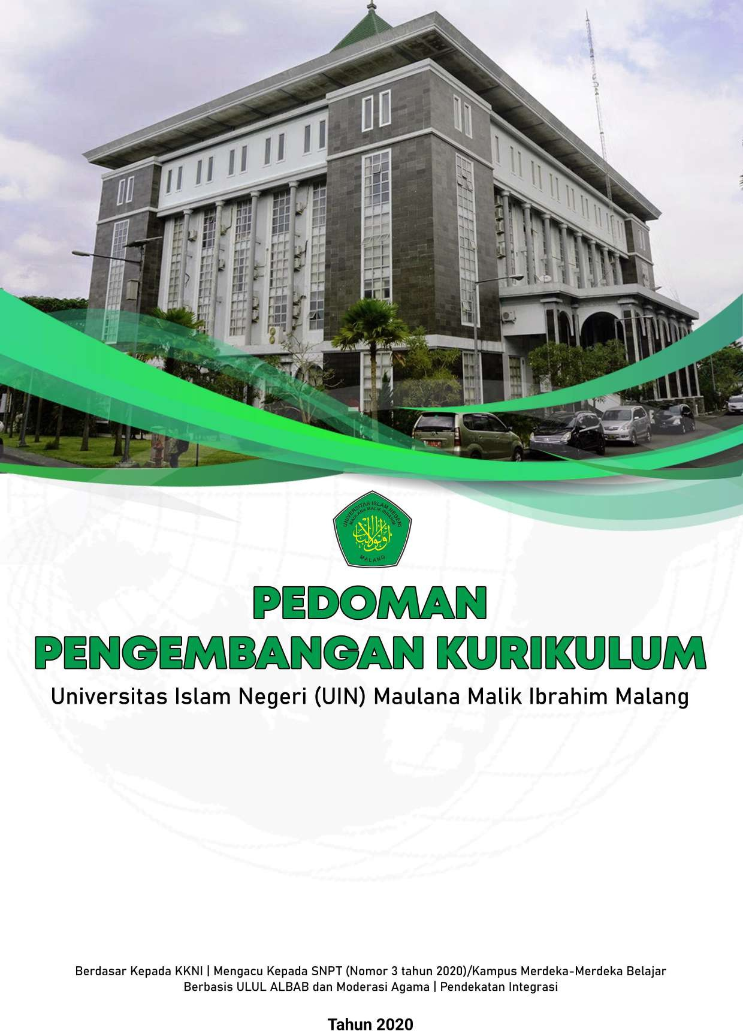

**EDITORIAL TEAM:**

Prof. Dr. H. M. Zainuddin, MA Dr. Muhammad Walid, MA Dr. Anton Prasetyo, MA

Dr. Ali Ridlo, M.Si Dr. M. Faisol, M.Ag Dr. Siswanto, M.Si

Dr. H. Badruddin, M.Hum

Apt. Dr. Roihatul Mutiah, S.F. M.Kes Dr. H. Mahfud Shodar, M.Ag

Imam Ahmad, M.Ag

# PREFACE

Prof. Dr. M. Zainuddin, M.A

Vice Rector for Academic Affairs

The higher education system in Indonesia has four main components, including inputs, processes, outputs, and outcomes. The Higher Education inputs are graduates of senior high schools, Islamic senior high schools, and vocational schools who register to participate in gaining learning experience in the learning process that has been offered. Good input has several indicators, including good graduation scores.

An educational institution is considered successful and qualified if its graduates have competence and can be recognized by the community. Therefore, the profile of graduates needs to be formulated properly and precisely under the needs of society. The graduate profile must also have competencies: moral, intellectual, social, and professional. Therefore, the quality of the curriculum must also consider the elements of conformity with goals, standards, customer satisfaction, and excellence.

During the era of the Minister of Education and Culture, Nadim Makarim, there were four important policies launched in the development of Higher Education, including ease of opening new study programs, changes in the campus accreditation system, ease of campus status to become a legal entity, and student internships for three semesters.

First, according to Nadim, the current curriculum of study programs remains theoretical and lacks alignment with the job market. So, the public and private universities with A and B accreditation can be granted permission to open new study programs, provided they collaborate with third parties such as industry players, world-class non-profit organizations, state-owned enterprises (BUMN and BUMD), or top 100 world universities based on QS ranking. This collaboration can include developing curricula and internship programs.

Second, an automatic accreditation program will be implemented for all rankings. The accreditation established by the National Accreditation Board for Higher Education (BAN-PT) will remain valid for five years and will be automatically renewed.

Third, there will be facilitated status changes from state universities (PTN-Satker) and public service agencies (PTN-BLU) to legal entities (PTN-BH). The government will assist and simplify the process for universities aiming to achieve PTN-BH status. By becoming PTN-BH, universities will gain autonomy and flexibility to collaborate with industry. This status change is expected to enhance the competitiveness of state universities on the global stage.

Fourth, the right to three semesters of internship outside the study program. This policy will allow students to take courses outside the study program for three semesters. Even so, this program is not compulsory. However, universities should provide this option.

Responding and following up on the policy of the Minister of Education and Culture, especially those related to the Independent Learning - Independent Campus program, UIN Maulana Malik Ibrahim needs to publish the guidebook. Hopefully, the publication of this guidebook can provide benefits for all parties, especially students.

We extend our highest gratitude and appreciation to the writing and drafting team, especially the Vice Deans of Academic Affairs at UIN Maulana Malik Ibrahim, who have consistently held discussions every Wednesday from one faculty to another to address various academic issues and government policies. Finally, we only seek guidance and assistance from Allah.

Malang, January 12, 2021

# RECTOR'S SPEECH

Prof. Dr. H. Abd. Haris, M.Ag

Rector of UIN Maulana Malik Ibrahim Malang

*Assalamualaikum warahmatullahi wabarakatuh... Bismillahirrahmanirrahim,*

To achieve the goals of higher education, particularly for State Islamic Higher Education Institutions under the Ministry of Religious Affairs of the Republic of Indonesia, it is necessary to develop a Curriculum Development Guide. This effort also represents a tangible commitment to fostering a high-quality academic culture on campus.

On behalf of the leadership of Maulana Malik Ibrahim State Islamic University (UIN) Malang, an institution with an international reputation and driven by the tagline “Islamic World Class University,” we express our biggest support and appreciation for the preparation of this Curriculum Development Guidebook.

We hope this Curriculum Development Guidebook will provide clear information and an overview of the fundamental principles and patterns of academic curriculum development for leaders, lecturers, educators, and all relevant stakeholders. This book is essential for dissemination to the targeted audience, especially as the curriculum renewal process continues to evolve. Furthermore, the content and objectives outlined in this book are part of the efforts to embrace the era of the Independent Campus and Independent Learning, initiated by the Minister of Education and Culture of the Republic of Indonesia.

Thus, we hope this curriculum development guide can serve its function as a reference in the implementation of campus curriculum development and innovation, and be used under the applicable rules and procedures.

*Wassalamualaikum warahmatullahi wabarakatuh...*

Malang, January 12, 20221

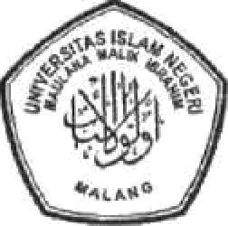

# RECTOR’S DECREE

**MAULANA MALIK IBRAHIM STATE ISLAMIC UNIVERSITY MALANG**

**Number 112 of 2021**

About

**CURRICULUM GUIDELINES**

**AT MAULANA MALIK IBRAHIM STATE ISLAMIC UNIVERSITY MALANG**

**BY THE GRACE OF ALMIGHTY GOD**

**RECTOR OF MAULANA MALIK IBRAHIM STATE ISLAMIC UNIVERSITY MALANG**

|  |  |
| --- | --- |
| **CONSIDERING :** | 1. To provide graduates under the independent learning mission formulated by the University within the framework of curriculum development, it is necessary to establish Curriculum guidelines; 2. Based on the considerations as referred to in point "a", it is necessary to issue the Rector's Decree on Curriculum Guidelines at Maulana Malik İbrahim State Islamic University Malang. |
| **NOTING :** | 1. Law No. 20 of 2003 on the National Education System; 2. Law No. 12 of 2012 on Higher Education (State Gazette of the Republic of Indonesia of 2003 No. 78, Additional of State Gazette of the Republic of Indonesia No. 4301); 3. Government Regulation of the Republic of Indonesia No. 4 of 2014 on the Implementation of Higher Education and Management of Higher Education (State Gazette of the Republic of Indonesia of 2014 No. 16, Additional of State Gazette of the Republic of Indonesia No. 5500); 4. Regulation of the Minister of Religious Affairs No. 40 of 2018 on the Change On the Regulation of the Minister of Religious Affairs No. 15 of 2017 Regarding the Statute of Maulana Malik Ibrahim State Islamic University Malang; 5. Minister of Education and Culture Regulation No. 3 of 2020 about National Standards for Higher Education (State Gazette of the Republic of Indonesia of 2020 No. 1947); 6. Decree of the Rector of Maulana Malik Ibrahim State Islamic University Malang Number: B.2438f/Un.3/KP.078/4/2018 about the Strategic Plan of Maulana Malik Ibrahim State Islamic University Malang of 2018-2022. |
| **REGARDING :** | The results of the University Senate Meeting on the Guidelines for the Independent Learning Curriculum at Maulana Malik Ibrahim State Islamic University Malang on November 16, 2020 |
|  | **DECLARE** |
| **ESTABLISH :** | **RECTOR'S DECREE ON CURRICULUM GUIDELINES AT MAULANA MALIK IBRAHIM STATE ISLAMIC UNIVERSITY MALANG.** |
| **First :** | The curriculum developed at Maulana Malik Ibrahim State Islamic University Malang is outlined in the curriculum guidelines attached to this Decree. |
| **Second :** | The Curriculum Guidelines, as outlined in the appendix to this Decree, serve as the framework for developing curriculum documents at Maulana Malik Ibrahim State Islamic University Malang. |
| **Third :** | This decision is effective from the date of enactment. The previously published Curriculum Guidelines at Maulana Malik Ibrahim State Islamic University Malang are no longer valid. Any errors found in this decision will be corrected as needed. |

Issued in : Malang

Date : January 12, 2021

Rector,

Signed and stamped

Abd. Haris

Copy:

1. Vice-chancellors
2. Heads of bureau
3. Deans
4. Graduate directors

# SHOLAWAT IRFAN

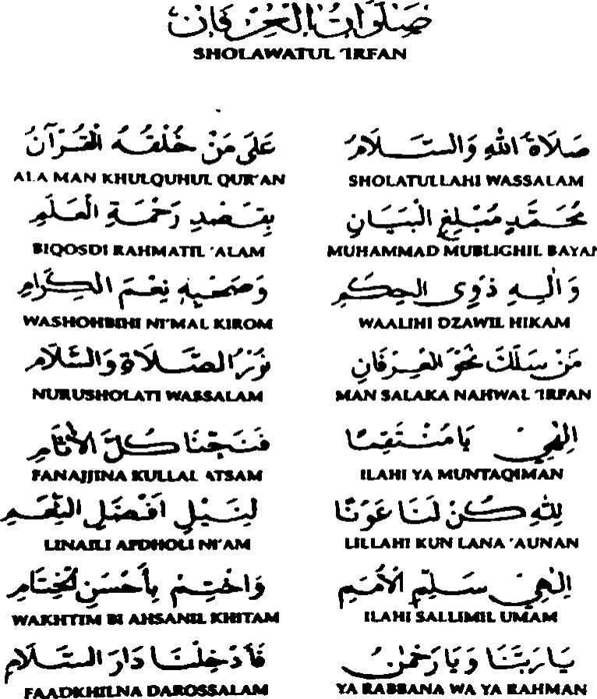

Composer: KH. Achmad Mudlor

# OFFICIAL ANTHEM OF UIN MAULANA MALIK IBRAHIM

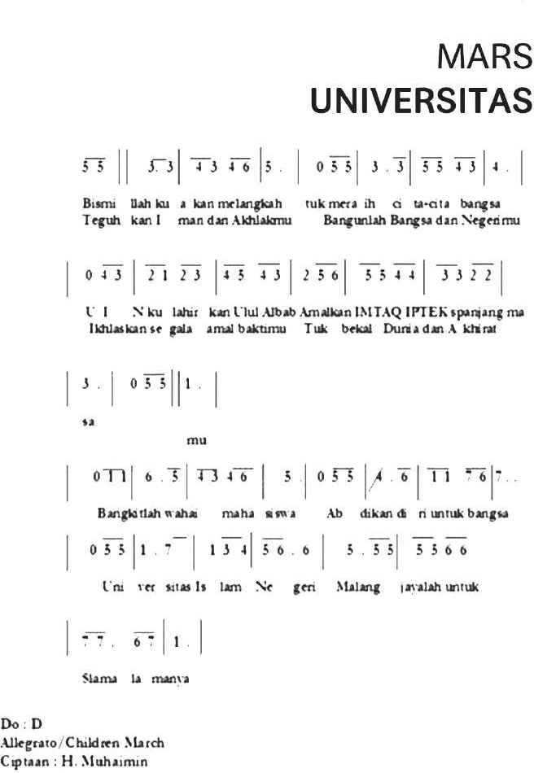

# LIST OF FIGURES

Figure 1 : Curriculum Development Map of Study Program

Figure 2 : KMMB Activities

Figure 3 : Course Codes

# LIST OF TABLES

Table 1 : Education Model

Table 2 : Example of Elective Courses

Table 3 : Regular Course Structure/ The example at the Faculty of Tarbiyah and Teacher Training (FITK)

Table 4 : Example of Independent Campus Course Structure / The example at the Faculty of Tarbiyah and Teacher Training (FITK)

Table 5 : Regular Curriculum Structure

Table 6 : Independent Campus Lecture Model Option 1

Table 7 : Independent Campus Lecture Model Option 2

Table 8 : Independent Campus Lecture Model Option 3

Table 9 : Independent Campus Lecture Model Option 4

Table 10 : Independent Campus Lecture Model Option 5

Table 11 : Independent Campus Lecture Model Option 6

Table 12 : Independent Campus Lecture Model Option 7

Table 13 : Independent Campus Lecture Model Option 8

Table 14 : Independent Campus Lecture Model Option 9

Table 15 : Independent Campus Course Model Option 10

Table 16 : Student Exchange across Faculty Elective Programs (package)

Table 17 : Student Exchange across Study Programs based on Additional Competencies

Table 18 : Student Exchange across the same Study Program at different Universities

Table 19 : Student Exchange across Study Programs

Table 20 : Free Form

Table 21 : Structured Form

Table 22 : KMMB Activity Forms

Table 23 : Examples of learning selection, forms, methods, and assignments

Table 24 : Classification of blended learning

Table 25 : Learning Principles

Table 26 : Assessment Techniques and Instruments

Table 27 : Assessment Categories (for nonmedical study programs)

Table 28 : Assessment Categories for Medical Study Programs

Table 29 : Report of Learning Outcomes Assessment

Table 30 : Student Graduation

# TABLE OF CONTENTS

PREFACE i

RECTOR'S SPEECH iv

RECTOR’S DECREE v

SHOLAWAT IRFAN vii

OFFICIAL ANTHEM OF UIN MAULANA MALIK IBRAHIM viii

LIST OF FIGURES ix

LIST OF TABLES x

TABLE OF CONTENTS xi

CURRICULUM DEVELOPMENT GUIDELINES 1

1. General Terms 1

2. Foundation for Curriculum Development 2

3. Principles of Curriculum Development 4

4. Curriculum Development Direction and Policy 5

5. Fundamentals of Curriculum Development 6

6. Curriculum Development Needs Analysis 7

7. Curriculum Formulation 7

8. Curriculum Implementation 8

9. KMMB Education Model (Independent Campus – Independent Learning) 9

10. Curriculum and Courses 10

11. Special Provisions for the Independent Campus – Independent Learning (KMMB) Curriculum 14

12. KMMB Curriculum Activities 30

13. Course Code Guidelines 39

14. Learning Process 40

15. Learning Assessment 45

16. Curriculum Documents Based on Study Program Accreditation 49

17. Curriculum Evaluation 50

18. Conclusion 51

REFERENCES 52

# CURRICULUM DEVELOPMENT GUIDELINES

**MAULANA MALIK IBRAHIM STATE ISLAMIC UNIVERSITY MALANG 2020**

## General Terms

With the issuance of Presidential Regulation Number 8 of 2012 concerning the Indonesian National Qualifications Framework (KKNI), and Law Number 12 of 2012 concerning Higher Education, all higher education institutions (including UIN Maulana Malik Ibrahim Malang) are encouraged to adapt to these regulations. The KKNI is a statement of the quality of Indonesian human resources, with qualification levels based on abilities defined in learning outcomes. Higher education institutions (in this case, UIN Maulana Malik Ibrahim Malang) need to assess whether the graduates have ‘capabilities’ equivalent to the ‘learning outcomes’ outlined in the KKNI qualification levels. Nationally agreed standards specify that, for instance, bachelor's program graduates should have a 'capability' equivalent to the learning outcomes defined at KKNI level 6, master's graduates at level 8, and doctoral graduates at level 9.

In developing or revising curricula, higher education institutions must refer to the KKNI and the National Standards for Higher Education. The challenge faced by institutions in curriculum development in the era of Industry 4.0 is to provide graduates with new literacy skills, including data literacy, technology literacy, and ethical literacy based on religious beliefs. Institutions need to reorient their curriculum development to address these challenges.

The higher education curriculum at UIN Maulana Malik Ibrahim Malang is designed to produce graduates, ensuring that the program guarantees that its graduates meet the qualifications agreed upon in the KKNI. The concept developed by the Directorate General of Learning and Student Affairs involves starting curriculum design by defining the graduate profile, which is then translated into learning outcomes. These outcomes, referred to in KKNI descriptors as "learning outcomes," encompass the competencies included or represented by these outcomes. The term "competency" used in higher education (DIKTI) is found in SN-Dikti Article 5, Paragraph (1), which states that the Graduate Competency Standards (SKL) are the minimum criteria for graduate qualifications, covering attitudes, knowledge, and skills, as articulated in the Graduate Learning Outcomes (CPL).

The description of learning outcomes in the KKNI includes four components: attitudes and values, work capabilities, mastery of knowledge, and authority and responsibility. In the National Standards for Higher Education (SN-Dikti), graduate learning outcomes are encompassed within one of the standards, specifically the Graduate Competency Standards (SKL). According to SN-Dikti, learning outcomes consist of attitudes, general skills, specific skills, and knowledge. Attitudes and general skills are detailed and included in the SN-Dikti appendix, while specific skills and knowledge must be defined by similar study program forums that reflect the characteristics of the program’s graduates. The formulation of learning outcomes for each type of study program is sent to the Director of Belmawa at the Ministry of Research, Technology, and Higher Education, and, after review by appointed expert teams, is approved by the Minister. Based on these graduate learning outcomes (CPL), the curriculum for a study program can be developed. According to Law Number 12 of 2012 on Higher Education, curriculum development is the right of higher education institutions, but it must adhere to national standards (Article 35, Paragraph 1).

In general, a curriculum, as a plan, consists of four components: learning outcomes, study materials, learning processes to achieve the outcomes and assessment. The formulation of graduate learning outcomes refers to KKNI descriptors, particularly in the areas of Knowledge and Specific Skills, while the areas of Attitudes and General Skills can be adopted from SN-Dikti. Comprehensive curriculum development also refers to the 8 National Education Standards, along with the 8 National Research Standards and 8 National Community Service Standards.

## Foundation for Curriculum Development

The curriculum development at UIN Maulana Malik Ibrahim Malang is based on a solid foundation, including philosophical, sociological, psychological, historical, and legal aspects. While developing a curriculum is both a right and a duty of each higher education institution, it must be grounded in the 1945 Constitution, Law No. 12 of 2012, the National Standards for Higher Education as outlined in Regulation No. 44 of 2015, and other applicable regulations. The curriculum is intended to enable students to master specific knowledge and skills while fostering noble character, thus contributing to the preservation of diversity, enhancing the welfare, and promoting the greatness of Indonesia.

* 1. Philosophical Foundations.

The philosophical foundation guides the design, implementation, and improvement of education (Ornstein & Hunkins, 2014). It outlines how knowledge should be examined and learned so that students understand the essence of life and develop the skills to enhance their quality of life both individually and within society (Zais, 1976).

* 1. Sociological Foundation

The sociological foundation supports curriculum development as an educational framework consisting of objectives, content, learning activities, and a positive learning environment that fosters relevant experiences for personal and social development (Ornstein & Hunkins, 2014, p. 128). The curriculum should facilitate the transfer of culture from one generation to the next. Culture is understood as part of group knowledge (Ross, 1963, p. 85). The curriculum must also help learners break free from cultural biases and avoid cultural encapsulation, which can lead to reluctance to understand other cultures (Zais, 1976, p. 219).

* 1. Psychological Foundations

Provides a foundation for curriculum development, so that the curriculum can continuously encourage student curiosity and motivate lifelong learning; a curriculum that facilitates student learning, enabling them to recognize their roles and functions within their environment; a curriculum that fosters critical thinking and higher-order reasoning; a curriculum that optimizes the development of students' potential to become desirable human beings (Zais, 1976, p. 200); a curriculum that facilitates students in becoming well-rounded individuals—those who are free, responsible, confident, moral or virtuous, capable of collaboration, tolerant, and fully educated to contribute to the realization of the ideals in the preamble of the 1945 Constitution.

* 1. Historical Foundation

A curriculum that facilitates students to learn according to their era; a curriculum that can inherit the cultural values and history of the golden nations of the past, and transform them in the era in which they are studying; a curriculum that prepares students to live better in the era of 21st-century, play an active role in the Industrial Era 4.0, and read the signs of the Industrial Revolution 5.0.

* 1. Legal Foundation

The legal foundation serves as the basis or reference at the stages of design, development, implementation, and evaluation, as well as the quality assurance system of higher education that will ensure the implementation of the curriculum and the achievement of curriculum goals. The following are some of the legal foundations needed in the preparation and implementation of the curriculum:

* + 1. Law of the Republic of Indonesia Number 14 of 2005 concerning Teachers and Lecturers (State Gazette of the Republic of Indonesia Year 2005 Number 157, Supplement to State Gazette of the Republic of Indonesia Number 4586)
    2. Law of the Republic of Indonesia Number 12 Year 2012 on Higher Education (State Gazette of the Republic of Indonesia of 2012 Number 158, Supplement to State Gazette of the Republic of Indonesia Number 5336);
    3. Presidential Regulation of the Republic of Indonesia Number 8 of 2012, concerning the Indonesian National Qualifications Framework (KKNI);
    4. Regulation of the Minister of Education and Culture of the Republic of Indonesia Number 73 of 2013, concerning the Implementation of KKNI in the Field of Higher Education;
    5. Regulation of the Minister of Research, Technology and Higher Education of the Republic of Indonesia Number 44 of 2015 on National Higher Education Standards;
    6. Regulation of the Minister of Religious Affairs Number 1 of 2016 concerning Diplomas, Academic Transcripts, and Diploma Supplements in Religious Higher Education Institutions;
    7. Regulation of the Minister of Research, Technology and Higher Education of the Republic of Indonesia Number 62 of 2016 concerning Higher Education Quality Assurance System;
    8. Regulation of the Minister of Research, Technology, and Higher Education Number 59 of 2018, concerning Diplomas, Certificates of Competence, Professional Certificates, Degrees, and Procedures for Writing Degrees in Higher Education;
    9. Decree of the Minister of Research, Technology and Higher Education No. 123/2019 on Internship and Recognition of Industrial Internship Semester Credit Units for Bachelor’s and Applied Bachelor’s Programs
    10. Minister of Education and Culture Regulation Number 3 of 2020, concerning National Higher Education Standards;
    11. Regulation of the Minister of Education and Culture No. 5 of 2020, concerning Accreditation of Study Programs and Higher Education Institutions
    12. Regulation of the Minister of Education and Culture No. 7 of 2020 on the Establishment of Changes, Dissolution of State Universities, and Establishment, Changes, and Revocation of Licenses of Private Universities.
    13. Ministry of Education and Culture Regulation No. 22 of 2020, on the Strategic Plan of the Ministry of Education and Culture.
    14. Decree of the Director General of Islamic Education Number 2500 of 2018 concerning Graduate Competency Standards and Graduate Learning Outcomes for Bachelor’s Programs in Islamic Religious Higher Education Institutions and Faculties of Islamic Studies in Higher Education Institutions
    15. Regulation of the Minister of Religious Affairs Number 40 of 2018 concerning the Statute of UIN Maulana Malik Ibrahim Malang
    16. Guidelines for Developing Higher Education Curricula in the Industrial Era 4.0 to Support the Independent Campus - Independent Learning (KMMB) program in 2020.

## Principles of Curriculum Development

1. The curriculum of UIN Maulana Malik Ibrahim Malang 2020 applies the following principles:
   1. Relevance: This can be distinguished into external relevance, which means that the goals, content, and learning processes must be relevant to the demands, needs, and developments of society; and internal relevance, which means there must be alignment or consistency between the curriculum components, namely the goals, content, delivery process, and assessment, showing curriculum integration*.*
   2. Continuity: Related to the development and learning process of students which occurs continuously, the learning experiences provided by the curriculum should also be continuous between one grade level and another, between one education level and another, and between the education level and employment.
   3. Effectiveness: This concerns the success of curriculum implementation both in quantity and quality. The curriculum is an elaboration of educational planning from government policies. In its development, the relationship between the main aspects of the curriculum, namely goals, content, learning experiences, and assessment, with government policies in the field of education must be considered.
   4. Efficiency: Efficiency in the teaching and learning process means that the time, effort, and costs used to complete the teaching program can achieve optimal results.
   5. Flexibility: Both vertically and horizontally. Effectiveness concerns the success of curriculum implementation in terms of both quantity and quality. The curriculum is an elaboration of educational planning from government policies. In its development, the relationship between the main aspects of the curriculum—goals, content, learning experiences, and assessment—with government policies in the field of education must be considered.
   6. Integrative: The curriculum is developed by integrating data, concepts, and theories derived from religious teachings (Al-Qur’an and Hadith) with data, concepts, and theories sourced from research results and existing practices in society. Additionally, the integrative curriculum must also receive institutional integration support.
2. The application of these principles is carried out to meet quality standards, community needs, and the development of science and technology, as well as to be future-oriented.

## Curriculum Development Direction and Policy

The direction and development of the curriculum of UIN Maulana Malik Ibrahim Malang in 2020 are oriented towards:

1. The curriculum development of UIN Malang 2020 is oriented towards achieving national education goals by taking into account the demands of stakeholders, the dynamics of science and technology development, and the demands of the future.
2. The development of UIN Malang 2020 curriculum is directed towards the formation of graduates' competencies with the following added values:
   1. Scientific, educational, and religious attitudes.
   2. Ability to adapt to dynamic changes over time.
   3. National insight and being good citizens.
   4. Ability to integrate skills in (1) learning and innovation, (2) information, media, and technology mastery, and (3) career and life skills development.
   5. Oriented to graduates who have the characteristics of Ulul Albab; including having spiritual depth, noble character, broad knowledge, and professional maturity.
   6. Ability to integrate religious and general sciences (science integration), supported by institutional integration. Thus, the concept of curriculum integration at UIN Maulana Malik Ibrahim Malang has two meanings. The first is scientific integration, which combines *kauniyah* and *qauliyah* verses, and the second is institutional integration, meaning the facilities and infrastructure that support the achievement of the desired graduate competencies (Expected Learning Outcomes) as envisioned by UIN Maulana Malik Ibrahim, namely Ulul Albab individuals with four characteristics: spiritual depth, noble character, broad knowledge, and professional maturity.
   7. Becoming lifelong learners.
3. Curriculum development refers to the National Standards for Higher Education
4. Curriculum development is based on the Vision, Mission, and Goals of UIN Maulana Malik Ibrahim Malang.
5. Curriculum development is based on the achievements of the Strategic Plan (Renstra), including Ministry of Education and Culture Renstra, Ministry of Religious Affairs Renstra, and UIN Maulana Malik Ibrahim Renstra as well as the Statute of UIN Maulana Malik Ibrahim.

## Fundamentals of Curriculum Development

The curriculum development of study programs at UIN Maulana Malik Ibrahim is based on the results of the previous curriculum evaluation by considering the following points:

1. Vision and Mission of UIN Maulana Malik Ibrahim
2. National and international job qualification needs
3. Community and stakeholder needs, and
4. The development of science and technology.

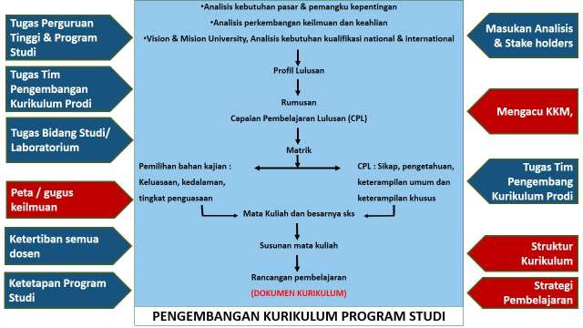

Figure 1: Study Program Curriculum Development Map

## Curriculum Development Needs Analysis

The needs analysis of curriculum development at UIN Maulana Malik Ibrahim refers to:

1. Community and Stakeholder Needs
2. The development of science and technology
3. National and International Qualification Needs
4. National and Global Issues
5. Educational Policies
6. Vision, Mission, and Goals of UIN Maulana Malik Ibrahim

## Curriculum Formulation

In formulating the curriculum at UIN Maulana Malik Ibrahim, the following points need to be considered:

1. Curriculum development must first determine the profile of graduates The formulation of Graduate Learning Outcomes (SLOs) should include attitudes, knowledge, general skills, and specific skills.

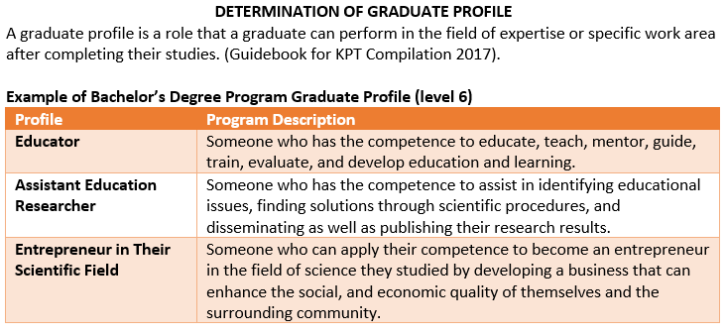

1. The formulation of attitudes and general skills must, at a minimum, align with the standards set out in the National Standards for Higher Education.
2. The knowledge and specific skills outcomes should be developed by each study program, taking into account the agreements of associations of similar study programs, and referring to the level descriptions in the Indonesian National Qualifications Framework (KKNI) documents.
3. The aspects of attitudes and general skills must meet the standards set by the Ministry of Research, Technology, and Higher Education, with additional distinctions specific to each study program. Specific skills and knowledge are derived from each study program.
4. The attitude aspect must also pay attention to the attitudes that are built based on the character of Ulul Albab, including: (1) Always being aware of God's presence accompanied by the ability to use the potential of the heart (dhikr), and reason (thought) to achieve conviction in Allah's greatness in all of His creations; (2) Fearing no one but Allah, distinguishing and choosing between good and bad; (3) Prioritizing quality of life in belief, speech, and action, being patient and resilient; (4) Serious and critical in exploring knowledge; (5) Being willing to share knowledge with the community and feeling called to help solve societal problems.
5. The curriculum must also be based on an integrative approach at all levels, from learning planning, and classroom implementation, to final assignments (thesis/dissertation), both in terms of science integration and institutional integration.

## Curriculum Implementation

In implementing the curriculum at UIN Maulana Malik Ibrahim, the following provisions are followed:

1. Implementation of the UIN Maliki Malang Curriculum is carried out in the form of lectures, practicum, work experience, community service, and research.
2. The implementation of UIN Maliki Malang's curriculum incorporates interactive, holistic, integrative, scientific, contextual, thematic, effective, collaborative, and student-centered learning.
3. Further details on point (b) can be found in the National Standards for Higher Education (SNPT) No. 44 of 2015, updated by the Ministerial Regulation No. 3 of 2020.
4. UIN Maulana Malik Ibrahim conducts lectures over two semesters within an academic year and may offer an additional interim semester to facilitate accelerated student progress.
5. The development of attitudes, knowledge, general skills, and specific skills are obtained through intra-curricular, co-curricular, and extracurricular activities.
6. Completion of studies at UIN Maulana Malik Ibrahim can be finalized with the preparation of a thesis, dissertation, or written work in the form of an article published in an accredited SINTA/international/reputable journal, or artistic/design work in other forms.

## KMMB Education Model (Independent Campus – Independent Learning)

According to the Ministerial Regulation No. 3 of 2020 concerning National Standards for Higher Education (SNPT), the education model at UIN Maulana Malik Ibrahim is divided into two models:

1. Students undertake their studies entirely within their chosen program of study according to the specified duration and credits.
2. Students complete part of their studies within their chosen program of study and fulfill the remaining credits through learning activities outside their chosen program:
   1. A minimum of 4 semesters and a maximum of 11 semesters is dedicated to learning within the Program of Study;
   2. 1 (one) semester or the equivalent of 20 (twenty) credit units is allocated to learning outside the Program of Study within the same institution;
   3. a maximum of 2 semesters or the equivalent of 40 semester credit units is:
      1. Learning in the same study program at different universities;
      2. Learning in different study programs in different universities; and/or
      3. Learning outside Higher Education in the form of activities (Teaching Assistance, student exchange, internships, research, entrepreneurship, village projects, humanitarian activities, and independent projects).

Table 1: Education Model

|  |  |  |  |
| --- | --- | --- | --- |
| Semester | Study Program Courses |  | Options |
| 8th semester | Learning Design for Competency Enhancement in Study Programs |  | Final Project |
| Interdisciplinary courses at different Higher Education Institutions or Learning Outside Higher Education Institutions (minimum of 20 credits and maximum of 40 credits) |
| 7th semester |  |
| 6th semester |  | Cross-disciplinary courses (equivalent to 20 credits) at the same university |
| 5th semester |  | Minimum Learning Outcomes of the Study Program. |
| 4th semester |  |
| 3rd semester |  |
| 2nd semester |  |
| 1st semester |  |

different or optional 8 Activity Forms

Option 1 Option 2

Interdisciplinary courses do not need to be completed in a single semester and can be offered for both Option #1 and Option #2. Students are allowed to choose, and lecturers have the opportunity to design their courses.

## Curriculum and Courses

Based on (1) the Learning Outcomes established by all study programs at UIN Maulana Malik Ibrahim, (2) the aspects of attitudes, skills, and knowledge that must be imparted to students of UIN Maulana Malik Ibrahim, and (3) the curriculum development guidelines based on KKNI and SNPT Kampus Merdeka Merdeka Belajar (KMMB), the curriculum is developed as follows:

* 1. The number of credits developed in study programs at UIN Maulana Malik Ibrahim is a minimum of 144 and a maximum of 155 credits, detailed as follows:

1. National and Institutional content is 20% (twenty percent);
2. Elective content is 10% (ten percent);
3. Field-specific disciplinary content is 70% (seventy percent);
4. The curriculum grouping refers to institutional guidelines while still being based on learning outcomes.
5. The grouping of courses in the curriculum at UIN Maulana Malik Ibrahim consists of:
   * 1. General Courses (MKU)
     2. University-Specific Courses (MKKU)
     3. Faculty Expertise Courses (MKF)
     4. Study Program Expertise Courses (MKKPS)
     5. Core Expertise Courses of Study Program (MKKIPS)
     6. Elective Expertise Courses of the Study Program (MKKPPS)
6. The total credits for General Courses (MKU) is 6 credits (see table).
7. The total credits for University-Specific Courses (MKKU) is 26 credits.
8. The total credits for Faculty Expertise Courses (MKF) range from 15 to 20 credits.
9. The remaining credits for Study Program Expertise Courses (MKKPS) are after deducting the credits for MKU, MKKU, and MKF.
10. Study Program Expertise Courses (MKKPS) consist of Core Expertise Courses of the Study Program (MKKIPS) with 98+ credits and Elective Expertise Courses of the Study Program (MKKPPS) with a minimum of 10 and a maximum of 20 credits.
11. Students are allowed to take MKU and MKKU courses across different study programs at UIN Maulana Malik Ibrahim.
12. Students are allowed to take MKF courses across different study programs within the same faculty.
13. The number of Elective Expertise Courses of the Study Program offered must be at least twice the required amount.
14. Elective Expertise Courses of the Study Program should support additional profiles, not just accommodate the field of study.
15. Core Expertise Courses of the Study Program and Elective Expertise Courses of the Study Program are under the authority of the study program, considering the graduate profile, Learning Outcomes, and the subject matter being developed.

Table 2: Example of Elective Courses

Additional profile Additional Profile

As an Education Researcher As a Language Interpreter

Elective Courses (10-20 credits) Elective Courses (10-20 credits)

1. Qualitative Research Methodology (2 credits)
2. Quantitative Research Methodology (3 credits)
3. Inferential Statistics (2 credits)
4. Qualitative data analysis (2 credits)
5. Quantitative data analysis (2 credits)
6. Data validity (2 credits)
7. And so on.
8. Introduction to Creative Writing (3 credits)
9. Introduction to Translation
10. Practicum of Translation
11. Subtitling
12. English for Social Communication
13. And so on.
14. There must be a minimum of four courses in each study program that are conducted through online learning (blended learning) or campus-based online learning, with a maximum ratio of 30% online and 70% offline.
15. The required learning materials that must be submitted include lesson plans (RPP), teaching materials, learning media, student worksheets (LKM), and assessment instruments.
16. The final project can be completed in collaboration with students from different study programs or faculties, provided that the student has taken at least 4 credits of courses related to the thesis topic in the respective study program.
17. The integration approach is a learning and non-learning approach that combines general and religious knowledge.
18. The integration approach is implemented in both learning and non-learning contexts.
19. Integration in learning can involve the integration of teaching materials, learning media, and assessment tools, as reflected in the planning and implementation of learning. Additionally, integration in learning can also be part of the final project/thesis/dissertation (specifically in the theoretical framework and discussion sections). Further details will be provided in a separate guidebook.
20. Outside of learning, integration can take the form of life values in the Ma'had (boarding school) and other learning centers.
21. The Ulul Albab approach aims to develop graduates characterized by the "Ulul Albab" attributes, which include: (1) Constant awareness of God's presence, accompanied by the ability to use the heart (*dzikir*) and intellect (thinking) to reach a conviction of God's greatness in all of His creations; (2) The courage to fear none but Allah, paired with the wisdom to discern and choose between good and evil; (3) Emphasis on quality of life in belief, speech, and actions, with patience and resilience; (4) A diligent and critical attitude in the pursuit of knowledge; (5) A commitment to sharing knowledge with society and dedication to addressing the challenges faced by the community.

Table 3: Structure of Regular Courses/Sample Courses at the Faculty of Tarbiyah and Teacher Training (FITK)

|  |  |  |  |  |
| --- | --- | --- | --- | --- |
|  | **Group and Course Name** | | | **Credits** |
| **A**. | **GENERAL COURSES (MKU)** | | |  |
| 1 | : | Pancasila | 2 |
| 2 | : | Citizenship | 2 |
| 3 | : | Bahasa Indonesia | 2 |
| Total | | | 6 |
| **B.** | **UNIVERSITY SPECIALTY COURSES (MKKU)** | | |  |
| 1 | : | Arabic 1 | 4 |
| 2 | : | Arabic 2 | 4 |
| 3 | : | English 1 | 3 |
| 4 | : | English 2 | 3 |
| 5 | : | Philosophy of Science | 2 |
| 6 | : | Study of al-Qur'an and al-Hadith | 2 |
| 7 | : | Fiqh Studies | 2 |
| 8 | : | Theosophy | 2 |
| 9 | : | History of Islamic Civilization | 2 |
| 10 | : | Community Service Program (KKM) | 2 |
| Total | | | 26 |
| **C.** | **FACULTY SKILLS COURSES (MKKF)** | | |  |
| 1 | : | Fundamentals of Education | 2 |
| 2 | : | Psychology of Education and Learning | 3 |
| 3 | : | Curriculum and Learning | 2 |
| 4 | : | Education Management | 2 |
| 5 | : | Education Statistics | 2 |
| 6 | : | Educational Research Methodology | 3 |
| 7 | : | Basic Teaching Skills | 3 |
| 8 | : | Technology-based Learning | 2 |
| Total | | | 15-20 |
| **D.** | **STUDY PROGRAM EXPERTISE COURSES (MKKPS)** | | |  |
|  | 1 | : | Core Expertise Study Program (MKKIPS),  (including MKPLSP, MKPPL, and Thesis) | Min 98 |
| 2 | : | Study Program Elective Expertise Course (MKKPPS) | Min 10, Max  20 |
| Total credits | | | | 144-156 |

1. The Ulul Albab approach and religious moderation can be achieved through the attitudes present in both curricular and extracurricular activities. In the curricular context, these values can be reflected in the learning outcomes of graduates and can also be seen in the curriculum itself. Meanwhile, in the extracurricular context, they can be embodied in the values of life at Mahad and other learning centers. These aspects will be further regulated through a separate guidebook.

## Special Provisions for the Independent Campus – Independent Learning (KMMB) Curriculum

* 1. The goal of the Independent Campus – Independent Learning (KMMB) educational model is to enhance graduates' competencies, both in soft skills and hard skills, making them more prepared and relevant to the demands of today’s world. It also aims to prepare graduates as future leaders of the nation who are outstanding and have strong character. The experiential learning program with flexible pathways is expected to facilitate students in developing their potential according to their passions and capability.
  2. UIN Maulana Malik Ibrahim students may take courses that support their competencies in other study programs at the same university, with a maximum of 20 credits.
  3. UIN Maulana Malik Ibrahim students may participate in activities planned in collaboration with other universities or institutions for a maximum of 40 credits.
  4. Students may take up to 20 credits, as mentioned in point (b), in different study programs within UIN Maulana Malik Ibrahim Malang after completing a minimum of 80 credits.
  5. Students may take 20 credits of activities in the same or different study programs at different universities and 20 credits of activities at different universities/institutions in forms such as student exchange, internships, teaching assistance, research, entrepreneurship, village projects, humanitarian activities, and independent projects after completing a minimum of 100 credits.
  6. Students may take up to 40 credits in forms such as student exchange, internships, teaching assistance, research, entrepreneurship, village projects, humanitarian activities, and independent projects after completing a minimum of 100 credits.
  7. The general requirements to participate in this educational model are: (1) Students must be enrolled in an accredited study program, and (2) Students must be actively registered in the PDDikti database.
  8. Cross-disciplinary courses that can be taken by other students include:
     1. The development of new courses (not within the existing structure) in the context of cross-disciplinary course development programs.

1. Integration of Knowledge, Digital Transformation, Social Entrepreneurship, Computerization, Technology-Based Learning, and others are implemented through various approaches.
2. Digital Transformation: Cross-disciplinary learning at the university level is conducted entirely online.
3. Social Entrepreneurship: Collaboration between study programs both within UIN Maulana Malik Ibrahim Malang and with institutions outside UIN.
4. Computerization: In collaboration with certain institutions and/or several universities in ASEAN.
   * 1. Courses in the curriculum structure:
        1. Not in package form (structured within the General Course Curriculum, University, Faculty, and Study Program levels).
        2. Package Courses:

* University Package Courses.
* Faculty Package Courses.
* Study Program Package Courses (from elective packages).
* Study Program Package Courses (from non-elective packages).
  + 1. Courses/Development activities not included in the curriculum structure:
       1. Eight Activities: (1) Classroom learning, (2) Work practice (internships), (3) Student exchange, (4) Village projects, (5) Entrepreneurship, (6) Research, (7) Independent study, and (8) Teaching activities in remote areas.
       2. Courses derived from activities that have been jointly designed by UIN Maulana Malik Ibrahim and other universities/institutions, either in free form or structured form.

Table 4: Example of Independent Campus Course Structure/Example at the Faculty of Tarbiyah and Teacher Training (FITK)

|  |  |  |  |  |
| --- | --- | --- | --- | --- |
|  | **Group and Course Name** | | | **Credits** |
| **A.** | **GENERAL COURSES (MKU)** | | |  |
| 1 | : | *Pancasila* | 2 |
| 2 | : | Citizenship | 2 |
| 3 | : | Indonesian Language | 2 |
| Total | | | 6 |
| **B.** | **UNIVERSITY SPECIALTY COURSES (MKKU)** | | |  |
| 1 | : | Arabic 1 | 4 |
| 2 | : | Arabic 2 | 4 |
| 3 | : | English 1 | 3 |
| 4 | : | English 2 | 3 |
| 5 | : | Philosophy of Science | 2 |
| 6 | : | Study of al-Qur'an and al-Hadith | 2 |
| 7 | : | Fiqh Studies | 2 |
| 8 | : | Theosophy | 2 |
| 9 | : | History of Islamic Civilization | 2 |
| 10 | : | Student Work Study (KKM) | 2 |
| Total | | | 26 |
| C. | FACULTY SKILLS COURSES (MKKF) | | |  |
| 1 | : | Fundamentals of Education | 2 |
| 2 | : | Psychology of Education and Learning | 3 |
| 3 | : | Curriculum and Learning | 2 |
| 4 | : | Education Management | 2 |
| 5 | : | Education Statistics | 2 |
| 6 | : | Educational Research Methodology | 3 |
| 7 | : | Basic Teaching Skills | 3 |
| 8 | : | Technology-based Learning/Technology in Learning | 2 |
| Total | | | 15 to 20 |
| D. | STUDY PROGRAM EXPERTISE COURSES (MKKPS) | | |  |
|  | 1 | : | *Core Expertise Courses of the Study Program (MKKIPS) can be taken at the same or different universities.* | Adjusted |
|  | 2 | : | *Elective Expertise Courses of the Study Program can be taken at the same or a different university.* | Adjusted |
| E. | ACTIVITIES | | |  |
| 1 | Internship/Practical Work Activities Supporting the Main Profession/Activities Outside the University. | | | 20 |
| 2 | Activities Supporting Other Professions (Teaching Assistance, Student Exchange, Internships, Research, Entrepreneurship, Village Projects, Humanitarian Activities, and Independent Projects). | | | 20 |
| Total credits | | | | 144/156 |

1. **The Learning Models according to the KMMB Curriculum**
   1. Regular Curriculum Model

Table 5: Regular Curriculum Structure

|  |  |  |
| --- | --- | --- |
|  | **Regular Curriculum Structure 1 (144 to 155)** | **Regular Curriculum Structure 2 (144 to**  **155)** |
| 1 | MKU 6 credits | MKU 6 credits |
| 2 | MKKU 26 credits | MKKU 26 credits |
| 3 | MKKF /15-20 | MKKPS 112 + credits (Faculty specialty courses are not offered/merged into MKKIPS) consisting of; |
| 4 | MKKPS 97+ credits consisting of |
| 1. Core Expertise Study Program (MKKIPS) 87+ 2. Study Program Elective Expertise Courses (MKKPPS)-10+ | 1. Core Expertise Courses of the Study Program (MKKIPS) 102+ |
| b. Elective Expertise Courses of the Study Program (MKKPPS) 10+ |

* 1. KMMB-1 Curriculum

Table 6: Independent Campus Lecture Model Option 1

|  |  |  |
| --- | --- | --- |
|  | **Regular Curriculum Structure 1 (144 to 155)** | **Independent Curriculum Structure 1 (144 to 155)** |
| 1 | MKU 6 credits | General Course (MKU 6 credits) |
| 2 | MKKU 26 credits | University Specialty Courses (MKKU 26 credits) |
| 3 | MKKF /15-20 | Faculty Specialty Courses (MKF 15-20) |
| 4 | MKKPS 97+ credits consisting of | Study Program Expertise Courses (MKKPS 97+ credits) consisting of |
| 1. Core Expertise Courses of the Study Program (MKKIPS) 87+ 2. Elective Expertise Courses of the Study Program (MKKPPS)-10+ | 1. Core Expertise Courses of the Study Program (MKKIPS) - 67 + credits 2. Elective Expertise Courses of the Study Program (MKKPPS)-10+ |
| 5 | Activities / Teaching Assistance / other equivalent to 20 credits (16 credits of activities during one semester and thesis-4 credits) |

* 1. KMMB-2 Curriculum

Table 7: Independent Campus Lecture Model Option 2

|  |  |  |
| --- | --- | --- |
|  | **Regular Curriculum Structure 1 (144 to 155)** | **Independent Curriculum Structure 2 (145 to 155)** |
| 1 | MKU 6 credits | MKU 6 credits |
| 2 | MKKU 26 credits | MKKU 26 credits |
| 3 | MKKF /15-20 | Faculty Specialty Courses (MKF 15-20) |
| 4 | MKKPS 97+ credits consisting of   1. Core Expertise Courses of the Study Program (MKKIPS) 87+ 2. Elective Expertise Courses of the Study Program (MKKPPS)-10+ | Study Program Expertise Courses (MKKPS 97+ credits) consisting of   1. Core Expertise Courses of the Study Program (MKKIPS) 2. Elective Expertise Courses of the Study Program (MKKPPS) are completed in the host study program.   (Core Expertise Courses can be taken outside the host study program, either at the same university or a different one, with a maximum of 20 credits). Internships/Practical Work for the main profile must be completed within the host study program. |

* 1. KMMB-3 Curriculum

Table 8: Independent Campus Lecture Model Option 3

|  |  |  |
| --- | --- | --- |
|  | **Regular Curriculum Structure 1 (144 to 155)** | **Independent Curriculum Structure 3 (145 to 155)** |
| 1 | MKU 6 credits | MKU 6 credits |
| 2 | MKKU 26 credits | MKKU 26 credits |
| 3 | MKKF /15-20 | Faculty Specialty Courses (MKF 15-20) |
| 4 | MKKPS 97+ credits consisting of   1. Core Expertise Courses of the Study Program (MKKIPS) 87+ 2. Elective Expertise Courses of the Study Program (MKKPPS)-10+ | Study Program Expertise Courses (MKKPS 97+ credits) consisting of   1. Core Expertise Courses of the Study Program (MKKIPS) 2. Elective Expertise Courses of the Study Program (MKKPPS)   (Core and/or Elective Expertise Courses of the Study Program can be taken outside the study program, either at the same university or at a different university, with a maximum of 20 credits. Internships/Practical Work for the main profile must be completed within the host study program. |

* 1. KMMB-4 Curriculum

Table 9: Independent Campus Lecture Model Option 4

|  |  |  |
| --- | --- | --- |
|  | **Regular Curriculum Structure** | **Independent Curriculum Structure 4 (145 to 155)** |
| 1 | MKU 6 credits | MKU 6 credits |
| 2 | MKKU 26 credits | MKKU 26 credits |
| 3 | MKKF /15-20 | MKKF /15-20 |
| 4 | MKKPS 97+ credits consisting of | MKKPS 97+ credits consisting of |
| 1. Core Expertise Courses of the Study Program (MKKIPS) 87+ 2. Elective Expertise Courses of the Study Program (MKKPPS)-10+ | 1. MKKIPS (A minimum of 37 credits is required, with the maximum adjusted according to the credit value specified in point b) 2. MKKPPS: minimum 10 credits, maximum 20 credits, and can be taken from another study program, either at the same or a different institution (Package system). |
| 5 | Activities equivalent to 20 credits that align with the main profile (mandatory) / Example: Teaching Assistance/Internship |
| 6 | Activities equivalent to 20 credits at other institutions (Research, entrepreneurship, student exchange, internship) including thesis |

* 1. KMMB-5 Curriculum

Table 10: Independent Campus Lecture Model Option 5

|  |  |  |
| --- | --- | --- |
|  | **Regular Curriculum Structure** | **Independent Curriculum Structure 5 (145 to 155)** |
| 1 | MKU 6 credits | MKU 6 credits |
| 2 | MKKU 26 credits | MKKU 26 credits |
| 3 | MKKF /15-20 | MKKF 10%/15-20 |
| 4 | MKKPS 97+ credits consisting of | MKKPS 97+ credits |
| 1. Core Expertise Courses of Study Program (MKKIPS) 87+ 2. Elective Expertise Courses of Study Program (MKKPPS)-10+ | 1. MKKIPS (A minimum of 37 credits is required, with the maximum adjusted according to the credit value specified in point b) 2. MKKPPS: A minimum of 10 credits and a maximum of 20 credits are required, which can be taken from another study program, whether at the same or a different institution (Package system) |
| 5 | Activities equivalent to 20 credits that match the additional profile. The example cases include Humanities and Science and Technology. |
| 6 | Activities equivalent to 20 credits at other institutions, such as research, entrepreneurship, student exchange, internships, and including the thesis, are recognized. |

* 1. KMMB-6 Curriculum

Table 11: Independent Campus Lecture Model Option 6

|  |  |  |
| --- | --- | --- |
|  | **Regular Curriculum Structure (145 to 155)** | **Independent Curriculum Structure 6 (145 to 155)** |
| 1 | MKU 6 credits | MKU 6 credits |
| 2 | MKKU 26 credits | MKKU 26 credits |
| 3 | MKKF /15-20 | MKKF /15-20 |
| 4 | MKKPS 97+ credits consisting of | MKKPS 97+ credits |
| 1. Core Expertise Courses of Study Program (MKKIPS) 87+ 2. Elective Expertise Courses of the Study Program (MKKPPS)- 10+ | 1. MKKIPS (A minimum of 37 credits is required, with the maximum adjusted according to the credit value specified in point 2) 2. MKKPPS: A minimum of 10 credits and a maximum of 20 credits are required, which can be taken from another study program, whether at the same or a different institution. |
| 5 | Activities equivalent to 20 credits at other institutions, such as research, entrepreneurship, student exchange, internships, and including the thesis, are recognized. |

* 1. KMMB-7 Curriculum

Table 12: Independent Campus Lecture Model Option 7

|  |  |  |
| --- | --- | --- |
|  | **Regular Curriculum Structure** | **Independent Curriculum Structure 7 (145 to 155)** |
| 1 | MKU 6 credits | MKU 6 credits |
| 2 | MKKU 26 credits | MKKU 26 credits |
| 3 | MKKF /15-20 | MKKF /15-20 |
| 4 | MKKPS 97+ credits consisting of | MKKPS 97+ credits consisting of |
| 1. Core Expertise Courses of the Study Program (MKKIPS) 87+ 2. Elective Expertise Courses of the Study Program (MKKPPS)- 10+ | 1. MKKIPS (A minimum of 47 credits is required, with the maximum adjusted according to the credit value specified in point b) 2. MKKPPS: A minimum of 10 credits is required, and must be taken from the host study program. |
| 5 | Activities equivalent to 20 credits that align with the main profile (mandatory) / Example: Teaching Assistance/Internship. |
| 6 | Activities equivalent to 20 credits at other institutions, such as research, entrepreneurship, student exchange, internships, and including the thesis, are recognized. |

* 1. KMMB-8 Curriculum

Table 13: Independent Campus Lecture Model Option 8

|  |  |  |
| --- | --- | --- |
|  | **Regular Curriculum Structure** | **Structure of Merdeka Curriculum 8 (145 to 155)** |
| 1 | MKU 6 credits | MKU 6 credits |
| 2 | MKKU 26 credits | MKKU 26 credits |
| 3 | MKKF /15-20 | MKKF 10%/15-20 |
| 4 | MKKPS 97+ credits consisting of | MKKPS 97+ credits |
| 1. Core Expertise Courses of the Study Program (MKKIPS) 87+ 2. Elective Expertise Courses of the Study Program (MKKPPS)-10+ | 1. MKKIPS (A minimum of 47 credits is required, with the maximum adjusted according to the credit value specified in point b) 2. MKKPPS: A minimum of 10 credits is required, and must be taken from the host study program. |
| 5 | Activities equivalent to 20 credits that align with the additional profile. The example cases include Humanities and Science and Technology. |
| 6 | Activities equivalent to 20 credits at other institutions, such as research, entrepreneurship, student exchange, internships, and including the thesis, are recognized. |

* 1. KMMB-9 Curriculum

Table 14: Independent Campus Lecture Model Option 9

|  |  |  |
| --- | --- | --- |
|  | **Regular Curriculum Structure (145 to 155)** | **Independent Curriculum Structure 9 (145 to 155)** |
| 1 | MKU 6 credits | MKU 6 credits |
| 2 | MKKU 26 credits | MKKU 26 credits |
| 3 | MKKF /15-20 | MKKF /15-20 |
| 4 | MKKPS 97+ credits consisting of | MKKPS 97+ credits |
| 1. Core Expertise Courses of the Study Program (MKKIPS) 87+ 2. Elective Expertise Courses of the Study Program (MKKPPS)-10+ | 1. MKKIPS (A minimum of 47 credits is required, with the maximum adjusted according to the credit value specified in point b) 2. MKKPPS: A minimum of 10 credits is required, and must be taken from the host study program. |
| 5 | Activities equivalent to 20 credits at other institutions, such as research, entrepreneurship, student exchange, internships, and including the thesis, are recognized. |

* 1. KMMB-10 Curriculum

Table 15: Independent Campus Lecture Model Option 10

|  |  |  |
| --- | --- | --- |
|  | Regular Curriculum Structure | Independent Curriculum Structure 10 (145 to 155) |
| 1 | MKU 6 credits | MKU 6 credits |
| 2 | MKKU 26 credits | MKKU 26 credits |
| 3 | MKKF /15-20 | MKKF 10%/15-20 |
| 4 | MKKPS 97+ credits consisting of | MKKPS 97+ credits |
| 1. Core Expertise Courses of the Study Program (MKKIPS) 87+ 2. Elective Expertise Courses of the Study Program (MKKPPS)-10+ | 1. MKKIPS (A minimum of 37 credits is required, with the maximum adjusted according to the credit value specified in point b) 2. MKKPPS: A minimum of 10 credits and a maximum of 20 credits are required, which can be taken from another study program, whether at the same or a different institution. (Package system). |
| 5 | Activities equivalent to 20 credits at other institutions, such as research, entrepreneurship, student exchange, internships, and including the thesis, are recognized. |

## KMMB Curriculum Activities

The learning activities in the KMMB Curriculum according to Permendikbud No. 3 of 2020, Article 15, paragraph 1 are described as follows:

Figure 2: KMMB Activities

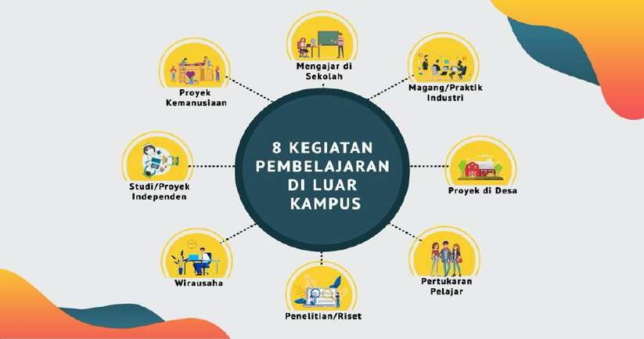

* 1. **Student Exchange**

Student exchange programs are organized to develop several attitudes in students as outlined in Permendikbud No. 3 of 2020, including valuing cultural diversity, viewpoints, religions, and beliefs, as well as respecting the opinions or original findings of others. They also aim to foster cooperation, social sensitivity, and concern for society and the environment.

Student exchanges across study programs at the same higher education institution can help achieve learning outcomes as specified in the study program’s curriculum structure or curriculum development for enriching graduate learning outcomes. These can take the form of elective courses. For example, students from the Faculty of Psychology may take elective courses (such as in the Islamic Education study program: Educational Researcher) or from other faculties (such as in Educator Training).

Table 16: Cross-program student exchange within faculty electives (package system)

|  |  |
| --- | --- |
| **Courses** | **Credits** |
| Lesson Planning | 3 |
| Learning Strategy | 3 |
| Learning Evaluation | 3 |
| Learning Media Development | 3 |
| Curriculum and Teaching Material Development | 8 |
| *Total* | *20* |

Another example is the Islamic Elementary School Teacher Education(PGMI) students must be able to master at least the three Course Learning Outcomes of the study program, but require additional competencies that can be taken from other study programs that support graduate competencies. Therefore, the students can take courses in accounting, management, and communication study programs within the same university.

Table 17: Student Exchange across Study Programs based on Additional Competencies

|  |  |  |  |
| --- | --- | --- | --- |
| Study Program | Graduate Learning Outcomes (GLOs) | Additional Competencies | Study Program |
| Islamic Elementary School Teacher Education (PGMI) | 1. Able to design innovative learning media products. 2. Able to evaluate design development objects. 3. Able to prepare and present learning media design products. | Able to develop, analyze, and interpret financial plans for the production of learning media (e.g., Financial Planning course). | Sharia Accounting at Economics Faculty |
| Able to carry out Learning Media Products Marketing (e.g., Basic Marketing Concepts course). | Management at the Faculty of Economics |
| Able to design advertising programs for learning media products (e.g., Media Advertising course). | Communication |
| Able to design learning media using advanced modern technology. | Information Technology at the Faculty of Science and Technology |

Student exchange within the same study program at different higher education institutions. This form of learning allows students to enrich their experience and academic context at other institutions that offer unique or supplementary learning resources to optimize learning outcomes.

Table 18: Student Exchange across the same study program at different universities

|  |  |  |  |
| --- | --- | --- | --- |
| Study Program | SLOs of the same study program across universities | Courses of PGMI Study Program at UIN Maliki Malang | Courses of PGSD (Elementary School Teacher Education) Study Program at the State University of Malang |
| Islamic Elementary School Teacher Education (PGMI) | Able to design and manage digital technology-based learning media. | 1. Management of Technology-Based Media | 1. Management of Learning Media for Elementary School/Islamic Elementary School Students |
| 1. Management of Digital Learning Media | 1. Development of Interactive Learning Media |

The Islamic Elementary School Teacher Education studyprogram at UIN Maulana Malik Ibrahim Malang and the Elementary School Teacher Education study program at Malang State University (UM) both include a learning outcome focused on designing and managing learning media. Students from UIN Maulana Malik Ibrahim Malang are eligible to enroll in courses offered by UM, and vice versa.

Student exchange between study programs at different higher education institutions allows students to take courses at other institutions to support achieving learning outcomes as specified in the study program's curriculum structure, as well as to enrich the curriculum and enhance graduate learning outcomes.

Table 19: Student Exchange across Study Programs

|  |  |  |  |
| --- | --- | --- | --- |
| Study Program | SLOs of Study Programs | Additional Competencies | Courses of Mechanical Engineering Study Program of another university |
| Industrial Engineering at UIN Malang | Able to design systems/components, processes, and industrial products to meet needs within realistic constraints (e.g., economic, environmental, health). | Able to design products for agricultural needs | Energy and Agricultural Machinery |
| Able to build models to analyze resources and the environment | Economic Modeling of Resources and Environment |

* 1. **Internship program for 1-2 semesters.**

So far, short-term internships (less than 6 months) have been insufficient for providing students with industry experience and competencies. Companies that accept interns also report that very short internships are not beneficial and can even disrupt industry activities.

This internship aims to provide students with substantial experience and direct workplace learning. During the internship, students will acquire both hard skills (such as technical skills, complex problem-solving, analytical skills, etc.) and soft skills (such as professional ethics, communication, teamwork, etc.). Meanwhile, industries benefit by identifying talents that could potentially be recruited directly, thus reducing recruitment and initial training/induction costs. Students who are already familiar with the workplace will be better prepared to enter the job market and their careers. Through this process, industry issues will flow into higher education, updating teaching materials and faculty learning, and making research topics at universities more relevant.

**Free-form Format**: A 6-month independent learning activity is equivalent to 20 credits without direct equivalence to specific courses. This amount is expressed in terms of the competencies acquired by students during the program, covering both hard skills and soft skills in line with the desired learning outcomes.

**Example**: A student completing a 6-month internship in the industry.

Table 20: Free Form

|  |  |  |  |
| --- | --- | --- | --- |
| **Hard Skills**   * Formulating engineering problems   Solving technical problems in the field   * Synthesis skills in design | :  :  : | 3 credits  3 credits  4 credits | A B A |
| **Soft Skills**   * Communication skills * Teamwork skills * Hard work * Leadership * Creativity | :  :  :  :  : | 2 credits  2 credits  2 credits  2 credits  2 credits | A A A A B |

**Structured Form**: Independent learning activities can be organized according to the student's curriculum. The 20 credits are equivalent to specific courses that match the competencies gained during the internship. For instance, a Chemical Engineering student who completes a 6-month internship in the petrochemical industry would be considered equivalent to taking the following courses:

Table 21: Structured Form

|  |  |  |  |
| --- | --- | --- | --- |
| * Transport Phenomenon | : | 2 credits | A |
| * Operation Unit | : | 3 credits | A |
| * Chemical Process Industry | : | 3 credits | B |
| * Chemical Reaction Engineering | : | 3 credits | A |
| * Chemical Process Control | : | 3 credits | A |
| * Separation Technology * Final report (replacing thesis) | :  : | 2 credits  4 credits | B  A |

In addition to the two aforementioned forms, combining both forms (hybrid form) is also permitted.

* 1. **Teaching Assistance in Educational Institutions**

The quality of basic and secondary education in Indonesia remains very low (PISA 2018 ranks Indonesia 7th from the bottom). There is a large number of educational institutions in Indonesia, each facing various issues. The learning activity in the form of teaching assistance is carried out by students in educational institutions such as elementary, secondary, and high schools. The schools for this teaching practice may be located in urban areas or remote regions.

The objectives of this activity are:

1. To provide an opportunity for students interested in education to teach and deepen their knowledge by becoming teachers in educational institutions.
2. To help improve the equity of education quality and the relevance of basic and secondary education with higher education and contemporary developments.
   1. **Research.**

For students at UIN Maulana Malik Ibrahim who are interested in pursuing a research career, the opportunity to intern at research laboratories is highly desirable. Additionally, research laboratories or institutions sometimes face shortages of research assistants when working on short-term research projects (1 semester to 1 year). Through research, students can develop critical thinking skills, which are essential for various fields of study at the higher education level. With strong critical thinking abilities, students will better explore, understand, and apply research methods.

The objectives of this program are:

1. To enhance the quality of student research and strengthen the pool of research talent in specific fields.
2. To provide students with research competencies through direct guidance from researchers at research institutions or study centers.
3. To improve the ecosystem and quality of research in laboratories and research institutions in Indonesia by supplying research resources and fostering early career development for researchers.
   1. **Humanitarian Project.**

Indonesia has experienced many natural disasters, including earthquakes, volcanic eruptions, tsunamis, hydrological disasters, and so on. While universities have contributed to disaster relief through humanitarian programs, student involvement has largely been voluntary and short-term. This initiative aims to prepare outstanding students who uphold humanitarian values in their tasks, grounded in religion, morality, and ethics, and to cultivate their social awareness to address and solve issues based on their interests and expertise.

In addition, many international organizations (such as UNESCO, UNICEF, WHO, etc.) have conducted in-depth studies and developed pilot projects in Indonesia and other developing countries. Students, with their youthful energy, knowledge, and interests, can serve as “foot soldiers” in humanitarian and development projects both within Indonesia and abroad.

The objectives of this program are:

* 1. To prepare exceptional students who uphold humanitarian values in their duties, guided by religion, morality, and ethics.
  2. To develop students’ social awareness, enabling them to explore and address existing issues and contribute solutions aligned with their interests and expertise.
  3. **Entrepreneurial Activities.**

According to the Global Entrepreneurship Index (GEI) of 2018, Indonesia had only 21% of entrepreneurs across various sectors, ranking 94th out of 137 surveyed countries. Research by the IDN Research Institute in 2019 shows that 69.1% of millennials in Indonesia are interested in entrepreneurship. Unfortunately, this entrepreneurial potential among millennials has not been effectively managed so far.

Entrepreneurship programs for students should be developed at the university level, with a curriculum that can account for 20 credits per semester or 40 credits per year. This program could combine courses from various disciplines offered by the university, including those from other institutions, and may include online or offline courses/micro-credentials. To assess the program, evaluation rubrics or success criteria should be established. For example, if a student successfully launches a startup at the end of the program, they could receive an A grade with 20 credits out of 40.

During the entrepreneurship program, students will be guided by faculty advisors and successful entrepreneur mentors. Universities with incubation centers are encouraged to integrate this program with their centers. Those without such centers can collaborate with external business incubators and accelerators. Universities should work with partner institutions to provide a comprehensive entrepreneurship learning system that includes practical experience. This system may include training, mentoring, and guidance from experienced entrepreneurs. Technical guidelines for entrepreneurship education activities should also be developed.

The objectives of this program are:

* 1. To provide opportunities for students interested in entrepreneurship to develop their ventures early on and with guidance.
  2. To address the issue of unemployment by creating opportunities for graduates, thus reducing intellectual unemployment among degree holders.
  3. **Independent Projects**

Many students have a passion for creating significant works that are competitive on an international level or for developing innovative ideas. Ideally, independent studies or projects should complement the existing curriculum. Universities or faculties can use independent study to cover topics not included in the standard course schedule but still available within the program's syllabus. Independent projects can be conducted in the form of interdisciplinary group work.

The objectives of independent projects are:

1. To bring students' ideas to life by developing innovative products based on their concepts.
2. To facilitate research and development (R&D)-based education.
3. To enhance students' achievements in national and international competitions.
   1. **Village Development: Thematic Community Service Program**

The Thematic Community Service Program (KKNT) is a form of education that provides students with the experience of living within a community outside the campus. This program involves students directly in identifying potential and addressing issues within the community, aiming to develop local potential and create solutions for existing problems.

KKNT activities are expected to enhance students' soft skills in partnership, interdisciplinary teamwork, and leadership in managing rural development programs. Although universities have implemented KKNT programs, the Semester Credit Units (SKS) have not yet been fully recognized according to the Independent Learning program, which acknowledges credits equivalent to 6 – 12 months or 20 – 40 credits. The implementation follows various models, and it is hoped that students will document their activities and results in their final assignments.

The objectives of this program are:

1. To provide students with the opportunity to apply their knowledge, technology, and skills in collaboration with stakeholders over a 6 to 12-month period.
2. To support the acceleration of rural development in collaboration with the Ministry of Village Development and Transmigration (PDTT).

Here is a table of activities included in the independent learning campus curriculum;

Table 22: The Activities of KMMB

|  |  |  |  |
| --- | --- | --- | --- |
|  | **Activities** | **Description** | **Notes** |
| 1 | Internship | Internships at companies, non-profit organizations, multilateral organizations, government institutions, or startups. | It must be supervised by a lecturer or instructor. |
| 2 | Village Projects | Social projects to assist communities in rural or remote areas with building local economies, infrastructure, etc. | It can be done in collaboration with village officials (village heads), BUMDes, cooperatives, or other village organizations. |
| 3 | Teaching at Schools | Teaching activities in primary, secondary, or high schools for several months. Schools can be located in urban or remote areas. | This program will be facilitated by the Ministry of Education and Culture (Kemendikbud). |
| 4 | Student Exchange | Taking classes or a semester at domestic or foreign universities, based on existing agreements. | Credits and grades from the host institution will be equated by the respective universities. |
| 5 | Research | Academic research, either in science or social humanities, is conducted under the supervision of a lecturer or researcher. | This can be done at research institutions such as LIPI/BRIN. |
| 6 | Entrepreneurial Activities | Students independently develop entrepreneurial activities, demonstrated through explanations/proposals and proof of consumer transactions or employee pay slips. | Supervision by a lecturer is required. |
| 7 | Independent Study/Project: | Students can develop a project based on a specific social topic and work on it collaboratively with other students. | Supervision by a lecturer is required. |
| 8 | Humanitarian Projects | Social activities for a foundation or humanitarian organization approved by the university, either domestically or internationally. | Examples of formal organizations that may be approved by the Rector include the Indonesian Red Cross, Mercy Corps, and others. |

## Course Code Guidelines

The course code system for study programs at UIN Maulana Malik Ibrahim Malang is structured as follows:

* 1. Course Code Sequence

1. First and Second Digits: Academic Year
2. Third and Fourth Digits: Faculty Code
3. Fifth and Sixth Digits: Study Program Code
4. Seventh Digit: Education Level
5. Eighth Digit: Required/Elective Course Group
6. Ninth Digit: Course Type
7. Tenth and Eleventh Digits: Course Sequence

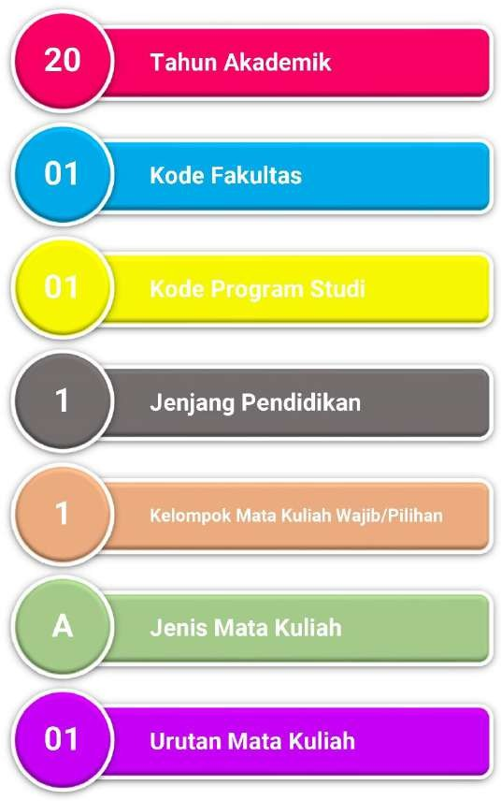

Figure 3: Course Codes

* 1. Course Classification Types:
  2. General and University-Specific Courses (MKU and MKKU): Code A
  3. Faculty-Specific Courses: Code B
  4. Study Program-Specific Expertise Courses: Code C
  5. Core Program Expertise Courses: Code D
  6. Elective Program Expertise Courses: Code E
  7. Final Project: Code TAS
  8. Additional Codes:

1. Required Courses: Code 1
2. Elective Courses: Code 2
3. Undergraduate Level (S-1): Code 6
4. Professional Level: Code 7
5. Master's Level (S-2): Code 8
6. Doctoral Level (S-3): Code 9

## Learning Process

Learning is the process of interaction between students, lecturers, and learning resources within a learning environment. The characteristics of the learning process are interactive, holistic, integrative, scientific, contextual, thematic, effective, collaborative, and student-centered. A student-centered approach means that the learning outcomes are achieved through a process that prioritizes the development of students' creativity, capacity, personality, and needs, as well as fostering independence in seeking and discovering knowledge.

Each characteristic of the learning process is defined as follows:

* + - 1. Interactive: Learning outcomes are achieved through a two-way interaction between students and lecturers.
      2. Holistic: The learning process encourages the formation of a comprehensive mindset by internalizing both local and national excellence and wisdom.
      3. Integrative: Learning outcomes are achieved through an integrated process that meets the overall learning outcomes within a single unified program, employing interdisciplinary and multidisciplinary approaches.
      4. Scientific: Learning outcomes are achieved through a process that emphasizes a scientific approach, creating an academic environment based on values, norms, and the principles of science, while upholding religious and national values.
      5. Contextual: Learning outcomes are achieved through a process tailored to the demands of problem-solving abilities within the student's area of expertise.
      6. Thematic: Learning outcomes are achieved through a process that aligns with the characteristics of the study program and is connected to real-world problems using a transdisciplinary approach.
      7. Effective: Learning outcomes are achieved successfully by prioritizing the correct and appropriate internalization of material within an optimal time frame.
      8. Collaborative: Learning outcomes are achieved through a collaborative learning process that involves interaction among learners to capitalize on attitudes, knowledge, and skills.

1. **Student-Centered Approach**

The learning process at UIN Maulana Malik Ibrahim Malang emphasizes a student-centered approach. Following the National Standards for Higher Education (SN-Dikti), the adopted approach is known as Student-Centered Learning (SCL). This paradigm is implemented through various forms of learning activities, methods, and assignments, all designed to provide students with learning experiences that align with the expected learning outcomes of each course.

According to SN-Dikti, several teaching methods can be utilized in the learning process, including group discussions, simulations, case studies, collaborative learning, cooperative learning, project-based learning, problem-based learning, and other effective methods that facilitate the achievement of learning outcomes.

In the current era of Industry 4.0, universities face the challenge of adopting teaching methods that combine traditional classroom-based learning with online learning through the use of information technology, commonly referred to as blended learning or hybrid learning. This approach is particularly well-suited to the learning styles of the millennial and Generation Z cohorts, offering students the opportunity to leverage information technology for data-driven research and learning. The use of blended learning also strengthens students' digital and technological literacy, skills that are highly relevant to the demands of the Industry 4.0 era.

1. **Forms and Methods of Learning**

The forms of learning in the National Standards for Higher Education (SN-Dikti) are regulated under Article 17 of the Minister of Education and Culture Regulation No. 3 of 2020. The selection of learning forms for student activities at UIN Maulana Malik Ibrahim Malang is used to estimate the learning time, which can then be used to calculate the credit weight of a course. Below is a tabulation of the learning forms and their estimated time. Learning methods can be defined as systematic steps in the learning process that employ specific strategies to achieve student learning outcomes.

According to Article 14 of SN-Dikti, the following learning methods may be used: group discussions, simulations, case studies, collaborative learning, cooperative learning, project-based learning, problem-based learning, or other methods that can effectively facilitate the achievement of student learning outcomes. The forms and methods of learning should be selected to align effectively with the characteristics of the course, ensuring that the intended competencies are developed as part of fulfilling the overall learning outcomes. Examples of the selection of learning forms, methods, and assignments are shown in Table 23.

Table 23: Examples of Learning Selection, Forms, Methods, and Assignments

|  |  |  |  |
| --- | --- | --- | --- |
| No. | Form of  Learning | Learning Methods | Assignment |
| 1 | Face to face | * case study; * group discussion; | Problem-solving |
| 2 | Practicum and Practice | project-based learning | Create a specific project |
| 3 | Field practice | * problem-based learning; * collaborative learning; * group discussion; | Create a problem-solving portfolio |

1. **Blended Learning**

Blended learning is a teaching method that harmoniously combines the strengths of both offline and online learning to achieve student learning outcomes (KPT Team, Ministry of Research, Technology, and Higher Education, 2018). In blended learning, students not only gain learning experiences while being accompanied by lecturers in the classroom or outside of it but also enjoy a broader range of independent learning experiences. In class sessions, the lecturers provide learning materials, practical examples, and direct motivation. Meanwhile, online learning allows students to control their study time, learn from any location, and break free from the confines of traditional teaching methods.

The learning materials are richer, comprising e-books, electronic articles, educational videos from the internet, virtual reality, and more. Students can easily access these resources using devices and applications right at their fingertips.

Blended learning occurs when 30%-79% of the learning materials can be accessed and studied online by students. The classification of blended learning based on student access to these materials is presented in Table 24.

Blended learning, both from the perspectives of lecturers and students, offers several best practice models. The taxonomy of blended learning models is described as follows (Staker & Horn, 2012). There are four models of blended learning:

* 1. **Rotation Model**: In this model, students rotate between different learning centers according to a schedule or syllabus determined by their lecturer. The cycle of learning activities might include attending lectures in a classroom, participating in small group discussions, engaging in online learning, collaborating on assignments, and then returning to classroom learning with the lecturer.

Table 24: Classification of blended learning

|  |  |  |
| --- | --- | --- |
| Percentage of  Online access | Learning Method | Description |
| 0% | Face to face | Learning materials are obtained in class and  oral teaching. |
| 1% - 29% | Web | Learning primarily occurs face-to-face in the classroom, with minimal online elements such as course outlines, assignments, and materials available on a web platform or learning management system (LMS). |
| 30% - 79% | Blended | Learning combines both online and face-to-face methods. Lectures, materials, assignments, and examples are accessible online, with classes possibly conducted via platforms like LMS-Moodle, Webex, Skype, Hangouts, Facebook, Edmodo, etc. |
| ≥ 80% | Online | Learning is fully online with no face-to-face interaction. All materials, examples, and assignments are provided and completed through online platforms. |

* 1. **Flex Model**: This model involves designing learning plans and materials to be delivered online via eLearning platforms. Most of the student's learning activities occur online, with face-to-face support from the instructor provided flexibly as needed.
  2. **Self-blend Model**: In this model, students independently choose to take online courses either from the campus or externally to complement their in-person classes. Students manage their blend of online and face-to-face learning activities.
  3. **Enriched Virtual Model**: This model combines classroom learning with remote learning. Students attend physical classes together and engage in distance learning at other times. They use various online tools such as video conferencing, Webex, and LMS. This model is often utilized by students who have limited time for in-person classes due to work commitments, or for supplementary and replacement classes.

**Rotation Model** includes several sub-models as follows:

1. **Flipped-Classroom Model:** In this model, students first engage with learning materials and complete assignments online outside of class. During subsequent in-person class sessions, students clarify and discuss what they learned online with their peers and instructor. The goal is to enhance active learning outside the classroom, where students master new concepts and theories independently using structured assignments and self-study. Tools such as learning management systems (e.g., SPADA) on <http://spada.ristekdikti.go.id> and online resources like videos and e-books are utilized. In-class time is then used for demonstrations, discussions, reflections, presentations, and deeper engagement with the instructor and classmates. The flipped classroom model can be applied over one or more weeks depending on the complexity of the learning outcomes.
2. **Station-Rotation Model:** Students rotate through different learning stations as per the pre-defined schedule. This model involves various activities such as classroom learning, group discussions, assignments, and online study, with periodic returns to the classroom. Students work in small groups or the entire class, with the instructor providing support during in-class activities.
3. **Lab-Rotation Model:** In this model, students rotate through different learning environments as scheduled by the instructor, with a focus on computer labs where they engage in online learning. They study materials prepared by the instructor or enrichment content available online. Additional classroom lectures may be included to reinforce understanding.
4. **Individual-Rotation Model:** Similar to the Station-Rotation Model, but with students rotating individually through the different learning activities. This model allows for a personalized learning experience where each student follows their rotation schedule.

Top of Form

Bottom of Form

1. **Regulations for the Implementation of the Credit System:**
2. Student Workload: Student workload is expressed in the number of SKS (Semester Credit Units).
3. Semester Duration: A semester is defined as a unit of effective learning time lasting at least 16 weeks, including mid-semester and end-of-semester exams.
4. Academic Year: An academic year consists of 2 semesters, and universities may offer an additional inter-semester period.
5. Inter-semester Period: When provided, the inter-semester period is:
   * At least 8 weeks long.
   * A maximum of 9 SKS.
   * Structured according to the student workload required to meet the established learning outcomes.
6. Inter-semester Classes: If conducted as lectures, there must be at least 16 class meetings, including mid-semester and end-of-inter-semester exams.

## Learning Assessment

Assessment is a process involving one or more methods to identify, collect, and prepare data and evidence to evaluate both the process and results of student learning. This includes principles of assessment; techniques and Instruments: mechanisms and procedures; implementation of assessment; Reporting; and student graduation. Assessment should effectively address key indicators related to integrity, discipline, communication, decisiveness, and confidence, which are essential attributes for students to develop.

* 1. **Assessment Principles**

Learning assessment at UIN Maulana Malik Ibrahim must adhere the following principles:

Table 25: Learning Principles

|  |  |  |
| --- | --- | --- |
| No. | Assessment Principle | Definition |
| 1 | Educative | This type of assessment aims to motivate students to:   1. Improve their planning and study methods; and 2. Achieve the intended learning outcomes. |
| 2 | Authentic | This assessment focuses on continuous learning processes and results that reflect the student's abilities during the learning process, including knowledge, skills, and attitudes. |
| 3 | Objective | This assessment is based on agreed-upon standards between the instructor and students, free from subjective biases of both the assessor and the assessed. |
| 4 | Accountable | This assessment is conducted according to clear procedures and criteria agreed upon at the beginning of the course, and understood by the students. |
| 5 | Transparent | This assessment ensures that the procedures and results are accessible to all stakeholders. |

* 1. **Assessment Techniques and Instruments**

The assessment of course learning outcomes at UIN Maulana Malik Ibrahim Malang involves evaluating students in the domains of attitude, knowledge, and skills. Each domain is assessed through specific techniques and instruments as detailed below:

* + 1. Attitude assessment. It is conducted through observation, self-assessment, peer assessment (Students assess the performance of their peers within a group or field), and personal aspects assessment that emphasizes aspects such as faith, moral character, self-confidence, discipline, and responsibility in interactions with the social environment, natural surroundings, and broader world and civilization.
    2. Knowledge assessment. It is carried out using various types of written and oral tests. These assessments can be conducted either directly (using face-to-face interactions, such as seminars and thesis examinations) or indirectly (using written test papers or other written formats)
    3. Skill Assessment. It involves performance evaluations through practicum, practice, simulations, and fieldwork that allow students to enhance their practical skills.

Table 26: Assessment Techniques and Instruments

|  |  |  |
| --- | --- | --- |
| **Assessment** | **Technique** | **Instrument** |
| Attitude | Observation | 1. Rubrics for process assessment and/or 2. Portfolio or design work for assessment   Results |
| General Skills | Observation, participation, performance, written test, oral test, and questionnaire |
| Special Skills |
| Knowledge |
| *The final assessment result is an integration of various techniques and*  *assessment instruments used.* | | |

* 1. **Learning Outcome Assessment**
     1. For non-medical study programs

Table 27: Assessment Categories (for non-medical study programs)

|  |  |  |  |  |
| --- | --- | --- | --- | --- |
| **No.** | **Scale**  **(Score 0 - 100)** | **Grade** | **Grade point** | **Graduation Honors** |
| 1 | 85 - 100 | A | 4 | Summa Cumlaude |
| 2 | 75 - 84 | B + | 3,5 | Cumlaude |
| 3 | 70 - 74 | B | 3 | Very satisfactory |
| 4 | 65 - 69 | C + | 2,5 | Satisfactory |
| 5 | 60 - 64 | C | 2 | Passed |
| 6 | 50 - 59 | D | 1 | Unsatisfactory |
| 7 | < 50 | E | 0 | Failed |

* + 1. For medical study programs

Table 28: Assessment Categories for Medical Study Programs

|  |  |  |  |  |
| --- | --- | --- | --- | --- |
| No. | Scale  (Score 0 - 100) | Grade | Grade Point | Graduation Honors |
| 1 | 80 - 100 | A | 4,00 | Summa Cumlaude |
| 2 | 75 - 79,5 | B + | 3,50 | Cumlaude |
| 3 | 70 - 74,9 | B | 3,00 | Very satisfactory |
| 4 | 65 - 69,9 | C + | 2,50 | Satisfactory |
| 5 | 60 - 64,9 | C | 2,00 | Passed |
| 6 | 55 - 59,9 | D | 1,00 | Unsatisfactory |
| 7 | < 55 | E | 0 | Failed |

* 1. **Assessment Report**

The report of student learning assessment results at UIN Maulana Malik Ibrahim Malang is presented as the qualification of student success in completing a course, expressed within the ranges shown in the following table.

Table 29: Report of Learning Outcomes Assessment

|  |  |  |
| --- | --- | --- |
| **Grade** | **Grade Point** | **Category** |
| A | 4 | Excellent |
| B | 3 | Good |
| C | 2 | Satisfactory |
| D | 1 | Poor |
| E | 0 | Failed |

* + 1. Grading can use the range of letters and the range of numbers. For the grading range, it is in the range of 0 (zero) to 4 (four).
    2. 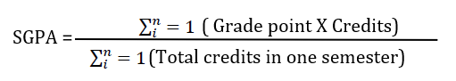The results of the assessment of graduate learning outcomes in each semester are expressed by the Semester Grade Point Average (SGPA). The calculation formula for the Semester Grade Point Average (SGPA) is described as follows:
    3. The results of the assessment of graduate learning outcomes at the end of each study are expressed by a cumulative Grade Point Average (GPA). The method for calculating the GPA is as follows:

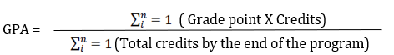

* + 1. A high-achieving student has a semester grade point average (GPA) greater than 3.50 (three point five zero) and meets the academic ethics.
  1. **Student Graduation**

The graduation honors for students at UIN Maulana Malik Ibrahim Malang are determined under the regulations set by SN-Dikti, as shown in Table 30.

Table 30: Student Graduation

|  |  |  |
| --- | --- | --- |
| Program | GPA | Graduate Honors |
| Diploma and Bachelor’s Degree | | |
| Students in diploma and bachelor's degree programs are considered to have graduated if they have completed all the required coursework and achieved the targeted learning outcomes of the program with a cumulative grade point average (GPA) of 2.00 (two point zero) or higher. | | |
|  | 2,00-2,75 | Passed |
| 2,76-3,00 | Satisfactory |
| 3,01-3,50 | Very Satisfactory |
| >3,50 | Cumlaude |
| Professional, specialist, master’s, applied master’s, doctoral, applied doctoral degrees: | | |
| Students in professional, specialist, master's, applied master's, doctoral, and applied doctoral programs are considered to have graduated if they have completed all the required coursework and achieved the targeted learning outcomes of the program with a cumulative GPA of 3.00 (three point zero) or higher. | | |
|  | 2,50-3,00 | Passed |
| 3,01-3,50 | Satisfactory |
| 3,51-3,75 | Very Satisfactory |
| >3,75 | Cumlaude |
| Graduates are entitled to receive a diploma, degree or title, and an academic transcript under the regulations. | | |

## Curriculum Documents Based on Study Program Accreditation

The curriculum document is composed of at least the following sections:

1. **Study Program Identity** - Details the identity of the Study Program, including Name of Higher Education Institution, Faculty, Program, Accreditation, Level of Education, Graduation Degree, Vision, and Mission.
2. **Curriculum Evaluation and Tracer Study** - Explains the results of the evaluation of the implementation of the curriculum that has been and is currently running, by presenting the mechanism of curriculum evaluation results. It requires a needs analysis based on stakeholder needs from the tracer study results.
3. **Foundations of Curriculum Design and Development** - Includes philosophical, sociological, psychological, legal foundations, etc.
4. **Formulation of Vision, Mission, Goals, Strategies, and University Values.**
5. Formulation of Graduate Competency Standards (SKL) expressed in Graduate Learning Outcomes (SLOs) - SLOs consist of aspects: Attitude and General Skills are at least adopted from SN-Dikti, and aspects of Knowledge, and Specific Skills are formulated referring to the KKNI descriptors corresponding to their level.
6. **Determination of Study Materials** - Based on SLOs and/or using the Body of Knowledge of a Study Program, which is then used for the formation of new courses, and evaluation and reconstruction of existing courses.
7. **Course Formation (MK) and Determination of Credit Points** - Explains the mechanism for course formation based on CPL (and its derivatives at the course level) and study materials, as well as determining credit points.
8. **Curriculum Matrix and Map** - Describes the organization of courses or curriculum maps in a logical and systematic structure according to the Learning Outcomes of Study Program. The distribution of courses is arranged in a series of semesters during the study period of Study Program graduates.
9. **Course Learning Plan (RPS)** - RPS is Prepared from the learning design, written in detail for all courses in the Study Program, accompanied by other teaching materials including assignment plans, assessment instruments in the form of rubrics and/or portfolios, teaching materials, etc.
10. **Implementation Plan for the Right to Study for a Maximum of 3 Semesters Outside the Study Programs** - This is an implementation of the "Merdeka Belajar- Kampus Merdeka" policy outlined in the regulations:
    1. Learning outside the Study Program at the same Higher Education Institution,
    2. Learning in the same Study Program outside the Higher Education Institution,
    3. Learning in a different Study Program outside the Higher Education Institution, and
    4. Learning outside the Higher Education Institution/Activities outside the Higher Education Institution.
11. **Curriculum Management and Implementation Mechanism** – Plan for curriculum implementation and Internal Quality Assurance System (SPMI) at each higher education institution related to curriculum implementation.

## Curriculum Evaluation

1. Curriculum evaluation includes the assessment of inputs, design, implementation, outcomes, and impact.
2. Curriculum evaluation can be conducted comprehensively (as a whole) or in parts (specific components).
3. A comprehensive evaluation is conducted at least every five years.

a. Specific component evaluations should be done periodically and continuously as needed.

1. Curriculum reviews are conducted continuously to obtain feedback for improving the ongoing curriculum.
2. Improvements following evaluations may include adjustments to both implementation and curriculum materials, aiming to update the curriculum in line with the latest developments in the field, societal demands, and labor market or expert needs.
3. Changes to the curriculum or the development of a new curriculum, resulting from curriculum reviews, are designed by the faculty and study programs, consulted with the rector, and enacted based on the faculty dean’s decree.
4. Curriculum changes are made after a review by the study program within a maximum period equivalent to the study period (4 years).
5. The curriculum review process consists of 1) a curriculum colloquium, 2) a curriculum workshop, and 3) a discussion for determination by the university, faculty, and study program leaders, and 4) approval by the rector.

## Conclusion

The Higher Education Curriculum (KPT) truly reflects the spirit, dedication, and responsibility of educators to provide professional learning experiences that provide high-quality graduates capable of adapting to their environments, especially in the era of Industry 4.0. The Higher Education Curriculum is a mandate of the institution that must be continually updated under evolving needs and advancements in science and technology, as outlined in the Graduate Learning Outcomes.

This Curriculum Preparation Guide from UIN Malang is one reference for curriculum development at the study program level, but it certainly requires additional support from other sources. This guide serves as a supplement alongside other resources for the preparation of the KPT at the study program level. It is expected that this guide will provide practical assistance to educators in curriculum development. Program administrators and educators are encouraged to thoroughly engage with this guide to maximize its benefits for curriculum preparation.

For readers, even if there is a solid understanding of curriculum development concepts and an intensive follow-up on educational paradigms, these ideas will remain theoretical until the curriculum document is concretely prepared. Therefore, study programs need to begin developing or refining their curricula promptly. Even when the curriculum document is complete, its benefits will not be fully realized until it is implemented in the study programs. Thus, study programs must work diligently to ensure that higher education in Indonesia benefits from improved quality in teaching and learning processes to provide Indonesian individuals who are positively characterized, intelligent, competent, and competitive.

# REFERENCES

Ornstein, A.C. and Hunkins, F.P. (2014). Curriculum: Foundations, Principles, and Issues. Pearson Education Ltd. Edinburgh Gate, Harlow, Essex CM20 2 JE, England. Printed and bound in Vivar, Malaysia. ISBN13:978-1-978-292- 16207-2

Allen, I. E, Seaman, J., and Garrett, R. (2007). *Blending in The Extent and Promise of Blended Education in the United States.* Sloan-C., MA-USA.

Anderson, L., & Krathwohl, D. (2001). *A Taxonomy for Learning, Teaching and Assessing: A Revision of Bloom's Taxonomy of Educational Objectives.* New York: Longman.

Attard,A.,DiLorio,E.,Geven,K.andSanta,R.(2010).*Student-centredlearning -Toolkit for students, staff and higher education institutions.* Brussels: European Students Union. http:// [www.esib.org/index.php/Publications](http://www.esib.org/index.php/Publications)

AUN-QA. (2015). *Guide to AUN-QA Assessment at Program Level Version 3.0.* Bangkok: ASEAN University Network.

Bin, J. O. (2015, December 24). *Living Better*. (AUN-QA Network) Retrieved March 2016, 2016, from [http://livingbetterforhappiness.blogspot.](http://livingbetterforhappiness.blogspot/) co.id/2015/12/the-ten-principles-behind-aun-qa-model.html

Bloom, B. S. (1984). *Taxonomy of Educational Objectives Book 1: Cognitive Domain 2nd edition Edition.* Boston: Addison Wesley Publishing Company.

Brookhart, S. M., & Nitko, A. J. (2015). *Educational assessment of students* (7th ed.). New Jersey: Pearson.

Bruner, J. S. (1977). *The Process of Education.* United States of America: Harvard University Press.

Caliguri, P (2012). *Cultural Agility: Building a Pipeline of Successful Global Professionals.* San Francisco, CA: Jossey-Bass.

Clark, R. C., & Lyons, C. (2010). *Graphics for Learning: Proven Guidelines for Planning, Designing, and Evaluating Visuals in Training Materials 2nd Edition.* San Francisco: Pfeiffer.

Dick, W., Carey, L., & Carey, J. O. (2014). *The Systematic Design of Instruction* (8th ed.). New York: Pearson.

Gagne, R. M., Briggs, L. J., & Wager, W. W. (1992). *Principles of Instructional Design* (4th ed.). New York: Harcourt Brace College Publishers.

Garrison, R. D., & Vaughan, N. D. (2008). *Blended Learning in Higher Education.* San Francisco: John Wiley & Sons, Inc.

Gredler, M. E. (2011). *Learning and Instruction: Theory into Practice* (6th ed.). New York: Pearson.

Harden, R. M. (1999). What is a spiral curriculum? *Medical Teacher, 21*(2), 141-142

Heywood, J. (2005). *Engineering Education: Research and Development in Curriculum and Instruction.* New Jersey: John Wiley & Sons.

Joyce, B., Weil, M., & Calhoun, E. (2009). *Models of Teaching* (8th ed.). New Jersey: Pearson Education, Inc.

Kelly, A. V. (2004). *The Curriculum: Theory and Practice* (5th ed.). London: Sage Publications.

Khataybeh, A., & Ateeg, N. A. (2011). How "Writing Academic English" Follows Bruner's Spiral Model in Curriculum Planning. *Journal of Emerging Trends in Educational Research and Policy Studies*, 127-138.

Marsh, C. J. (2004). *Key Concepts for Understanding Curriculum* (3rd ed.). New York: RoutledgeFalmer.

Marzano, R. J., & Kendall, J. S. (2007). *The New Taxonomy of Educational Objectives.*

California: A Sage Publications Company.

Minister of Education and Culture of the Republic of Indonesia. (2013, June 10). Implementation of the Indonesian National Qualifications Framework for Higher Education. *Regulation of the Minister of Education and Culture of the Republic of Indonesia Number 73 of 2013.* Jakarta, Indonesia: Ministry of Education and Culture of the Republic of Indonesia.

Minister of Education and Culture of the Republic of Indonesia. (2014, August 21). Higher Education Diplomas, Certificates of Competence, and Professional Certificates. *Regulation of the Minister of Education and Culture of the Republic of Indonesia Number 81 of 2014.* Jakarta, Indonesia: Ministry of Education and Culture of the Republic of Indonesia.

Minister of Education and Culture of the Republic of Indonesia. (2020, January 24). *National Higher Education Standards. Regulation of the Minister of Education and Culture of the Republic of Indonesia Number 3 of 2020.* Jakarta, Indonesia: Ministry of Education and Culture of the Republic of Indonesia.

Minister of Education and Culture of the Republic of Indonesia. (2020, January 24). Accreditation of Study Programs and Higher Education. *Regulation of the Minister of Education and Culture of the Republic of Indonesia Number 5 of 2020.* Jakarta, Indonesia: Ministry of Education and Culture of the Republic of Indonesia.

Minister of Education and Culture of the Republic of Indonesia. (2020, January 24). Establishment, Change, Dissolution of State Universities, and Establishment, Change, Revocation of Licenses of Private Universities *Regulation of the Minister of Education and Culture of the Republic of Indonesia Number 7 of 2020.* Jakarta, Indonesia: Ministry of Education and Culture of the Republic of Indonesia.

Ornstein, A. C., & Hunkins, F.P. (2004). *CURRICULUM: Foundations, Principles, and Issues* (4th ed.). New York: Pearson.

Ornstein, A.C. and Hunkins, F.P. (2014). Curriculum: Foundations, Principles, and Issues. Pearson Education Ltd. Edinburgh Gate, Harlow, Essex CM20 2 JE, England. Printed and bound in Vivar, Malaysia. ISBN13:978- 1-978-292-16207- 2

President of the Republic of Indonesia. (2012, January 17). Indonesian National Qualification Framework. *Presidential Regulation of the Republic of Indonesia Number 8 of 2012.* Jakarta, Indonesia: Minister of Law and Human Rights of the Republic of Indonesia.

President of the Republic of Indonesia. (2012, August 10). Higher Education. *Law Number 12 of 2012*. Jakarta, Indonesia: Ministry of State Secretariat of the Republic of Indonesia.

Provus, M. M. (1969). *The Discrepancy Evaluation Model: An Approach to Local Program Improvement and Development.* Washington D.C.: Pittsburgh Public Schools. Retrieved July 14, 2016, from [http://eric.](http://eric/) ed.gov/?id=ED030957

Rada, M. (2017, January 2). *Industry 5.0 Definition.* Retrieved from Medium: [https:](https://medium.com/%40michael.rada/industr)//medium.com/@michael.rada/industry-5-0-definition- 6a2f9922dc48

Slattery, P. (2006). *Curriculum Development in the Postmodern Era* (2nd ed.). New York: Routledge.

Staker, H., & Horn, M. B. (2012, May). *iNacol.* USA: Innosight Institute. Retrieved from Resources: [https://www.christenseninstitute.org/](http://www.christenseninstitute.org/) wp.../04/Classifying-K-12- blended-learning.pdf

Taba, H. (1962). *Curriculum Development: Theory and Practice.* USA: Harcourt Brace Jovanovich, Inc.

Work Team. (2005). *Competency-Based Curriculum for the Fields of Science.* Jakarta: Directorate General of Higher Education - Ministry of National Education.

Work Team. (2005). *Questions and Answers About Competency-Based Curriculum in Higher Education.* Jakarta: Directorate General of Higher Education - Ministry of National Education.

Work Team. (2005). *Questions and Answers on Material Development Unit and Learning Process in Higher Education.* Jakarta: Directorate General of Higher Education - Ministry of National Education.

Tyler, R. W. (2013). *Basic Principle of Curriculum and Instruction.* Chicago and London: The University of Chicago Press.

UNESCO. (2007). *Convention on the Recognition of Studies, Diplomas and Degrees concerning Higher Education in the States belonging to the European Region 1979.*

Weimer, M. (2002) *Learner-centered Teaching: Five Key Changes to Practice.* San Francisco: ossey- Bass.

Zais, R. S. (1976). *Curriculum: Principles and Foundations.* New York: Harper & Row.

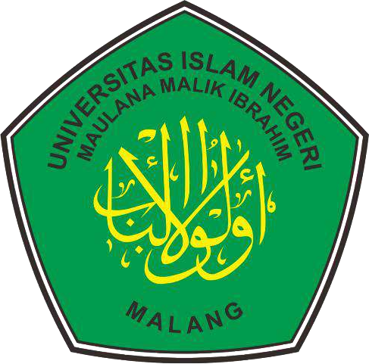

**CURRICULUM DEVELOPMENT GUIDELINES**

**STATE ISLAMIC UNIVERSITY (UIN) MAULANA MALIK IBRAHIM MALANG 2020**

Based on KKNI | Refers to SNPT (Number 3 of 2020)/Independent Campus-Independent Learning Based on ULUL ALBAB and Religious Moderation | Integration Approach